 

## South Valley University

Faculty of Computer and Information Technology

Computer Science and Information Technology Departments

Final Year Project

Student Management System

EDUWAY

Presented By:

|  |  |
| --- | --- |
| *Mohamed Hesham Abdelrahman* | *Mohamed Saad Redawi* |
| *Abdellatif Ahmed Abdellatif Osama Mohamed Fahmy*  *Ahlam Ahmed Shaker* | *Abdallah Ahmed Bestawy Mohamed Abdallah Fahim*  *Mariam Khaled AbdelWaha* |

*b*

Supervised By:

*DR. Sara Farrag*

J u l y – 2 0 2 4

1



**Students Contribution**

Student Management System (EDUWAY) By:

|  |  |  |
| --- | --- | --- |
|  | *Title* | *Contributors* |
| *1* | *UX/UI* | *Mohamed Hesham Abdelrahman Ahlam Ahmed Shaker* |
| *2* | *Front-end developer* | *Abdellatif Ahmed Abdellatif*  *Osama Mohamed Fahmy Mariam Khaled AbdelWahab* |
| *3* | *back-end developer* | *Mohamed Abdullah Fahim Mohamed Saad Redawi Abdallah Ahmed Bestawy* |
| *4* | *Book* | *Mohamed Hesham Abdelrahman Mohamed Saad Redawi* |

July 1, 2024



**ACKNOWLEDGMENTS**

First and foremost, I would like to express my deepest gratitude to the chairman of our committee, Dr. Sara, for her unwavering support, outstanding guidance, and encouragement throughout my senior project. Her insightful advice and dedication have been invaluable to my success.

I would also like to extend my heartfelt appreciation to Dr. Emad Ali and Dr. Randa Mohamed for their tremendous help and guidance throughout my education. Their expertise and support have been instrumental in my academic journey.

Additionally, I would like to thank my family, especially my parents, for their constant encouragement, patience, and assistance over the years. We are forever indebted to them for their unwavering support and for always keeping me in their prayers.



**ABSTRACT**

The EduWay Student Management System (SMS) is designed to streamline and enhance the management of student-related data and administrative processes at SVU University. This documentation serves as a comprehensive guide, offering detailed instructions and insights to help users effectively navigate and utilize the system.

EduWay encompasses a wide range of features, catering to various user roles including administrators, students, teachers, teacher assistants, control members, and staff. Key functionalities include:

**Administration Management:** Tools for managing faculties, courses, students, and staff, as well as generating and extracting detailed reports.

**Student Services:** Access to personal data, academic schedules, tuition fee information, exam schedules, grades, portfolios, and progress tracking.

**Teacher and Teacher Assistant Utilities:** Course management, grade submission, and daily note-taking functionalities to support educational activities.

Control Members Functions: Management of final grades and extraction of reports to ensure academic standards are maintained.

2

July 1, 2024

**Staff Capabilities:** Adding and managing student information to support the administrative backbone of the university.



**CONTENTS**

Students Contribution 1

ACKNOWLEDGMENTS 2

ABSTRACT 2

CONTENTS 3

LIST OF FIGURES 5

LIST OF TABLES 7

Chapter 1: 8

1. Introduction 9
2. Problem Definition 9
3. Motivation 10
   1. Objective 10
   2. Scope 10
   3. Benefits 11

Chapter 2: 12

1. Related Work 13

Chapter 3: 20

5. Domain Analysis and Technique 21

* 1. Domain Analysis 21
  2. Risk/Constraints 21
  3. Project Plan 24
  4. Quality Assurance Plan 25
     1. Objectives 25

July 1, 2024

3

* + 1. Standards and Procedures 26
    2. Testing Strategy 26
  1. Feasibility Study 26
     1. Technical Feasibility 26
     2. Operational Feasibility 27
     3. Schedule Feasibility 27
  2. Expected Outputs 27
     1. Functional Outputs 27
     2. Technical Outputs 27
     3. Organizational Outputs 28
     4. Educational Outputs 28

Chapter 4: 29

6. Software Requirements Specification 30

* 1. Introduction 30
     1. Purpose 30
     2. Project Scope 30
  2. Overall Description 31
     1. Product Features 31
     2. User Classes and Characteristics 34
     3. Operating Environment 36
  3. System Features 37
     1. User Management 37
  4. Other Nonfunctional Requirements 40
     1. Security Requirements 40
  5. Use case Diagram 42

Chapter 5: 43

.7 Results 44

* 1. Login 44
  2. Administration 45
  3. Teacher 73
  4. Teacher Assistant 77

July 1, 2024

4

* 1. Control Members 80
  2. Staff 88

Student92

CONCLUSION 94



**LIST OF FIGURES**

Figure 2.2 website interface 13

Figure 2.2 website interface 14

Figure 2.3 website interface 14

Figure 3.3 project plan 24

Figure 4.5 use case Diagram 42

FIGURE 5.1 LOGIN PAGE 44

FIGURE 5.2.1 BASIC INFORMATION 45

FIGURE 5.2.2 FACULTY 46

FIGURE 5.2.3 FACULTY 47

FIGURE 5.2.4 FACULTY 47

FIGURE 5.2.5 FACULTY 48

FIGURE 5.2.6 FACULTY 48

FIGURE 5.2.7 FACULTY 49

FIGURE 5.2.8 FACULTY 49

FIGURE 5.2.9 FACULTY 50

FIGURE 5.2.10 FACULTY 50

FIGURE 5.2.11 FACULTY 51

FIGURE 5.2.12 FACULTY 51

FIGURE 5.2.13 FACULTY 52

FIGURE 5.2.14 FACULTY 52

FIGURE 5.2.15 FACULTY 53

FIGURE 5.2.16 FACULTY 53

FIGURE 5.2.17 FACULTY 54

FIGURE 5.2.18 FACULTY 54

FIGURE 5.2.18 FACULTY 55

FIGURE 5.2.19 FACULTY 55

FIGURE 5.2.20 FACULTY 56

FIGURE 5.2.21 FACULTY 56

FIGURE 5.2.22 FACULTY 57

FIGURE 5.2.23 FACULTY 57

FIGURE 5.2.24 FACULTY 58

5

July 1, 2024

FIGURE 5.2.25 FACULTY 58

FIGURE 5.2.26 STUDENT 59

FIGURE 5.2.27 STUDENT 59

FIGURE 5.2.28 STUDENT 60

FIGURE 5.2.29 STUDENT 60

FIGURE 5.2.230 COURSES 61

FIGURE 5.2.31 COURSES 62

FIGURE 5.2.32 COURSES 62

FIGURE 5.2.33 COURSES 63

FIGURE 5.2.34 STAFF 63

FIGURE 5.2.35 STAFF 64

FIGURE 5.2.36 STAFF 64

FIGURE 5.2.37 STAFF 65

FIGURE 5.2.38 STAFF 65

FIGURE 5.2.39 STAFF 66

FIGURE 5.2.40 CONTROL 66

FIGURE 5.2.41 CONTROL 67

FIGURE 5.2.42 CONTROL 67

FIGURE 5.2.43 CONTROL 68

FIGURE5.2.44 CONTROL 68

FIGURE 5.2.38 CONTROL 69

FIGURE 5.2.38 TIMETABLE 69

FIGURE 5.2.39 REPORT 70

FIGURE 5.2.40 REPORT 70

FIGURE 5.2.41 REPORT 71

FIGURE 5.2.42 REPORT 71

FIGURE 5.2.43 REPORT 72

FIGURE 5.2.44 REPORT 72

FIGURE 5.2.45 REPORT 73

FIGURE 5.3.1 BASIC INFORMATION 74

FIGURE 5.3.2 ENTER GRADES 75

FIGURE 5.3.3 ENTER GRADES 75

FIGURE 5.3.4 ENTER GRADES 76

FIGURE 5.3.5 ENTER GRADES 76

FIGURE 5.3.6 ENTER GRADES 77

FIGURE 5.4.1 BASIC INFORMATION 78

FIGURE 5.4.2 ENTER GRADES 78

FIGURE 5.4.3 ENTER GRADES 79

FIGURE 5.4.4 ENTER GRADES 79

FIGURE 5.4.5 ENTER GRADES 80

FIGURE 5.5.1 BASIC INFORMATION 81

July 1, 2024

6

FIGURE 5.5.2 ENTER GRADES 81

7

FIGURE 5.5.3 ENTER GRADES 82

FIGURE 5.5.4 ENTER GRADES 82

FIGURE 5.5.5 ENTER GRADES 83

FIGURE 5.5.5 ENTER GRADES 83

FIGURE 5.5.6 REPORTS 84

FIGURE 5.5.7 REPORT 84

FIGURE 5.5.7 REPORT 85

FIGURE 5.5.8 REPORT 85

FIGURE 5.5.8 REPORT 86

FIGURE 5.5.9 REPORT 87

FIGURE 5.5.10 REPORT 88

FIGURE 5.6.1 BASIC INFORMATION 89

Figure 5.6.2 Student 89

FIGURE 5.6.3 STUDENT 90

FIGURE 5.6.4 STUDENT 90

FIGURE 5.6.5 STUDENT 91

FIGURE 5.7.1 BASIC INFORMATION 92

Figure 5.7.2 Student 93

FIGURE 5.7.3 STUDENT 93



**LIST OF TABLES**

Table 3.2 risk 23

Table 3.3 phases 25

July 1, 2024

8

# Chapter 1:

## System Overview

July 1, 2024

### Introduction



The purpose of this Software Requirements Specification (SRS) document is to provide a detailed overview of the requirements for the development of the EduWay Website, And to Define System Requirements Clearly articulate the functional and non-functional requirements of the Student Affairs Program, providing a comprehensive overview of the expected features and behaviors of the software.

an innovative educational website. EduWay aims to create a seamless online learning experience, catering to students, Teachers, Staff, and administrators.

EduWay is designed to serve as a comprehensive platform, offering a wide range of educational resources, interactive features, and administrative tools. The scope of this document encompasses the functional and non-functional requirements, outlining the system's capabilities, constraints, and performance expectations.

The scope of this program includes the following:

Student Information Management: Capture, store, and manage student data, including personal information and academic records.

Communication and Collaboration: Enable effective communication and collaboration among students, faculty, and staff to enhance the overall student experience.

### Problem Definition



The current manual methods of managing student data and administrative tasks within our university are inefficient and prone to errors. These methods involve tedious paperwork, and time-consuming processes, and often result in miscommunication between students, faculty, and administration. Key issues include:

1- Data Discrepancies 2- Inefficient Processes

3- Limited Accessibility 4- Lack of Analytics 5 - Security Risks

9

July 1, 2024



1. **Motivation**

Motivation for Implementing a Student Management System In today's dynamic educational landscape, the efficient management of student data and administrative processes is paramount to the success of any academic institution. Recognizing the need to streamline operations, enhance academic experiences, and ensure transparency and accountability, our university is motivated to implement a comprehensive Student Management System (SMS).

The University of SVU is committed to providing an exceptional educational experience for all our students. As our student population continues to grow, it has become increasingly important to have a robust and efficient student management system in place. The current system in use is outdated and lacks the functionality required to effectively manage the diverse needs of our student body.

The primary objective of implementing a Student Management System (SMS) within our university is to modernize and optimize administrative processes, enhance the student experience, and improve overall efficiency and effectiveness. Specifically, the objectives



* 1. **Objective**
  2. Automation
  3. Centralization
  4. Enhanced Communication
  5. Data Analytics
  6. Security and Compliance
  7. Scalability



* 1. **Scope**

The scope of the project is to deliver a high web based application which would pragmatically serve many major tasks in a university such as course scheduling, and a number of tools which can be used by the departments or professors. This system

10

July 1, 2024

would act as a better bridging tool between students, professors and the department also.

11



* 1. **Benefits**
* Faster and reliable.
* Easy management.
* Time saving.
* Paperless work.
* Requires less man-power and human working hours.
* Platform independent.
* Interactive GUI.

July 1, 2024

12

# Chapter 2:

## Related Work

July 1, 2024

13



1. **Related Work**
2. South Valley University: SUV had made an online website to deals with the faculty and student information within the university , The university website was made up using Html , CSS, JavaScript, and database.

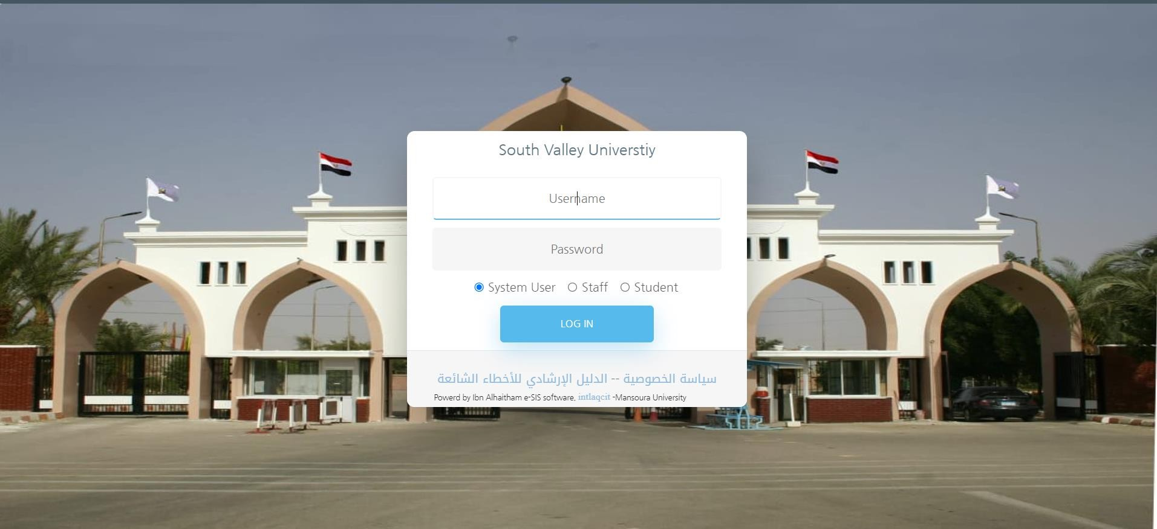

*Figure 2.2 website interface*

1. Cairo university: Cairo University had made an online university system to help students in different ways such as studies, deals with faculty etc.

July 1, 2024

And this website is made by html, CSS, JavaScript, and database.



*Figure 2.2 website interface*



*Figure 2.3 website interface*

#### New features in our system:

Here are some new features that could enhance the functionality of your Student Management System:

1. **Online Enrollment and Registration**

Allow students to enroll in courses and register for semesters online.

**Features:**

14

July 1, 2024

* + **Course Catalog:** Display available courses with detailed descriptions and prerequisites.
  + **Enrollment:** Enable students to enroll in courses online, with real-time availability and conflict checking.
  + **Registration Confirmation:** Provide instant confirmation and summaries of enrolled courses.

1. **Mobile App Integration**

Develop a mobile application to provide students, teachers, and staff with access to the system on the go.

**Features:**

* + **Notifications:** Send push notifications for important updates, deadlines, and announcements.
  + **Mobile Timetable:** Allow students to view their timetable on their mobile devices.
  + **Mobile Grades:** Enable students to check their grades through the app.

1. **Attendance Management**

Track and manage student attendance for each class.

**Features**:

* + **Attendance Records:** Allow teachers to mark attendance directly in the system.
  + **Attendance Reports:** Generate attendance reports for students and classes.
  + **Automated Alerts:** Send alerts to students and parents when attendance falls below a certain threshold.

15

July 1, 2024

1. **Learning Management System (LMS) Integration**

Integrate with popular LMS platforms (e.g., Moodle, Canvas) to streamline course management and content delivery.

**Features:**

* + **Content Delivery:** Provide access to course materials, assignments, and resources.
  + **Online Assessments:** Enable online quizzes and exams with automatic grading.
  + **Discussion Forums:** Facilitate online discussions and collaborations among students.

1. **Parent Portal**

Create a portal for parents to monitor their child's academic progress and stay informed.

**Features:**

* + **Access to Grades:** Allow parents to view their child's grades and progress reports.
  + **Communication:** Enable direct communication between parents and teachers.
  + **Attendance Tracking:** Provide parents with access to their child's attendance records.

1. **Academic Advising and Counseling**

Provide tools for academic advising and counseling to help students with their educational and career goals.

**Features:**

16

July 1, 2024

* + **Advising Appointments:** Allow students to schedule appointments with academic advisors.
  + **Progress Tracking:** Track student progress towards degree requirements.
  + **Career Counseling:** Provide resources and tools for career planning and internships.

1. **Alumni Management**

Manage and engage with alumni to build a strong university community.

**Features:**

* + **Alumni Directory:** Maintain a directory of alumni with their contact information and career details.
  + **Networking Events:** Organize events and reunions for alumni networking.
  + **Donations and Fundraising:** Facilitate donations and fundraising campaigns targeting alumni.

1. **Scholarship and Financial Aid Management**

Manage scholarship and financial aid applications and awards.

**Features:**

* + **Application Portal:** Allow students to apply for scholarships and financial aid online.
  + **Eligibility Tracking:** Track student eligibility and status for various scholarships and aid.
  + **Award Notifications:** Notify students of award decisions and disbursement schedules.

17

July 1, 2024

1. **Enhanced Reporting and Analytics**

Provide advanced reporting and analytics tools for data-driven decision-making.

**Features:**

* + **Custom Reports:** Allow users to create and customize reports based on various parameters.
  + **Data Visualization:** Use charts, graphs, and dashboards to visualize data trends.
  + **Predictive Analytics:** Implement predictive analytics to forecast enrollment trends, academic performance, and other key metrics.

1. **Feedback and Surveys**

Description: Collect feedback and conduct surveys to improve the educational experience.

**Features**:

* + **Course Evaluations:** Allow students to provide feedback on courses and instructors.
  + **Surveys:** Conduct surveys on various topics to gather insights from students, faculty, and staff.
  + **Feedback Reports:** Generate reports based on survey results to inform decision-making.

1. **Digital Certificates and Transcripts**

Provide digital certificates and transcripts for students.

**Features:**

* + **E-Transcripts:** Enable students to request and receive digital transcripts.

18

July 1, 2024

* + Digital Certificates: Issue digital certificates for course completions and achievements.

19

* + **Verification:** Allow third parties to verify the authenticity of digital certificates and transcripts.

These new features will enhance the overall functionality of your Student Management System, providing greater value to students, faculty, staff, and other stakeholders.

July 1, 2024

20

# Chapter 3:

##### Domain Analysis and Technique

July 1, 2024

21

Domain analysis is a crucial step in the development of the EduWay Student Management System, as it involves understanding the domain in which the system will operate, identifying the key concepts, processes, and requirements, and ensuring that the system is aligned with the needs of its users. This section provides an in-depth analysis of the domain, focusing on the specific requirements and constraints of the South Valley University (SVU).

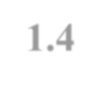

**5. Domain Analysis and Technique**

* 1. **Domain Analysis**

**purpose of the Domain Analysis**

The primary purpose of the domain analysis for EduWay is to:

* **Understand the Context:** Gain a thorough understanding of the educational environment at SVU, including its structure, workflows, and user interactions.
* **Identify Key Stakeholders**: Determine the key stakeholders, including students, faculty, administrative staff, and other personnel involved in the student management process.
* **Define Requirements:** Elicit and document the functional and non-functional requirements of the system based on the needs of these stakeholders.
* **Establish System Boundaries:** Clearly define the boundaries of the EduWay system, identifying what is within the scope of the project and what is not.
* **Ensure Alignment:** Ensure that the system's features and capabilities are aligned with the goals and objectives of SVU.



**1.5 Risk/Constraints**

|  |  |  |  |
| --- | --- | --- | --- |
| Risks | Effects | Priority | strategy |
| Academic risks: refer to the students’ possibility of failing | If that happens to many students in a university, its | High | educators and administrators must implement student |

July 1, 2024

22

|  |  |  |  |
| --- | --- | --- | --- |
| some of their classes and lectures. | education quality can diminish |  | assistance programs or peer tutoring programs |
| Financial risks: these risks are attached to financial problems like funding | Every financial asset, and funding can go to waste potentially if the university’s administration doesn’t manage finances well  enough | Moderate | create a business plan or budget |
| Operational Risks: operational risks are hazards or dangers that can occur during  classes, lectures | Can cause physical damage for a person or a device | High | the university’s administrator check devices before the semester begins. |
| Strategic risks :refer to a university’s business decisions in gathering advantageous elements from a business standpoint, such as  marketing | Some of business decisions &strategies might not pay off for a university | High | University hires data analytics |

July 1, 2024

23

|  |  |  |  |
| --- | --- | --- | --- |
| Reputational Risks: Universities pride themselves for educating and nurturing young minds | their reputation will be tested due to issues and problems concerning their educational  system | High | maintaining proper standards in operations |
| Insurance Risks r refer to the minimal power of insurances to cover the damages caused by certain incidents during on-campus activities and  operations | It can affect badly on employees with low salary | Low | university stakeholders and administrators must still manage insurance risks to regulate losses. |
| Enrolment Supply Risks One of the most occurrences is a depletion of a number of enrolees each  semester | The university will suffer losses instead of profit subsequently | High | The enrolment procedure can be happened automatically. |

Table 3.2 risk

July 1, 2024



**1.6 Project Plan**

24

|  |  |  |  |  |  |  |  |  |  |
| --- | --- | --- | --- | --- | --- | --- | --- | --- | --- |
| **phase** | **Oct** | **Nov** | **Dec** | **Jan** | **Feb** | **Mar** | **Apr** | **May** | **Jun** |
| **project specification** |  | |  | | | | | | |
| **Design** | |  | |  | | | | | |
| **proposal writing** | | |  | |  | | | | |
| **Implementation** | | | | |  | | |  | |
| **Testing** | | | | | | |  | |  |
| **Evaluation** | | | | | | | | |  |

*Figure 3.3 project plan*

July 1, 2024

25

|  |  |
| --- | --- |
| **Phase** | **Activity** |
| **project specification** | * Searching for idea * Searching for similar previous project * What is the benefits resulting from this project |
| **Design** | * Project Design (overview, ER Diagram, use case, seq…) * Prepare 1st version for project documentation |
| **Proposal**  **writing** | * Dividing the work on the member of the team * Processing the proposal |
| **Implementa- tion** | * Implement project frontend * Implement project backend * Analysis data set |
| **Testing**  **Evaluation** | * Testing website * Final testing |
| * Evaluation project * Final documentation and Discussion |

Table 3.3 phases

The Quality Assurance Plan (QAP) for our Student Management System(EduWay) at South Valley University aims to ensure that the project meets its requirements and functions correctly and efficiently. The QAP will focus on the following key areas:



**1.7 Quality Assurance Plan**

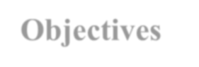

* + 1. **Objectives**
* **Ensure System Functionality:** Verify that all features work as intended.

July 1, 2024

* **Enhance User Experience:** Ensure the system is user-friendly and accessible to all intended users.

26

* **Maintain Data Integrity:** Ensure the accuracy and consistency of data throughout the system.
* **Performance Optimization:** Ensure the system performs efficiently under expected load conditions.



**1.7.2** **Standards and Procedures**

* **Coding Standards:** Adhere to .NET and MSSQLServer coding standards for maintainable and scalable code.
* **Documentation Standards**: Maintain comprehensive and clear documentation for all aspects of the project.
* **Version Control:** Utilize Git for version control to manage code changes and collaborate effectively.



**1.7.3 Testing Strategy**

* **Manual Testing:** Test individual components and functions of the system to ensure they work correctly in isolation.
* **Integration Testing:** Test combined parts of the system to ensure they work together as expected.
* **System Testing:** Test the complete system to ensure it meets the specified requirements.
* **User Acceptance Testing (UAT):** Involve actual users to validate that the system meets their needs and expectations.
* **Performance Testing:** Assess the system's performance under various conditions to ensure it can handle peak usage times.

The feasibility study evaluates the practicality and potential success of the Student Management System project at South Valley University. This study covers several key areas:



**1.8 Feasibility Study**



**1.8.1 Technical Feasibility**

* **Technology Stack:** The system will be developed using .NET and MSSQLSERVER, which are robust and widely used for web applications.

July 1, 2024

* **Infrastructure:** The university's existing IT infrastructure can support the new system with minimal upgrades.
* **Integration:** The system will integrate with existing databases and tools currently in use at the university.



**1.8.2** **Operational Feasibility**

* **User Training:** Adequate training will be provided to all users, including administrators, teachers, and students.
* **Support:** Ongoing technical support will be available to address any issues that arise post-implementation.
* **User Adoption:** Surveys and feedback indicate a high level of interest and readiness among users to adopt the new system.



**1.8.3** **Schedule Feasibility**

* **Project Timeline:** A detailed project plan has been developed, outlining all phases from initiation to deployment.

The expected outputs of the Student Management System project are as follows:

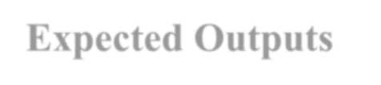

**1.9 Expected Outputs**

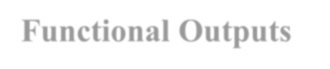

**1.9.1 Functional Outputs**

* **Administration Management:** Comprehensive management of faculties, courses, students, staff, and control members.
* **Student Services:** Access to timetables, tuition fee information, exam schedules, course grades, portfolios, and progress tracking.
* **Teacher and TA Services:** Tools for managing courses, submitting grades, and keeping daily notes.
* **Control Member Services:** Oversight of course management and final grade submissions, with the ability to extract detailed reports.

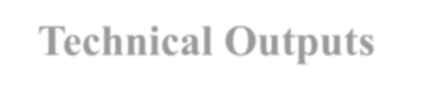

**1.9.2** **Technical Outputs**

* **Stable and Secure System**: A reliable and secure web-based application that ensures data privacy and integrity.
* **Responsive Design:** A user interface that is responsive and accessible across various devices, including desktops, tablets, and smartphones.

27

July 1, 2024

* **Scalability:** The system is designed to scale with the growing number of users and data over time.

28

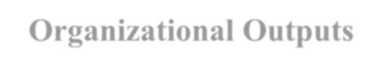

**1.9.3** **Organizational Outputs**

* **Increased Efficiency:** Streamlined administrative processes, reducing the time and effort required for managing student and faculty data.
* **Improved Accuracy:** Enhanced accuracy in data handling and reporting, minimizing errors.
* **Enhanced Communication:** Better communication and information flow between students, faculty, and administration.

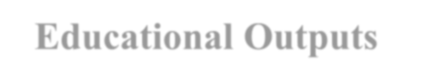

**1.9.4** **Educational Outputs**

* **Student Performance Tracking:** Improved ability to track and analyze student performance and progress over time.
* **Enhanced Learning Experience:** Access to timely and relevant information that supports students' academic journey and helps them make

informed decisions.

July 1, 2024

29

# Chapter 4:

##### Software Requirements Specification

July 1, 2024

30

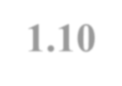

**6. Software Requirements Specification**

**1.10 Introduction**

**Tazkartak** is a project aimed at developing a comprehensive platform for booking local bus tickets, offering a seamless and reliable user experience. The platform features a unique capability that allows users to refund the ticket value in the event of a cancellation, provided that the ticket is subsequently booked by another user, thereby enhancing user trust in transportation services. The project targets all segments of society, from students to tourists, and provides a variety of options from local bus companies. With a vision for future expansion through the integration of new technologies, **Tazkartak** seeks to improve public transportation services and facilitate travel experiences for citizens.



**1.10.1**



**Purpose**

This document aims to define the functional and non-functional requirements for an online bus ticket reservation system. The system is designed to enable users to easily book tickets for any local bus company while introducing an innovative feature that allows users to receive a refund upon cancellation of their reservation by reassigning the ticket to another person.



**1.10.2**



**Project Scope**

The system covers all bus companies operating within the country and facilitates users in booking tickets, selecting trip schedules, and choosing their preferred company. Additionally, the system provides a ticket resale feature for canceled bookings, enabling users to recover the full amount paid if the ticket is sold to another user.

July 1, 2024

This section provides an overall description of **Tazkartak**, including its key features, user classes, and the operating environment in which it will function.



**1.11 Overall Description**



**1.11.1**



**Product Features**

**Tazkartak** offers a comprehensive set of features designed to book local bus tickets . Key product features include:

##### Administration

**Personal Data Management:** Administrators can manage their personal information, contact details, and payment data.

* + **Manage Companies:**
    - Add Company
    - Delete Company
    - Edit Company Trips

July 1, 2024

* + **Manage Users:**
    - Show , delete and edit users information.
  + **Extraction Reports:**
    - Generate various reports as needed.
  + **Manage Permissions:**
    - Assign and manage user permissions and roles.

##### Users

32

July 1, 2024

* + **Personal Data Management**: Users can manage their personal information, contact details, and payment data.
  + **Trips:** SearchView Available Trips.
  + **Tickets:** Choose seats , payment , book , cancel ,View and their Tickets.

##### Companies

* + **Personal Data Management:** Company can manage their personal information, contact details, and payment data.
  + **Trip Management:** View and manage trips.
  + **Booked Tickets :**View and manage Booked Tickets

July 1, 2024

Tazkartak is built using .NET Core 8, Entity Framework Core, SQL Server, React JS for the front end, and is hosted on Monster ASP.NET for API services.



**1.11.2**



**User Classes and Characteristics**

Tazkartak caters to various user classes, each with distinct characteristics and requirements:

##### Users:

* + Use the system for book a Ticket, view all trips by search, pay for his ticket and cancel booking.
  + Require a user-friendly interface and access to mobile applications.

##### Companies:

* + Manage Trips information and booked tickets.
  + Need tools for efficient communication with users and companies.

##### Administrators:

* + Oversee user management, system maintenance, and data integrity.
  + Require comprehensive access to all system functionalities and reporting tools.

July 1, 2024

34



**1.11.3**



**Operating Environment**

* + - 1. Hardware:
         * **Servers**: The Tazkartak system requires one or more servers to host the application, database, and associated services. These servers should be equipped with adequate processing power, memory, and storage capacity to handle concurrent user access and data storage requirements. Given the scale of the system and the anticipated user load, high-performance servers are recommended to ensure seamless operation.
         * **Client Devices**: Tazkartak will be accessible from various client devices, including desktop computers, laptops, tablets, and smartphones. Ensuring compatibility with different operating systems (Windows, macOS, Linux, iOS, Android) and web browsers (Chrome, Firefox, Safari, Edge) is essential to provide broad accessibility and a consistent user experience.
      2. Software:
         * **Operating System**: Operating System: The servers hosting the Tazkartak system can run on operating systems such as Linux, Windows Server, or macOS Server, based on the preferences and expertise of the system administrators.
         * **Web Server:** A web server software like Apache, Nginx, or Microsoft Internet Information Services (IIS) will be used to serve web pages and handle HTTP requests from client devices. This ensures reliable and efficient delivery of web content.
         * **Database Management System (DBMS**): Tazkartak will utilize Microsoft SQL Server (MSSQL) for storing and managing system data, including student records, course information, and user accounts. MSSQL is chosen for its robustness, security features, and seamless integration with the .NET framework.
         * **Application Framework**: The system will be built using the .NET 8 framework, leveraging its comprehensive set of tools and libraries for developing web-based applications efficiently.
         * **Programming Languages:** C# will be the primary programming language used for developing the Tazkartak system, given its compatibility with the

.NET framework and its strong support for building scalable and maintainable applications.

36

July 1, 2024

* + - 1. Network Infrastructure:
         * **Internet Connectivity:** Internet access is crucial for users to connect to Tazkartak from remote locations outside the institution's network. Reliable and high-speed internet connectivity will ensure that the system remains accessible to all users, regardless of their location.
         * **Firewalls and Security Measures:**  
           To safeguard the TAZKARTAK system from unauthorized access, data breaches, and other cyber threats, comprehensive security measures will be deployed. This includes advanced firewalls, intrusion detection/prevention systems (IDPS), encryption technologies, and multi-factor authentication (MFA) to fortify system defenses. Regular security audits and monitoring will also be conducted to identify and address potential vulnerabilities in real-time. These proactive measures will ensure the system’s integrity, protect sensitive user data, and maintain compliance with industry security standards.
      2. Backup and Disaster Recovery:

Regular data backups and a comprehensive disaster recovery plan are critical to mitigate the risk of data loss and ensure the continuity of service. These measures will address potential hardware failures, software glitches, or other unforeseen events that could disrupt the system. Backups will be performed routinely, and recovery procedures will be tested periodically to ensure the system can be restored quickly and effectively in the event of a disaster.



**1.12 System Features**



**1.12.1**



**User Management**

The TAZKARTAK system includes comprehensive user management features, enabling different types of users to access and manage their data effectively. The primary user roles include Administrators, Users, Companies. Each role has specific pages and functionalities tailored to their needs:

* + - 1. Administration:

Personal Data, Contact Data, Prequalification Data Pages

**Roles:**

37

July 1, 2024

* + - * 1. **Manage Companies :**

Add Company

Delete Company

Edit Company

* + - * 1. **Manage Users:**

Show, Add, Delete, Edit User

* + - * 1. **Manage Ads:**

Show, Add, Delete, Edit Courses

* + - 1. Users*:*

Personal Data, Contact Data, Prequalification Data Pages* Roles:

* View Trips of all companies
* View Available Seats in the Chosen Trip
* Show, Edit, Delete, Account
* Booking and selling tickets

July 1, 2024

* + - 1. Companies:

Personal Data, Contact Data, Prequalification Data Pages

**Roles:**

* + - * 1. **Manage Trips:**

Add, Edit and Delete Trip

* + - * 1. **Manage Tickets:**

Specifying Ticket Quantity and Price

July 1, 2024



**1.13 Other Nonfunctional Requirements**



**1.13.1**



**Security Requirements**

Security is a critical aspect of the TAZKARTAK system to ensure the protection of sensitive data and maintain user privacy. The system includes several security measures:

1. **Authentication and Authorization:**
   * Users must authenticate using secure login credentials.
   * Role-based access control ensures users can only access data and functions pertinent to their roles.
2. **Data Encryption:**
   * Sensitive data, such as personal information, are encrypted both in transit and at rest.
3. **Secure Communication:**
   * All data exchanges between client devices and servers use HTTPS to prevent interception and tampering.
4. **Regular Security Audits:**
   * Periodic security assessments and audits are conducted to identify and address vulnerabilities.
5. **Data Integrity:**

40

July 1, 2024

* + Mechanisms to ensure data integrity include checksums and transaction logs to prevent and detect data corruption or unauthorized modifications.

41

1. **User Activity Monitoring**:
   * Monitoring and logging of user activities to detect and respond to suspicious behavior or potential security breaches.
2. **Backup and Disaster Recovery:**
   * Regular backups and disaster recovery plans are in place to ensure data can be restored in case of system failure or data loss.

These security requirements ensure that the TAZKARTAK system remains secure, reliable, and capable of protecting the integrity and confidentiality of user data.

July 1, 2024

42

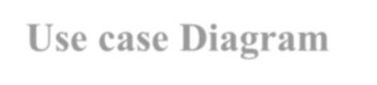

**1.14 Use case Diagram**

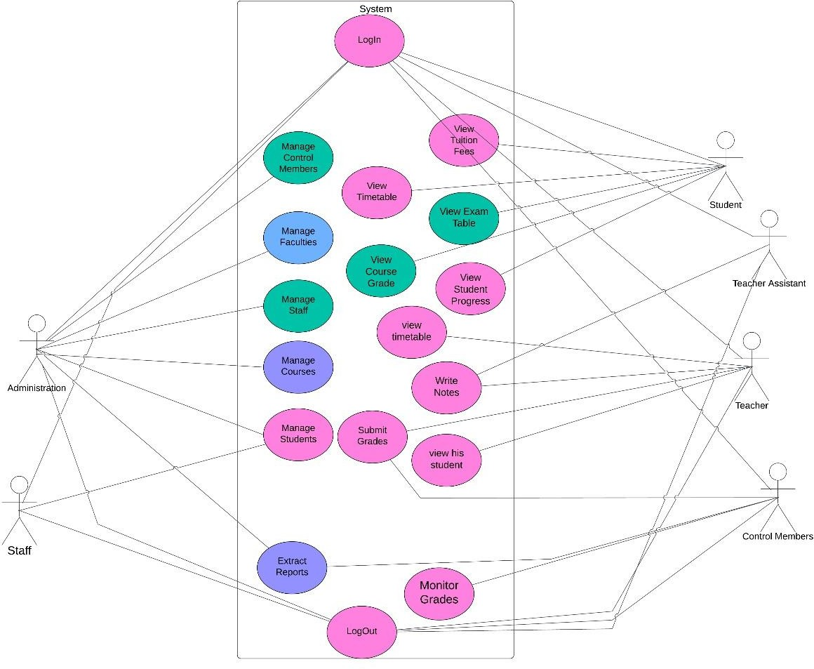

*Figure 4.5 use case Diagram*

July 1, 2024

43

# Chapter 5:

#### Results

July 1, 2024

44

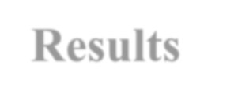

**7. Results**

Login For All Types Of users



**1.15 Login**

* + - Administration
    - Teacher
    - Teacher Assistant
    - Control Members
    - Staff
    - Students

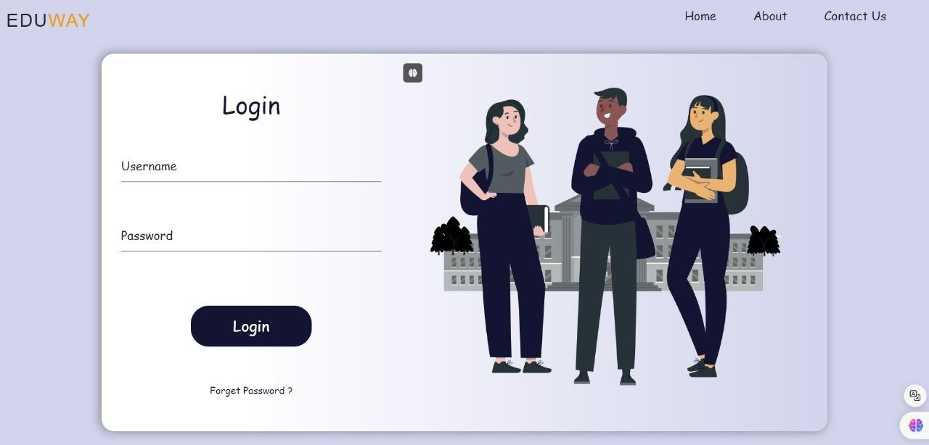

*Figure* 5*.1 Login page*

July 1, 2024

45



**1.16 Administration**

* **Basic information**
  + - * **Personal Data**

Arabic Name, English Name, Gender, Nationality, Religion, Date of Birth, National ID \ Passport No, Release Place, Place of Birth

* + - * **Contact Data**

Address, Postal Code, Email

* + - * **Prequalification Data**

Pre-Qualification, Qualification Year, Degree, Seat Number

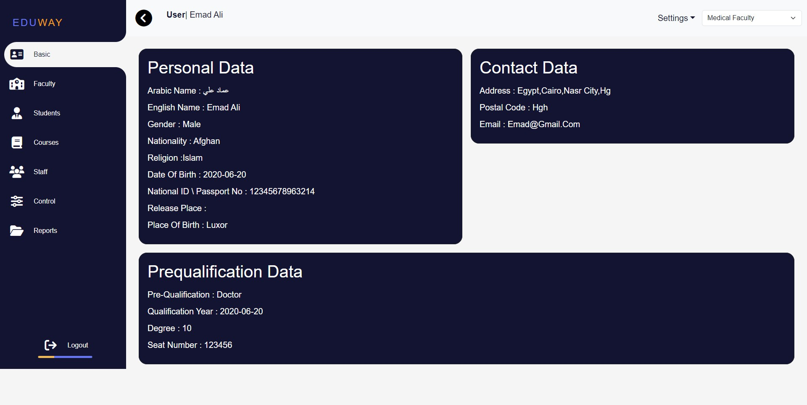

*Figure* 5*.2.1 Basic Information*

July 1, 2024

* **Faculty page:**

46

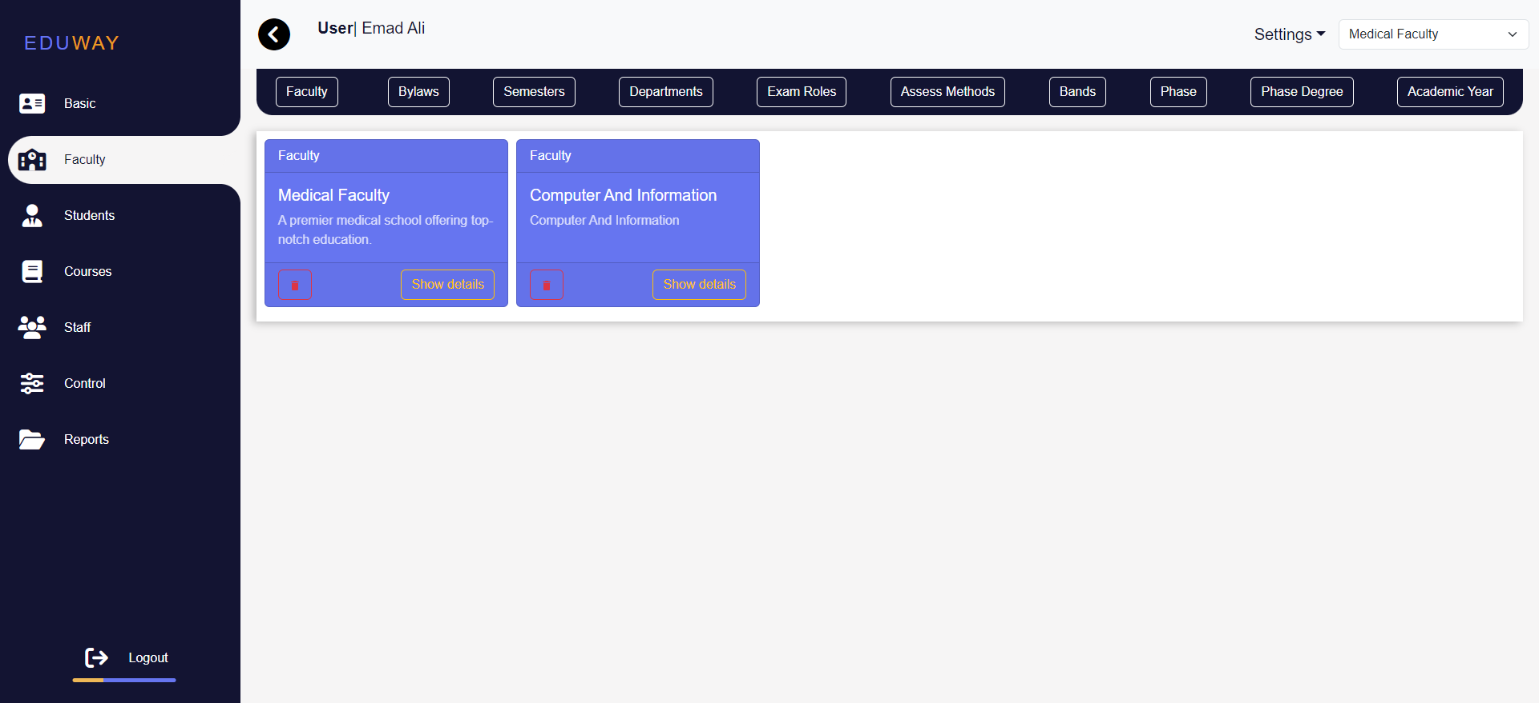

Through this bar you can add

Faculty, Bylaws, Semesters, Semesters, Departments, Exam Roles , Assessment Methods

,Bands, Phase , Phase Degree

Through this button

you can delete faculty

Through this button

you can Show details about the faculty

Through this button

you can Show details about the faculty

Through this

list you can select Faculty

*Figure* 5*.2.2 Faculty*

###### Through this page you can

July 1, 2024

* + Add Faculty

47

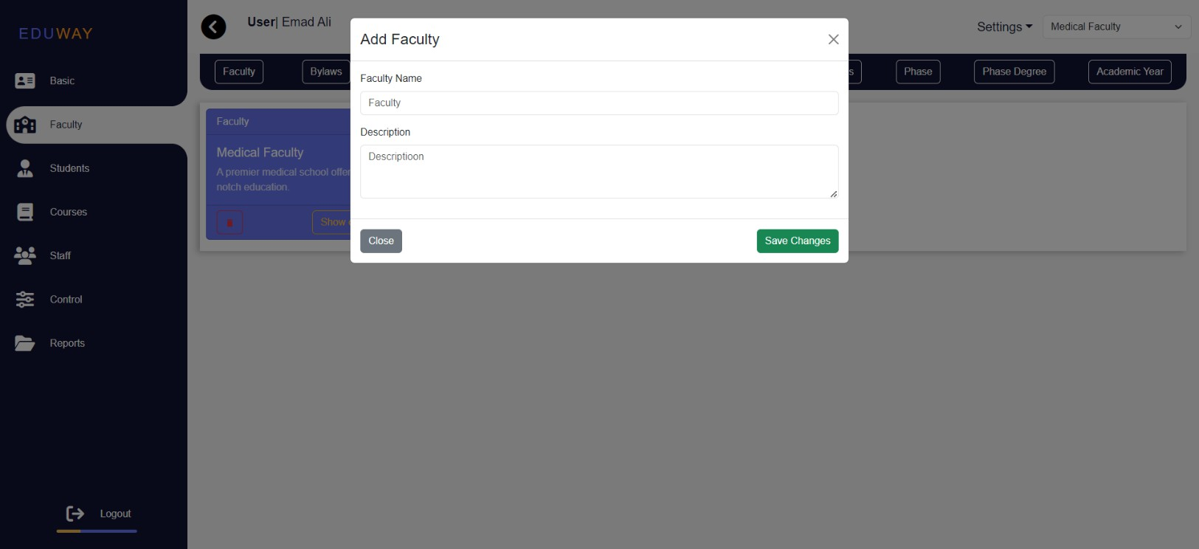

*Figure* 5*.2.3 Faculty*

* + Add Bylaws

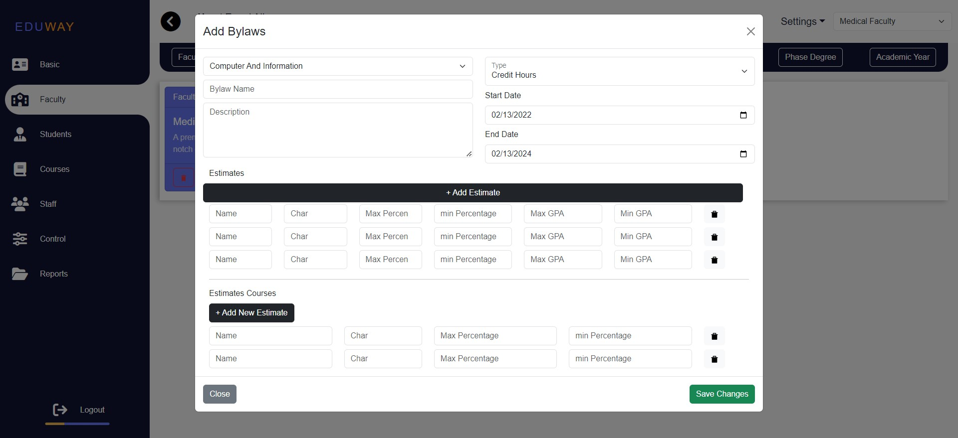

*Figure* 5*.2.*4 *Faculty*

July 1, 2024

48

* + 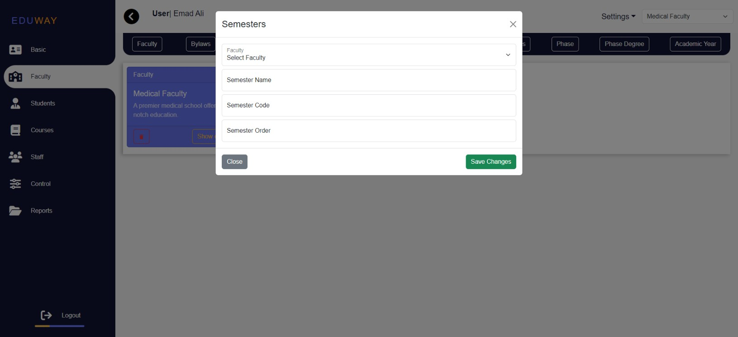Add Semesters

*Figure* 5*.2.*5 *Faculty*

* + Add Departments

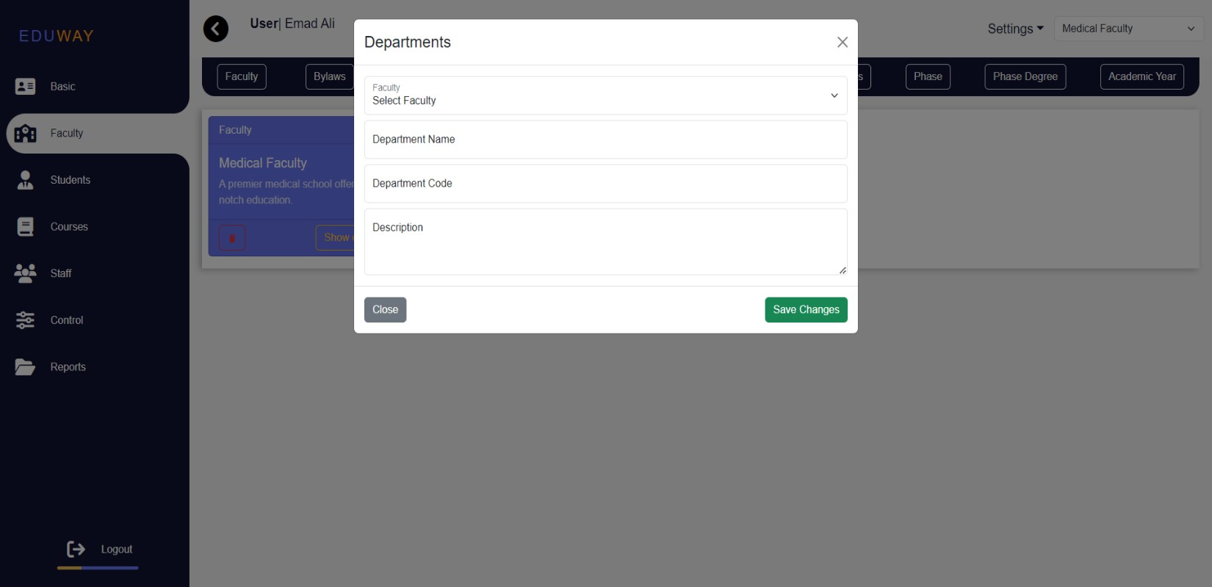

*Figure* 5*.2.*6 *Faculty*

July 1, 2024

* + Add Exam Roles

49

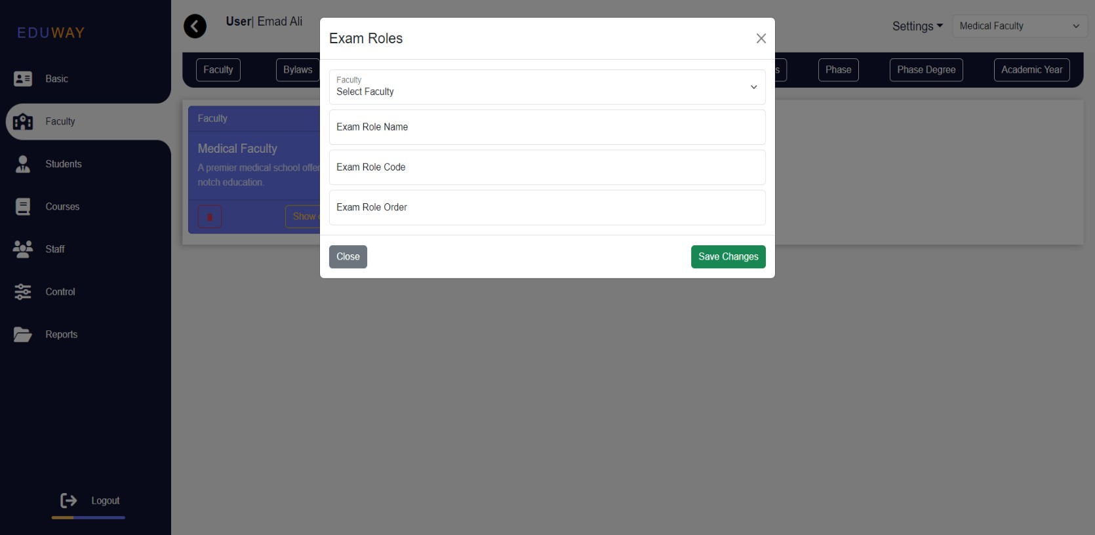

*Figure* 5*.2.7 Faculty*

* + Add Assessment Methods

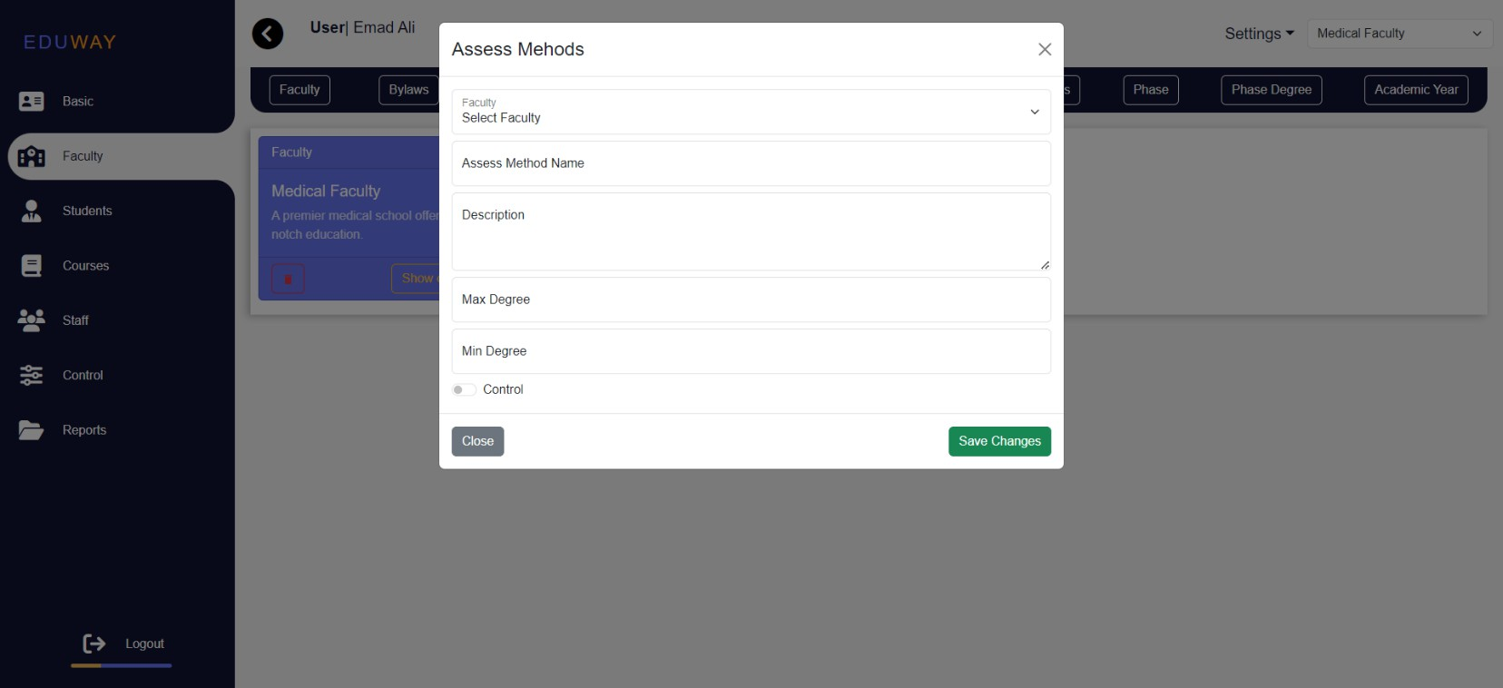

*Figure* 5*.2.8 Faculty*

July 1, 2024

* + Add Bands

50

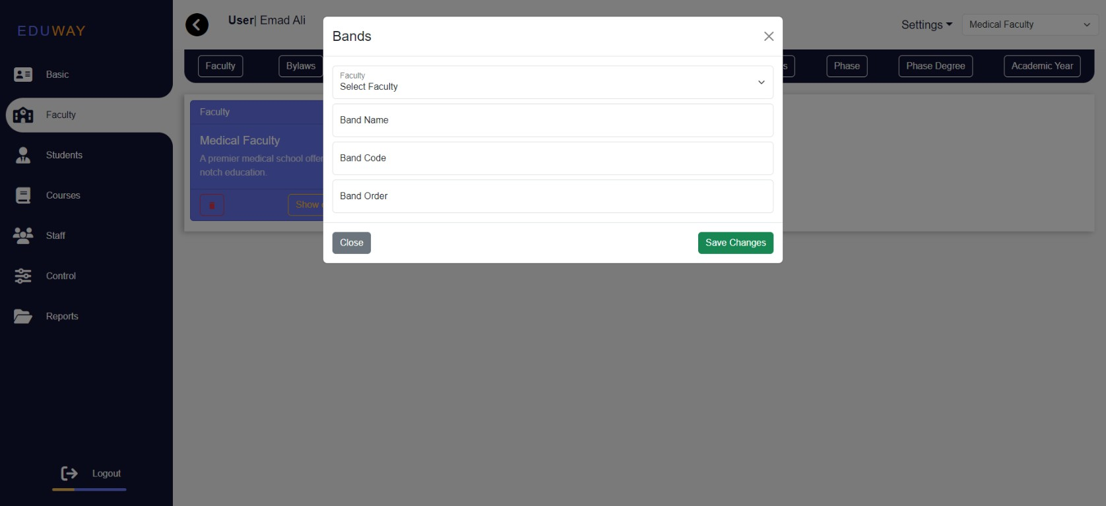

*Figure* 5*.2.9 Faculty*

* + Add Phase

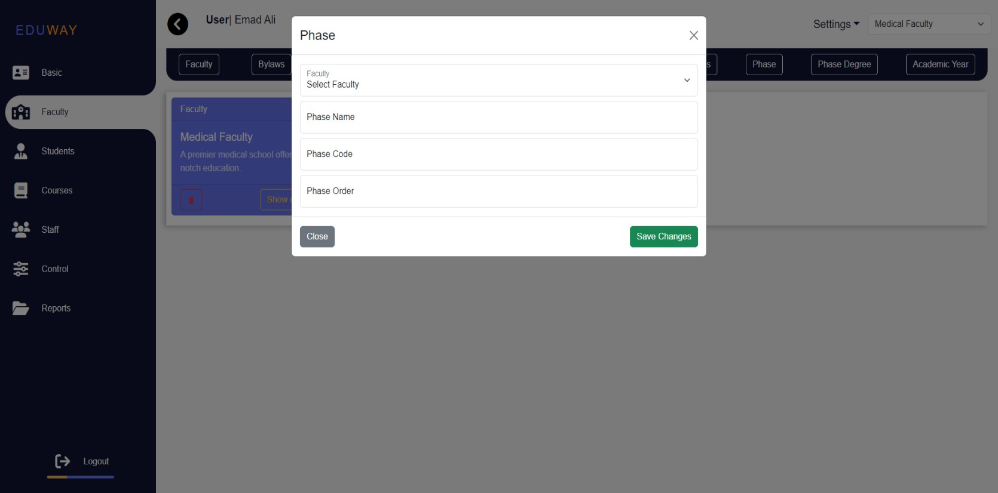

*Figure* 5*.2.10 Faculty*

July 1, 2024

51

* + Add Phase Degree

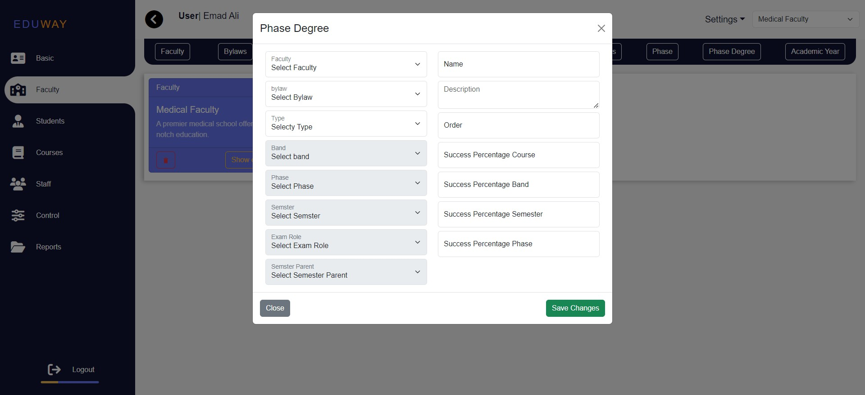

*Figure* 5*.2.11 Faculty*

* + Add Academic Year

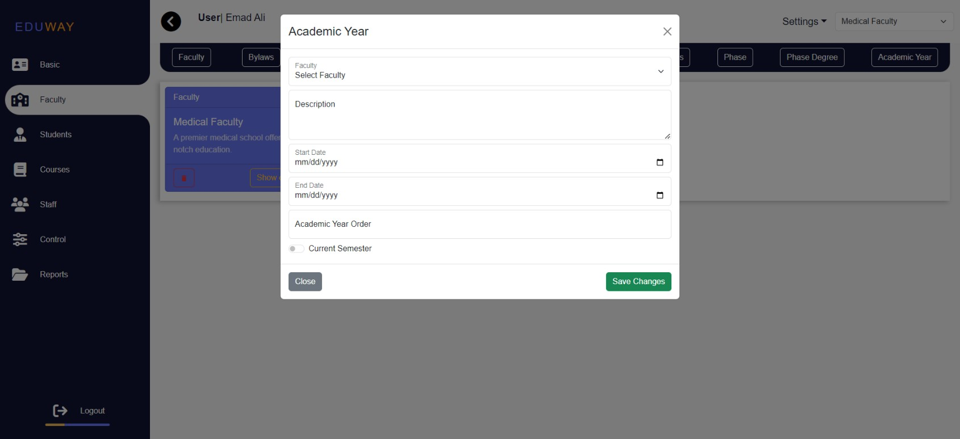

*Figure* 5*.2.12 Faculty*

July 1, 2024

52

* + Show Faculty details
    - View the bylaws for faculty, you can edit and delete

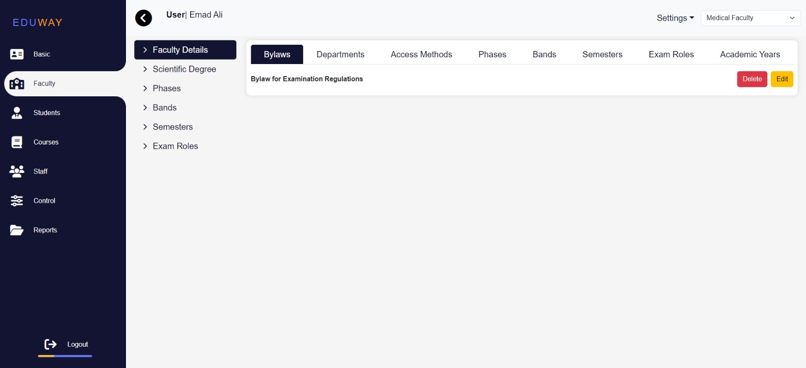

*Figure* 5*.2.13 Faculty*

* + - View the Departments for faculty, you can edit and delete

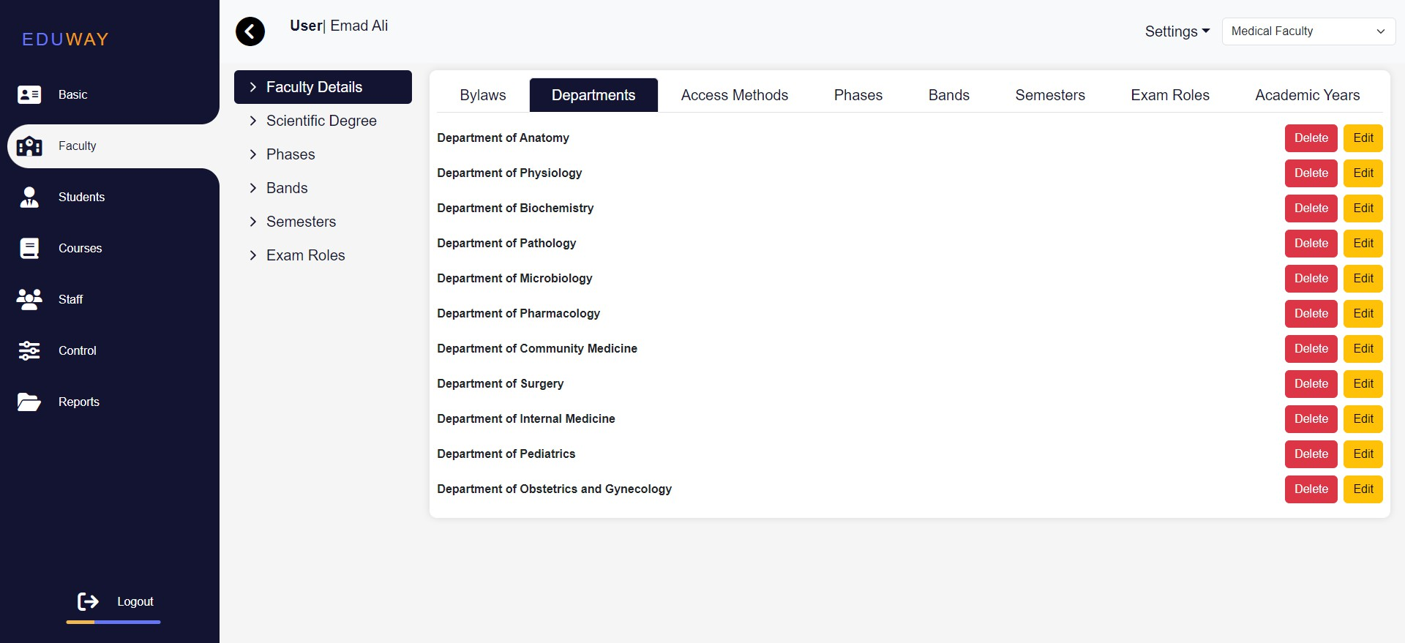

*Figure* 5*.2.14 Faculty*

July 1, 2024

* + - View the Access Methods for faculty, you can edit and delete

53

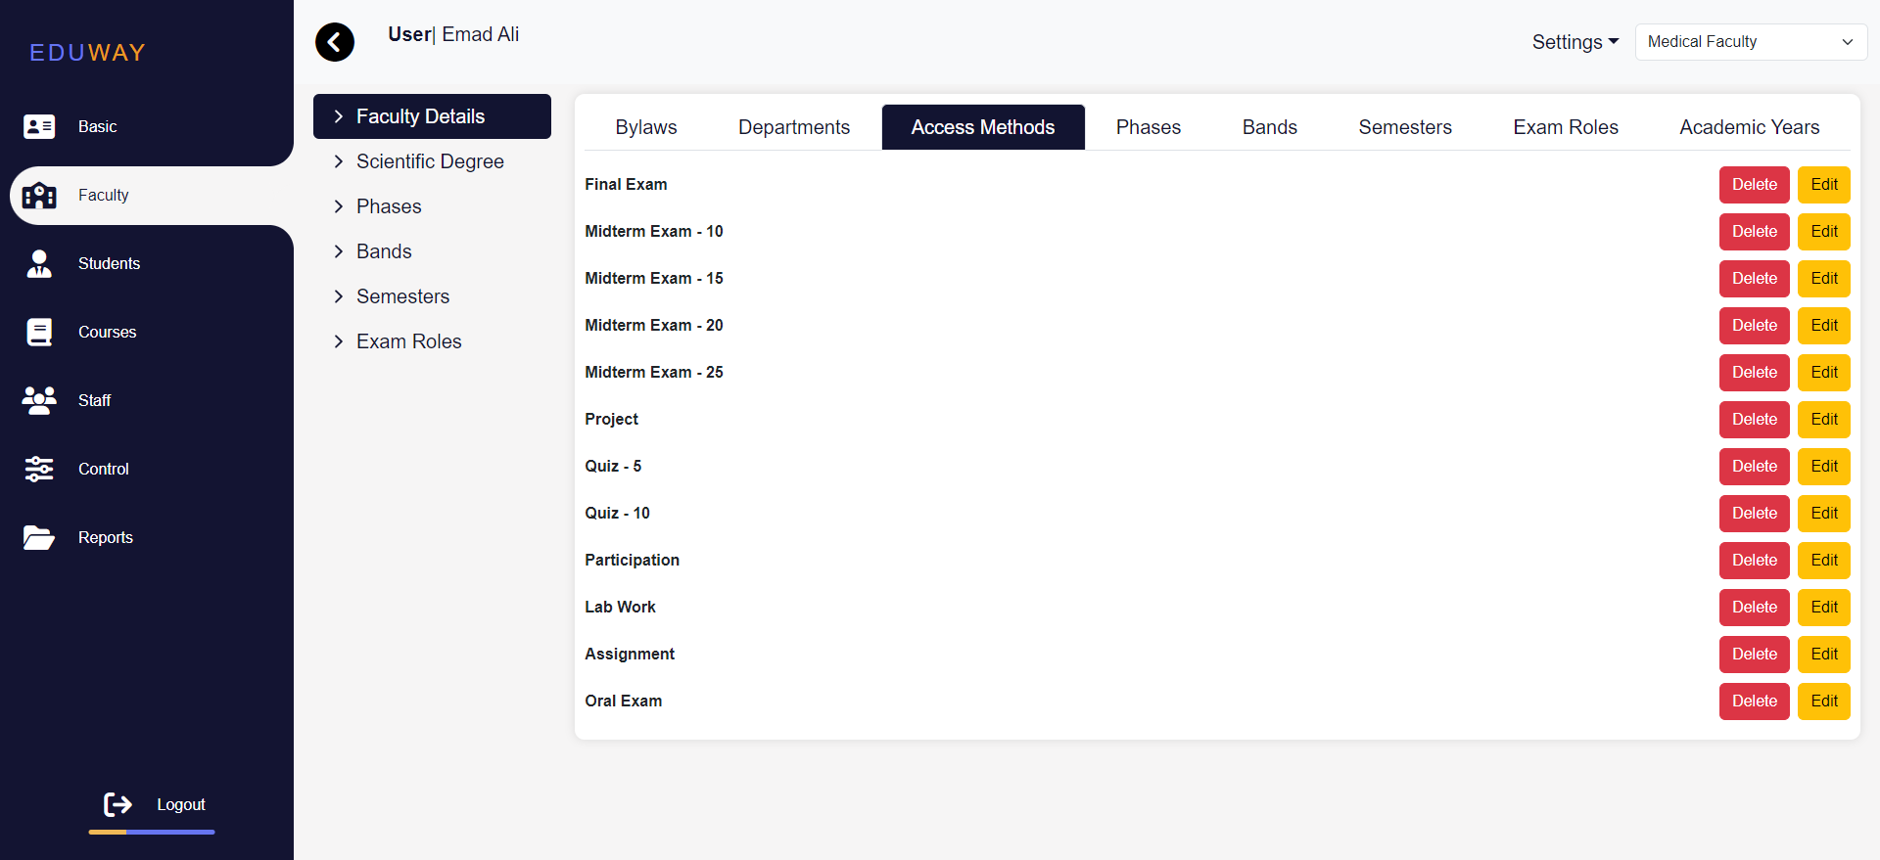

*Figure* 5*.2.15 Faculty*

* + - 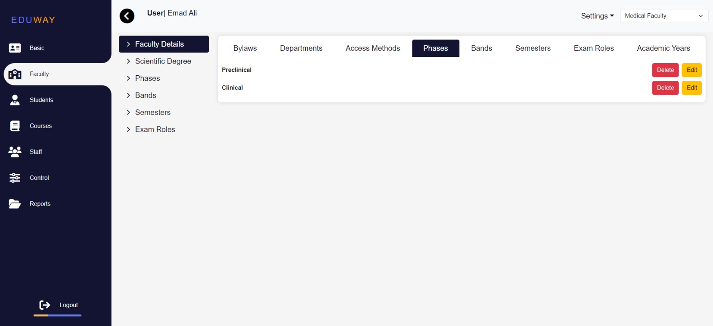View the phases for faculty, you can edit and delete

*Figure* 5*.2.16 Faculty*

July 1, 2024

* + - 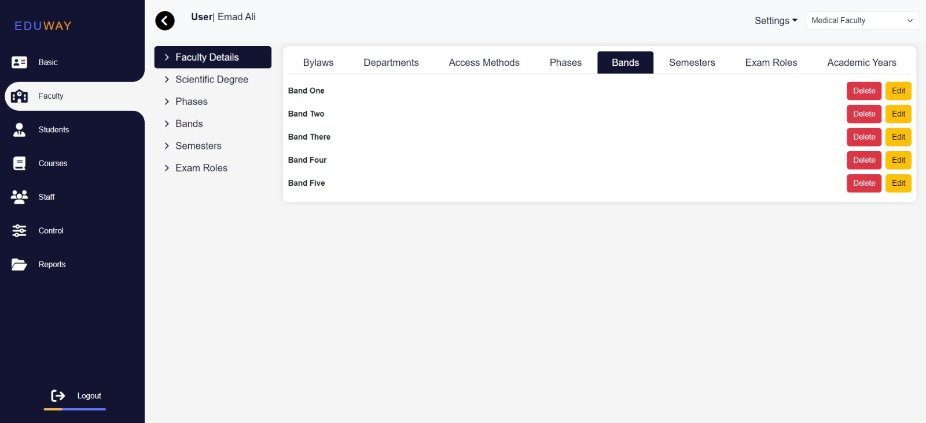View the Bands for faculty, you can edit and delete

54

*Figure* 5*.2.17 Faculty*

* + - View the Semesters for faculty, you can edit and delete

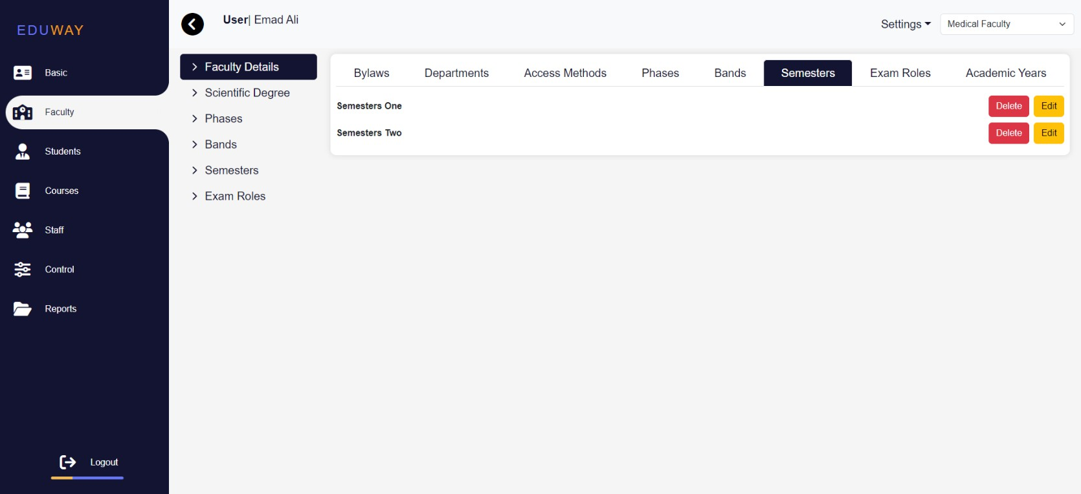

*Figure* 5*.2.18 Faculty*

July 1, 2024

* + - View the Exam Roles for faculty, you can edit and delete

55

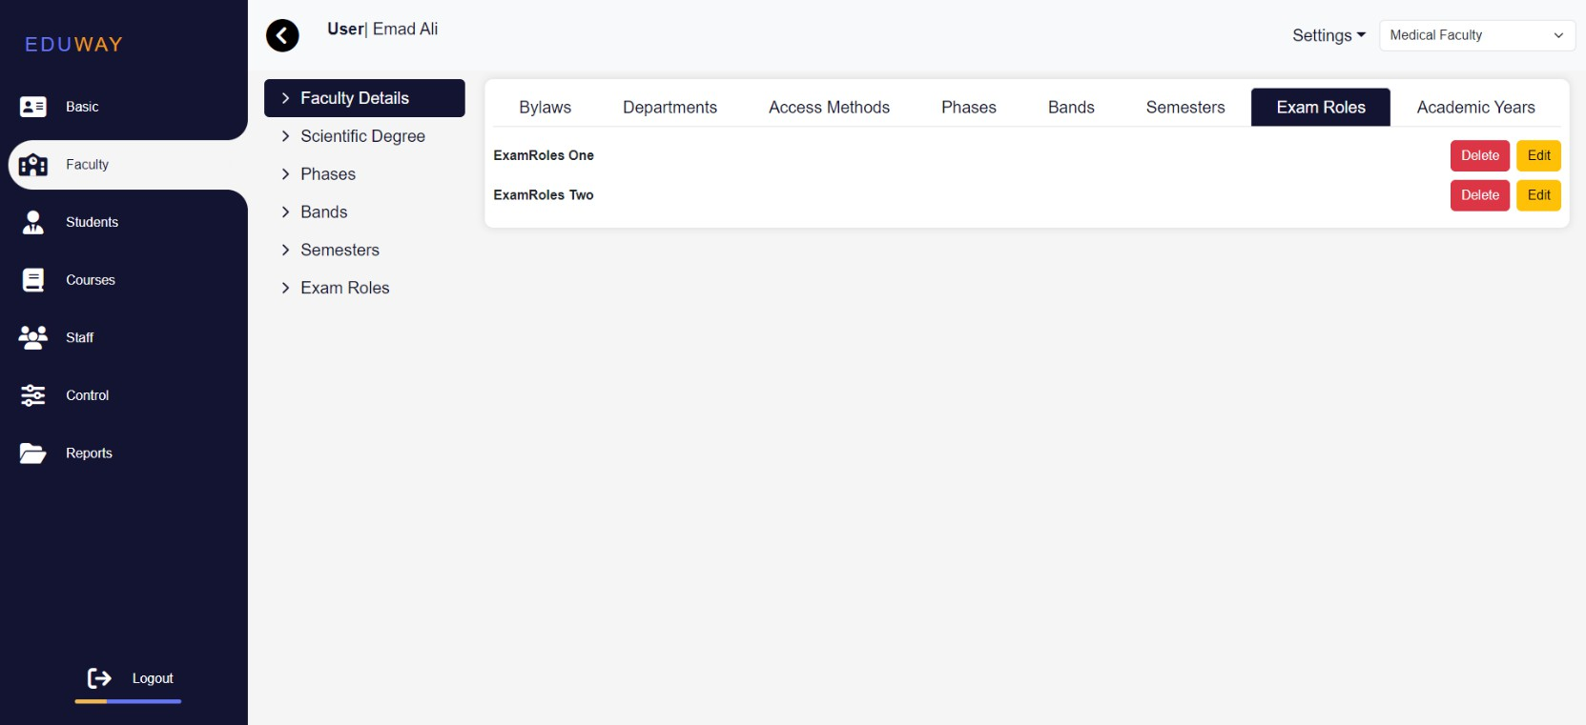

*Figure* 5*.2.18 Faculty*

* + - View the Academic Year for faculty, you can edit and delete

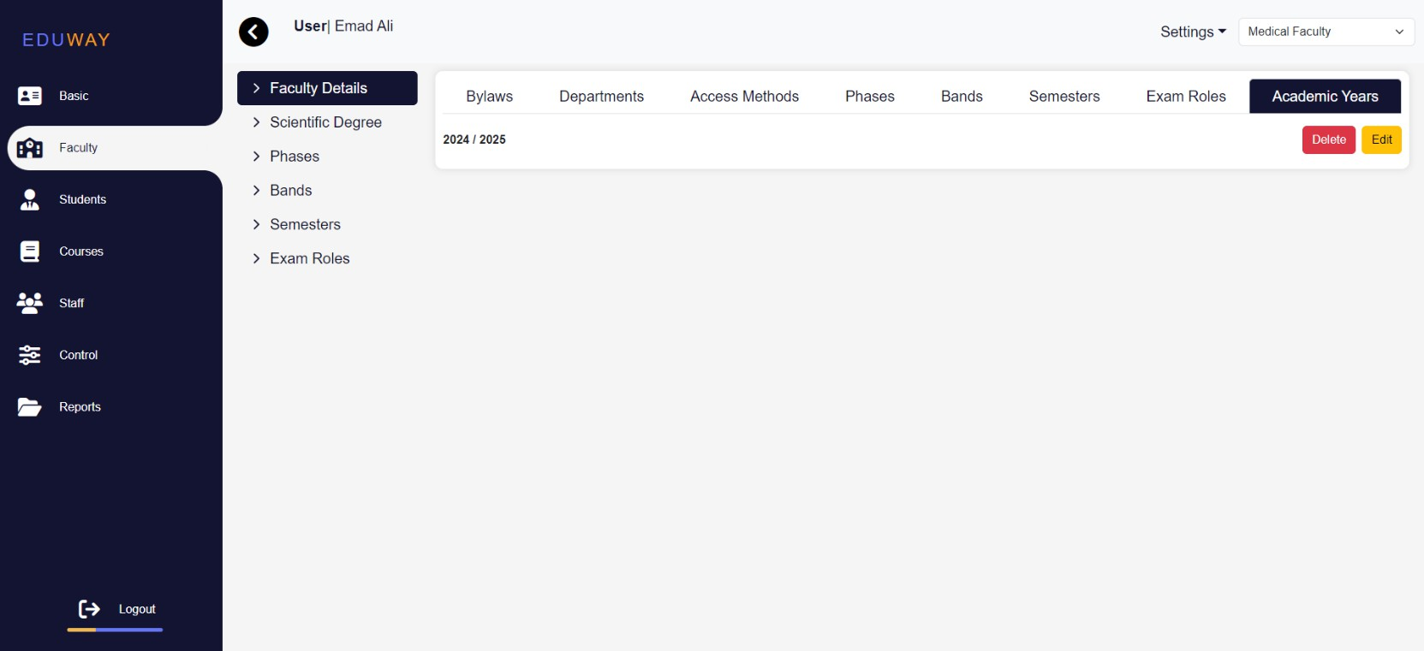

*Figure* 5*.2.19 Faculty*

July 1, 2024

* + Show Scientific degree, you can edit and delete

56

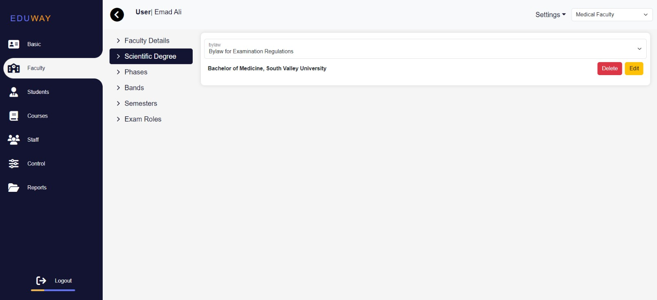

*Figure* 5*.2.20 Faculty*

* + Show Phases, you can edit and delete (The appearance of Phases depends on the Bylaw selection)

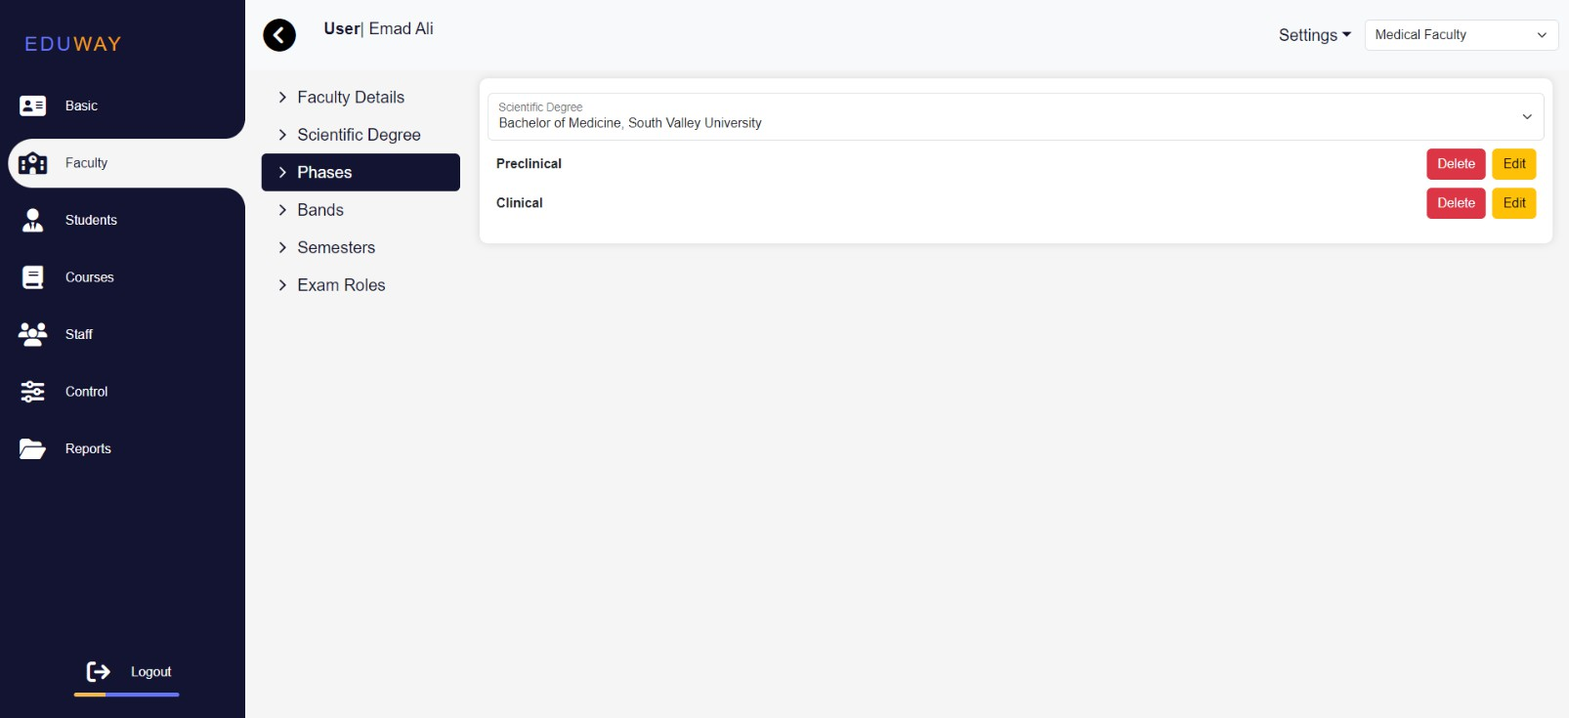

*Figure* 5*.2.21 Faculty*

July 1, 2024

* + Show Bandas, you can edit and delete (The appearance of Bands depends on the Phase selection)

57

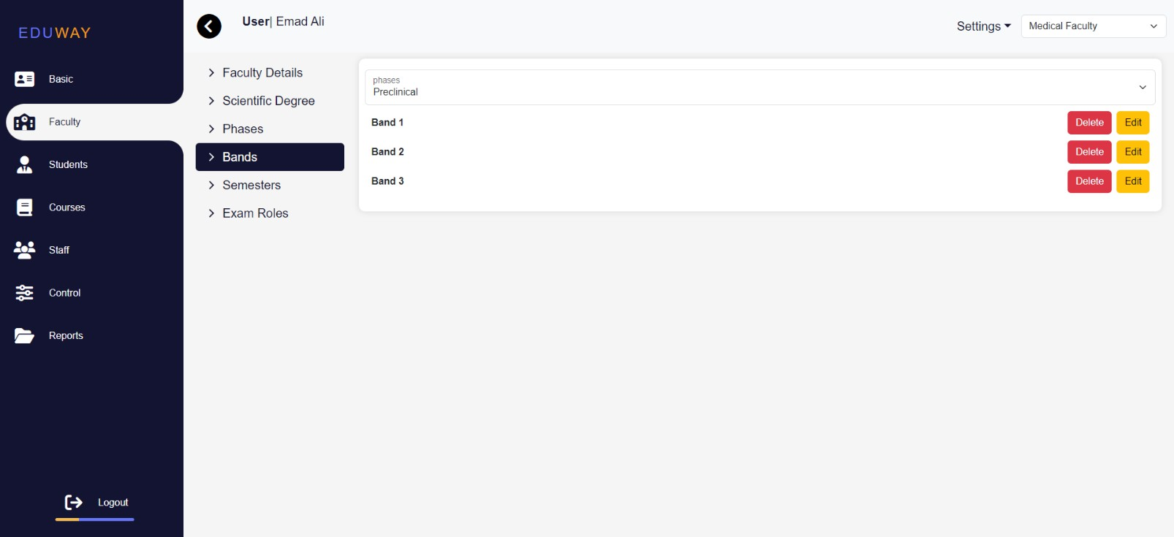

*Figure* 5*.2.22 Faculty*

* + Show semesters , you can edit and delete (The appearance of semesters depends on the Banda selection)

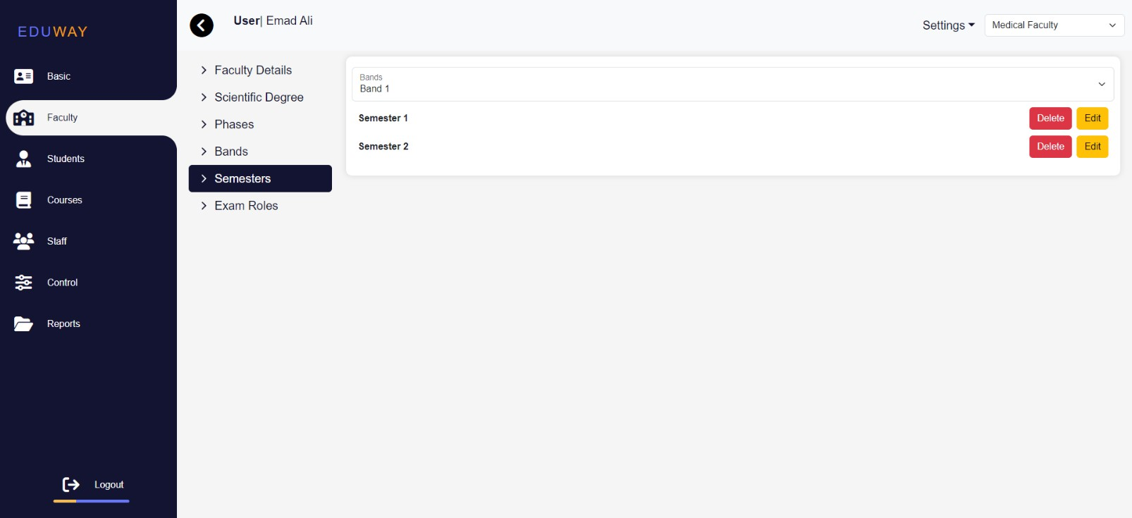

*Figure* 5*.2.23 Faculty*

July 1, 2024

* + Show Exam Rolos, , you can edit and delete (The appearance of exam roles depends on the semester selection)

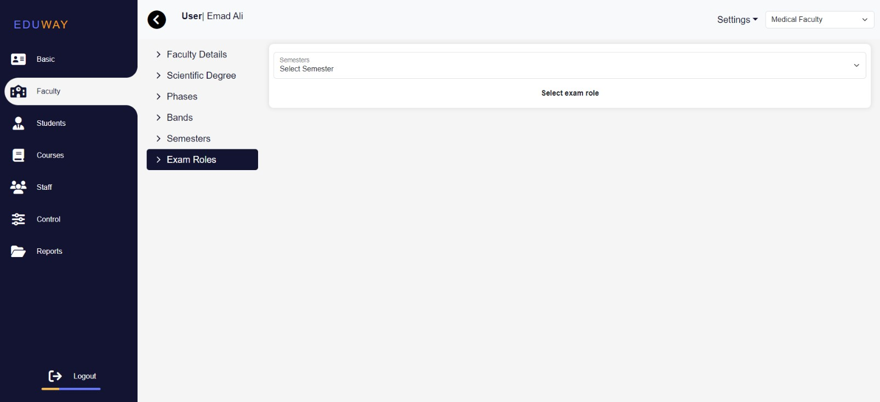

*Figure* 5*.2.24 Faculty*

* + Delete Faculty

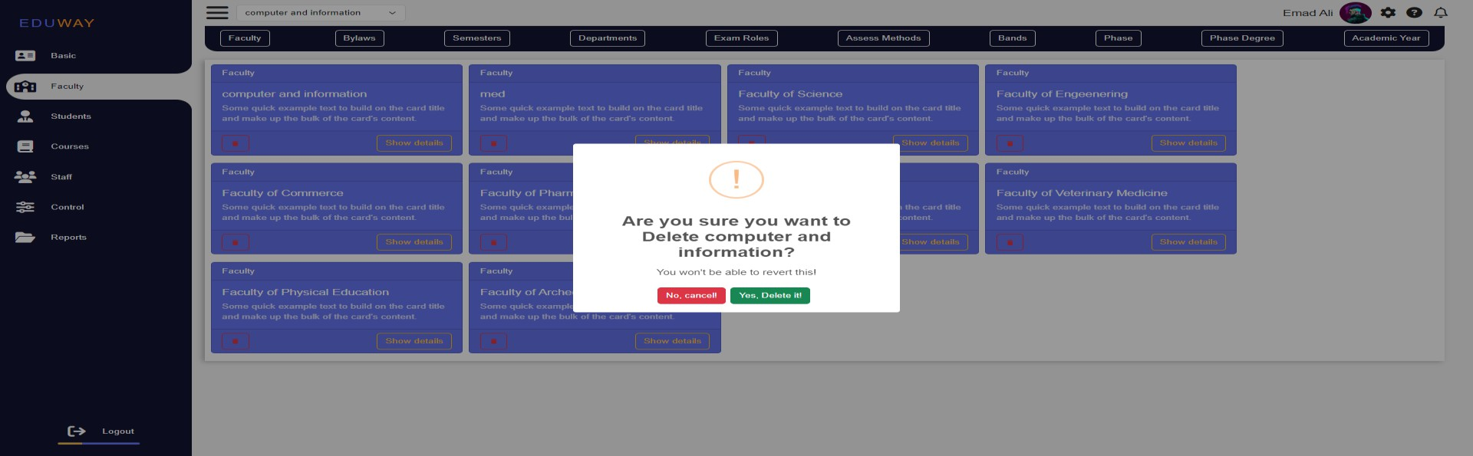

*Figure* 5*.2.25 Faculty*

* **Students Page:**

58

July 1, 2024

* + Show, add, delete, and edit student information.

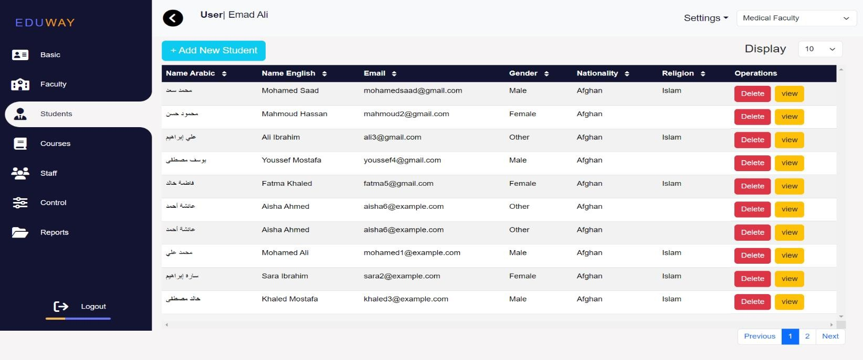

Through this button

you can add a new student

Through this

list you can select Faculty

Through this button

you can delete Student

Through this button

you can Show details about the student

Through this list

you can select Number of students in Page

59

*Figure* 5*.2.26 Student*

* + Add New Student

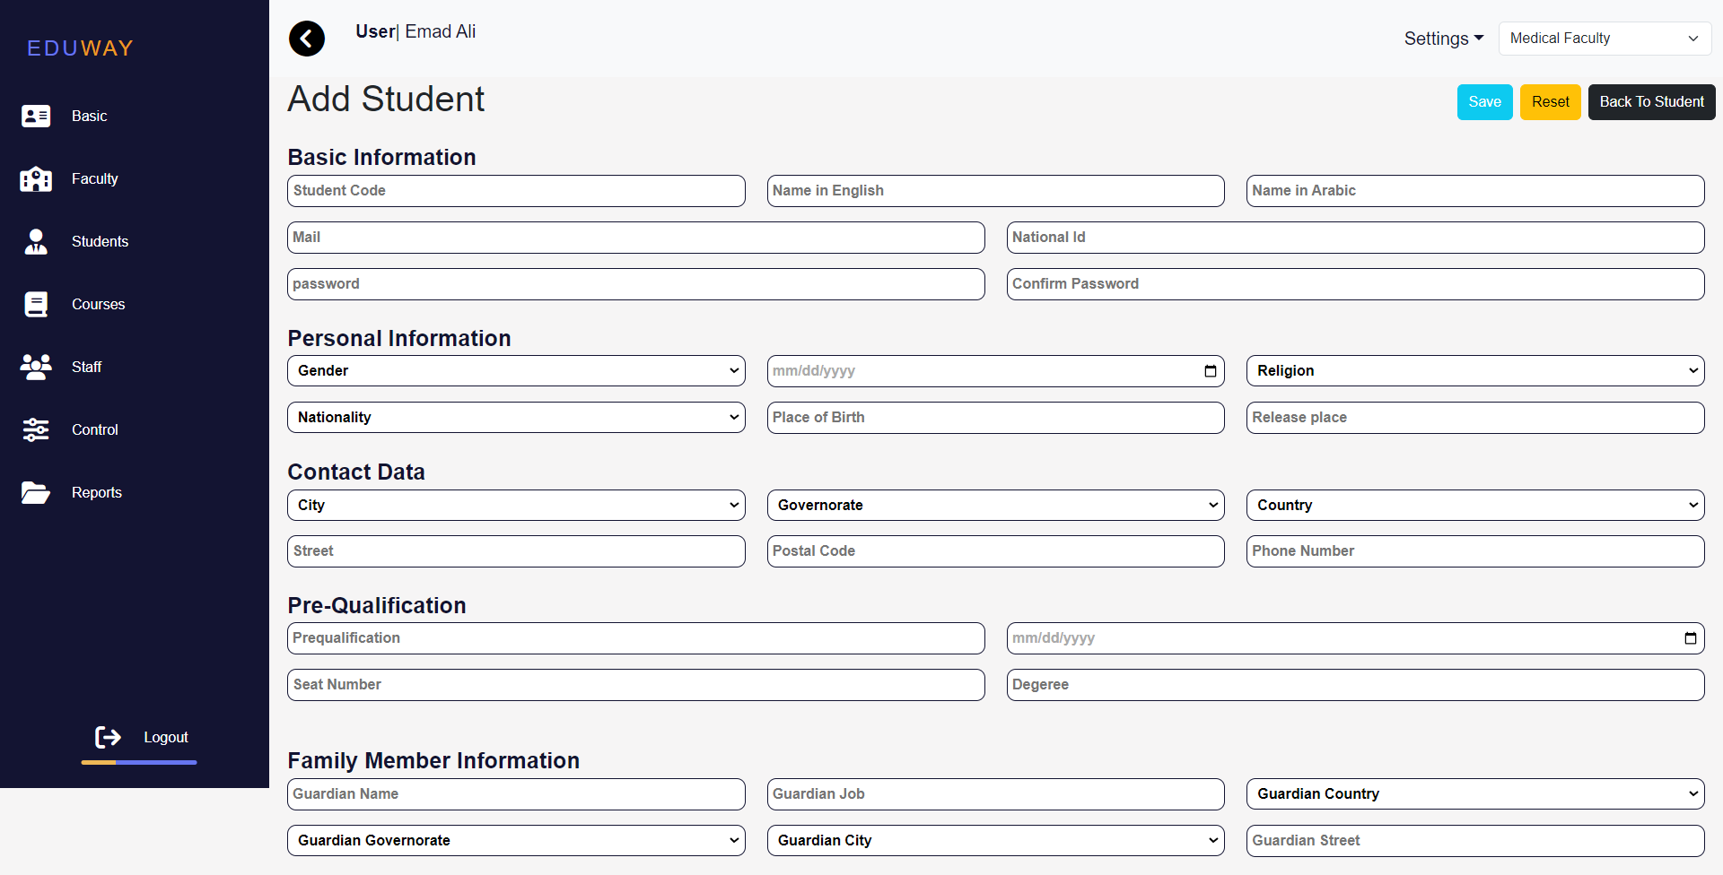

*Figure* 5*.2.27 Student*

July 1, 2024

* + View student information

60

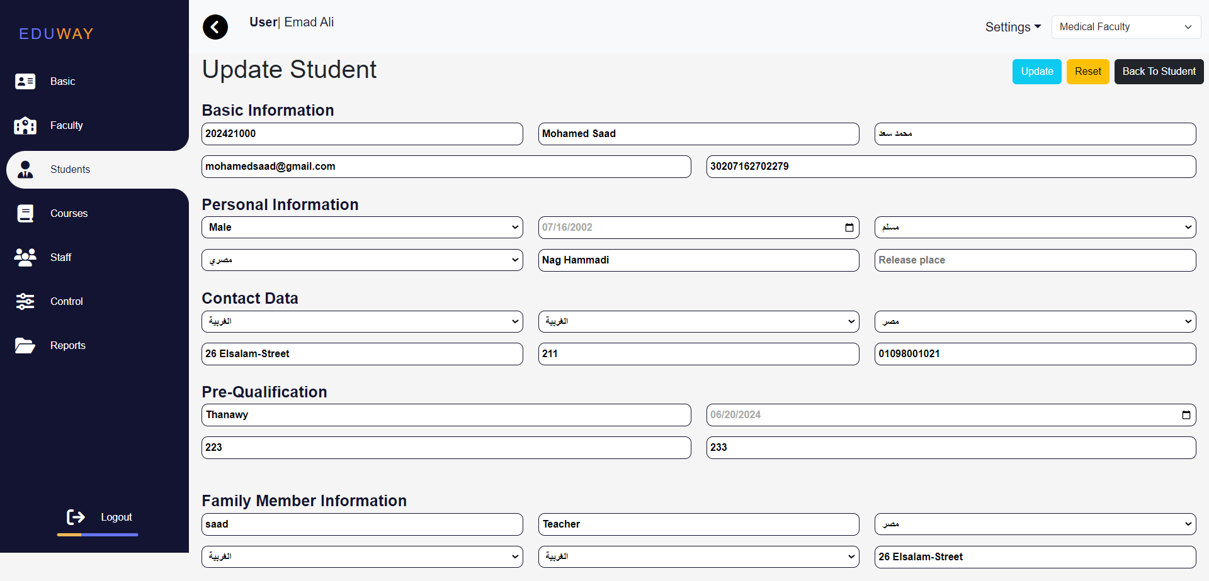

*Figure* 5*.2.28 Student*

* + Delete student

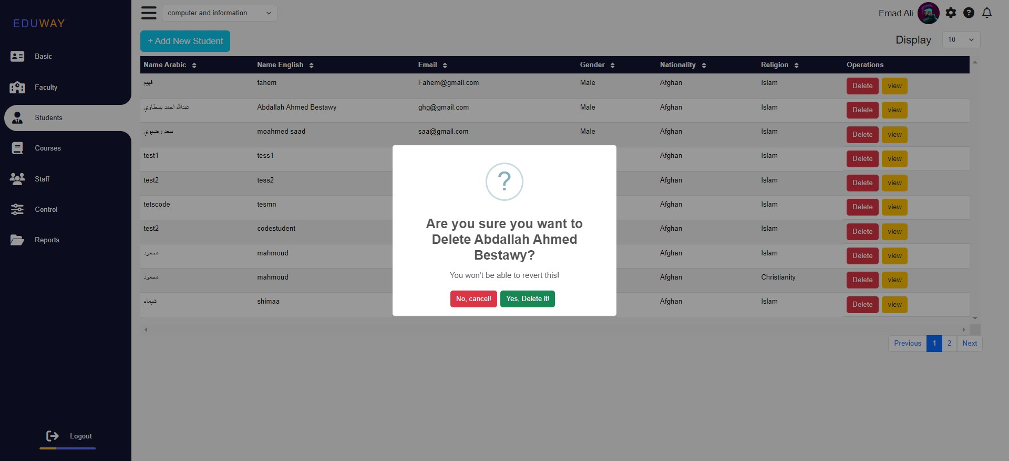

*Figure* 5*.2.29 Student*

July 1, 2024

61

* **Course Page:**
  + Show, add, delete, and edit course information.

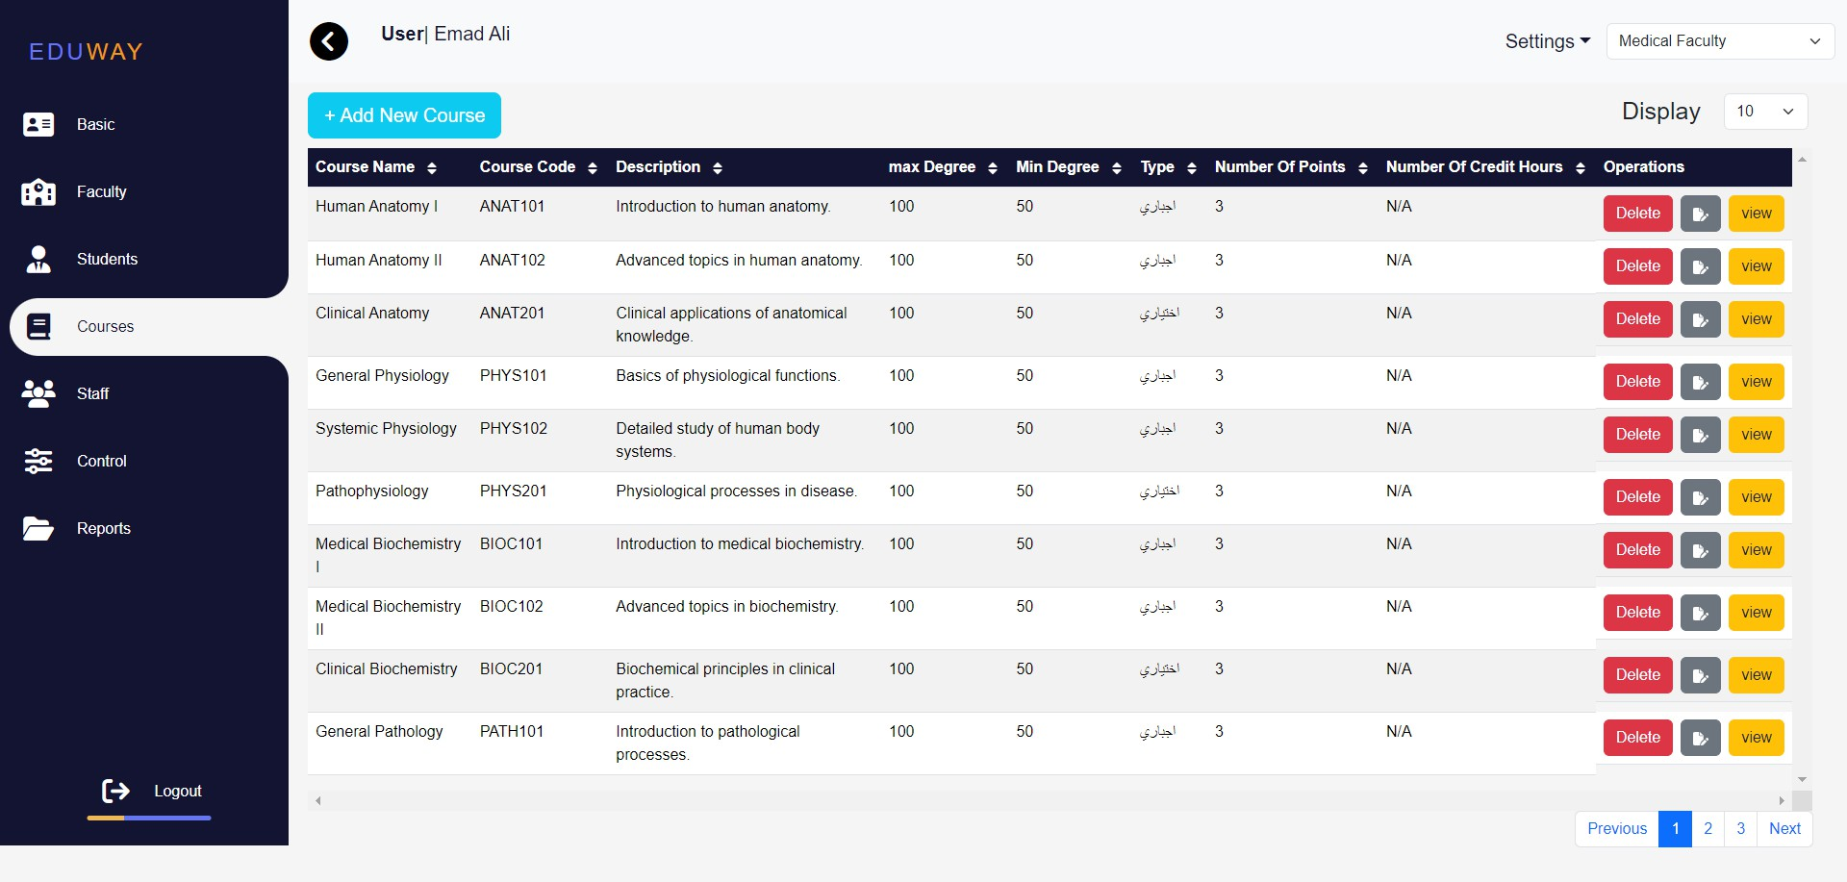

Through this

list you can select Faculty

Through this button

you can add a new student

Through this list

you can select Number of

Courses in Page

Through this button

you can delete Courses

Through this

button you can display

Prerequisite

Through this button

you can Show details about the Course

*Figure* 5*.2.230 Courses*

July 1, 2024

* + Add new course

62

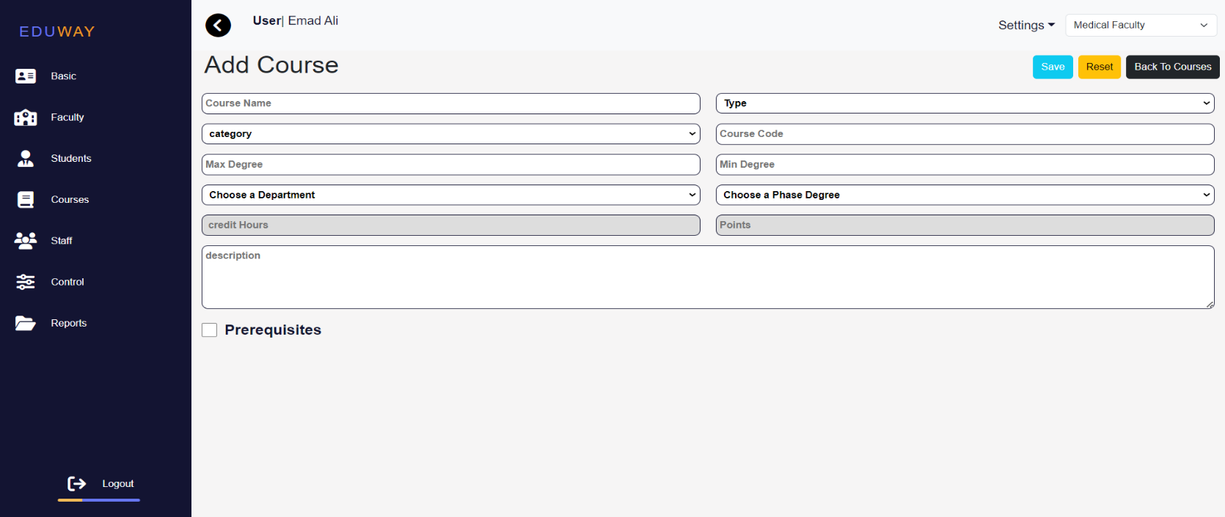

*Figure* 5*.2.31 Courses*

* + View the course

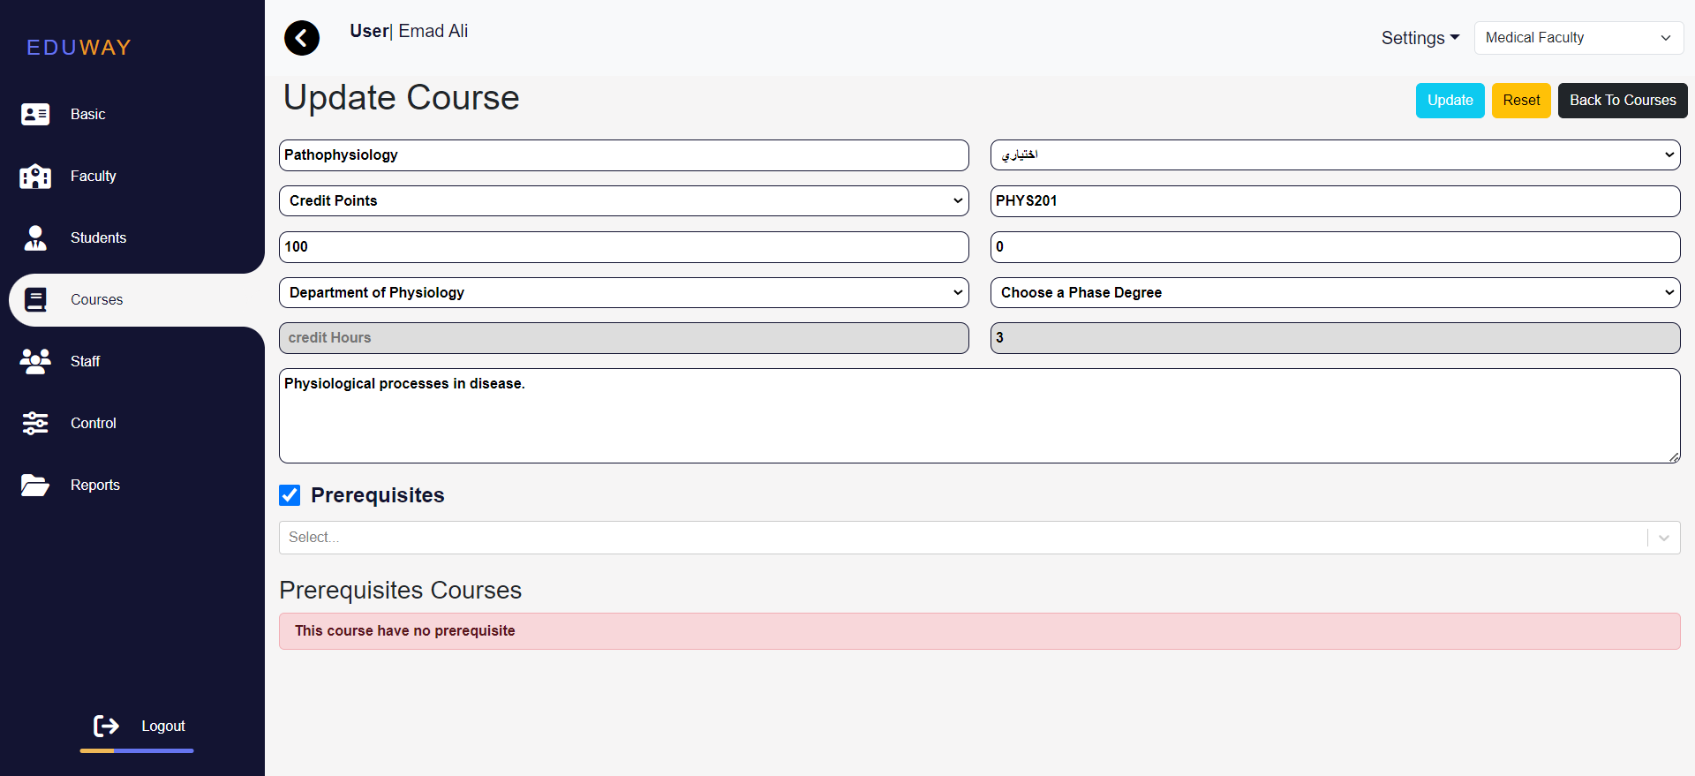

*Figure* 5*.2.32 Courses*

July 1, 2024

* + Delete course

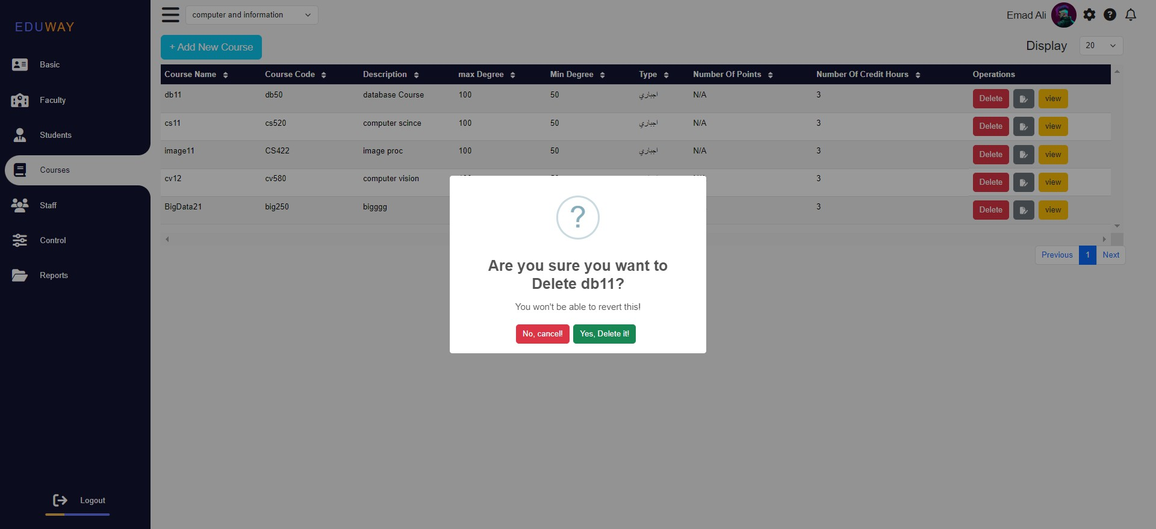

* **Staff page:**

*Figure* 5*.2.33 Courses*

* + Manage Administration: Show, add, delete, and edit administration staff.

63

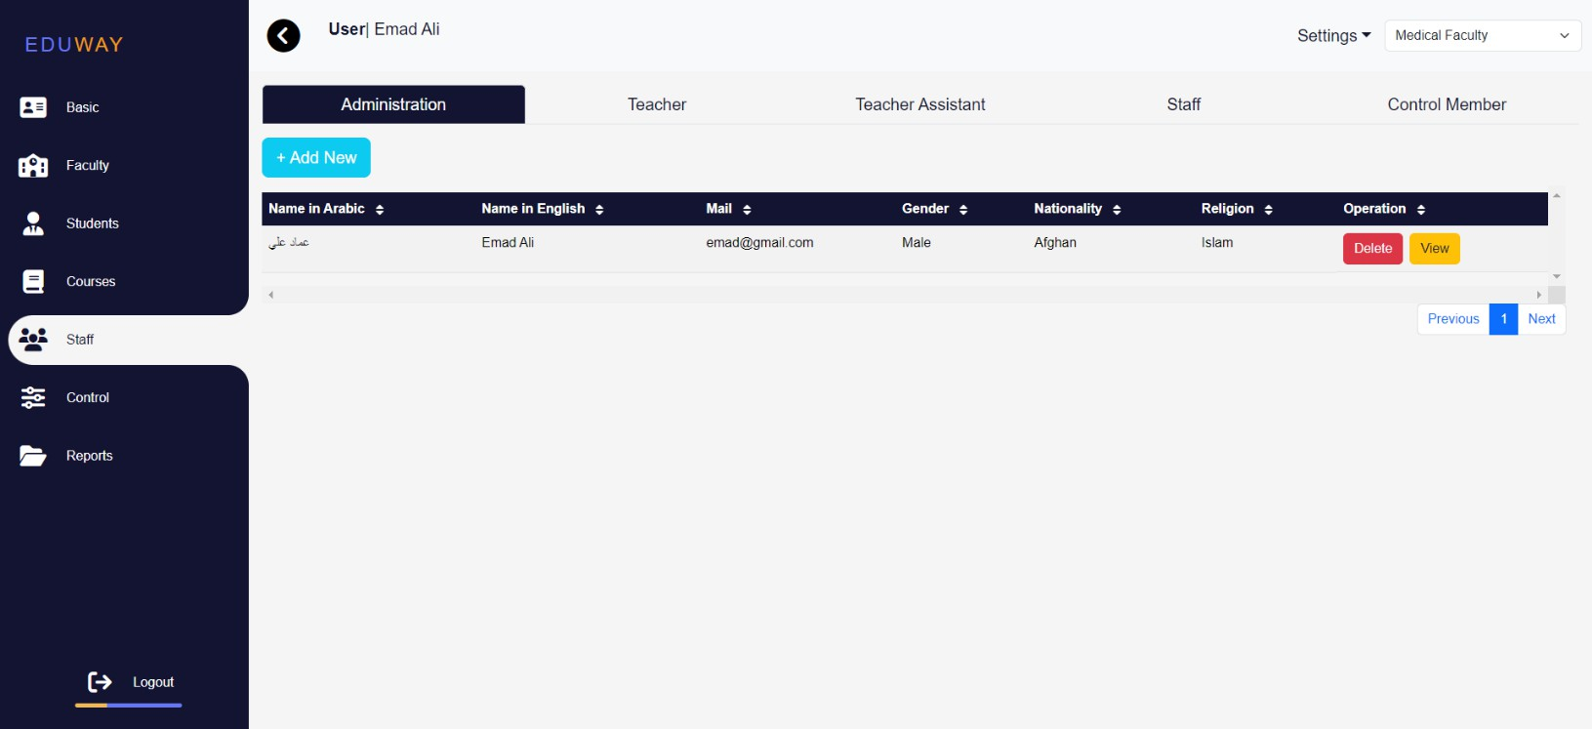

*Figure* 5*.2.34 Staff*

July 1, 2024

* + Add new Administration

64

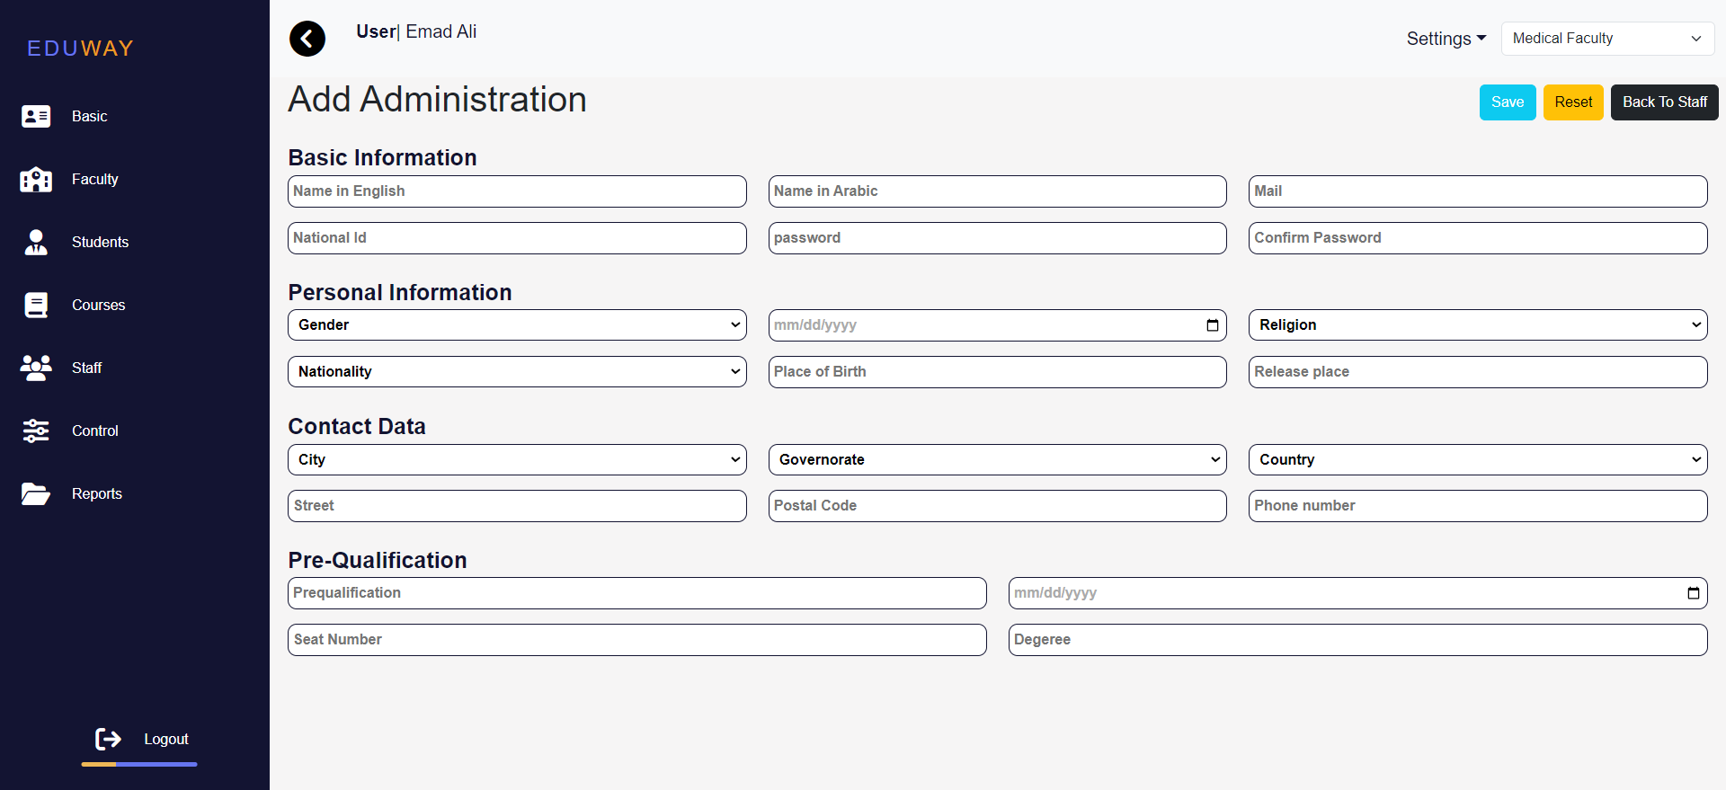

*Figure* 5*.2.35 Staff*

* + Manage Teachers: Show, add, delete, and edit teachers.

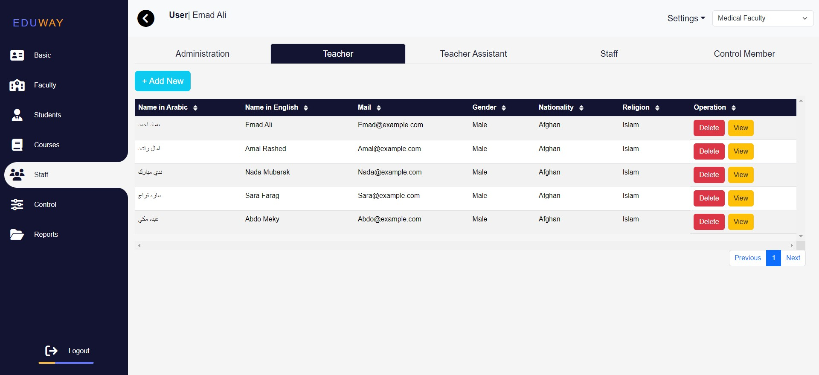

*Figure* 5*.2.36 Staff*

July 1, 2024

* + Manage Teacher Assistants: Show, add, delete, and edit teacher assistants.

65

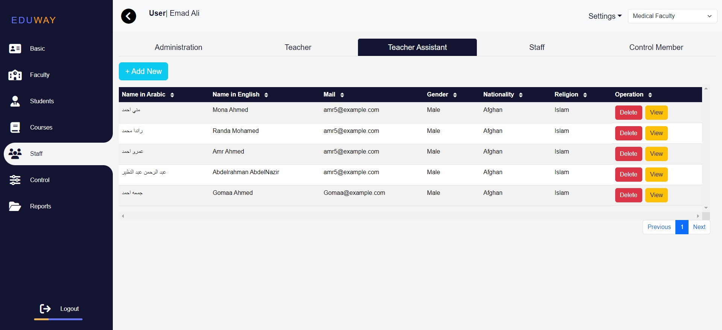

*Figure* 5*.2.37 Staff*

* + 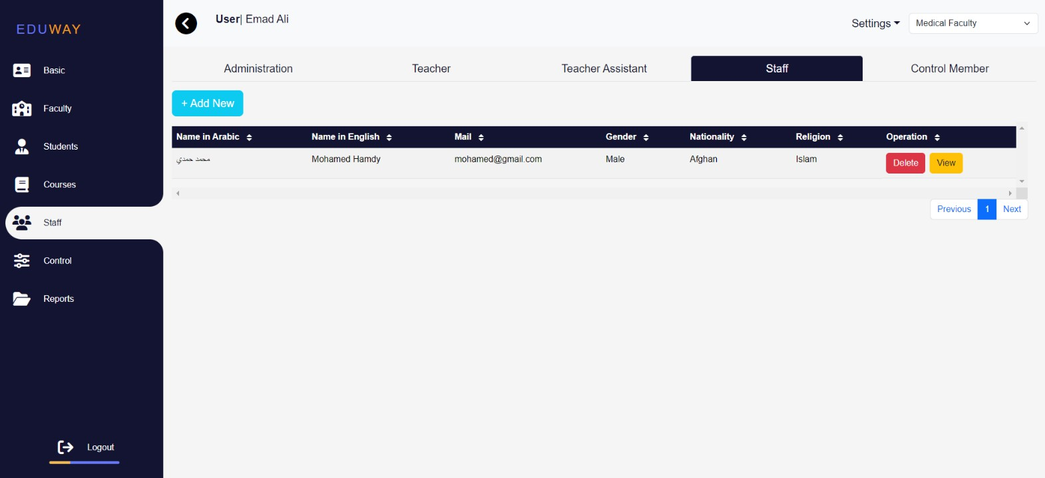Manage Staff: Show, add, delete, and edit other staff members.

*Figure* 5*.2.38 Staff*

July 1, 2024

* + Manage Control Members: Show, add, delete, and edit control members.

66

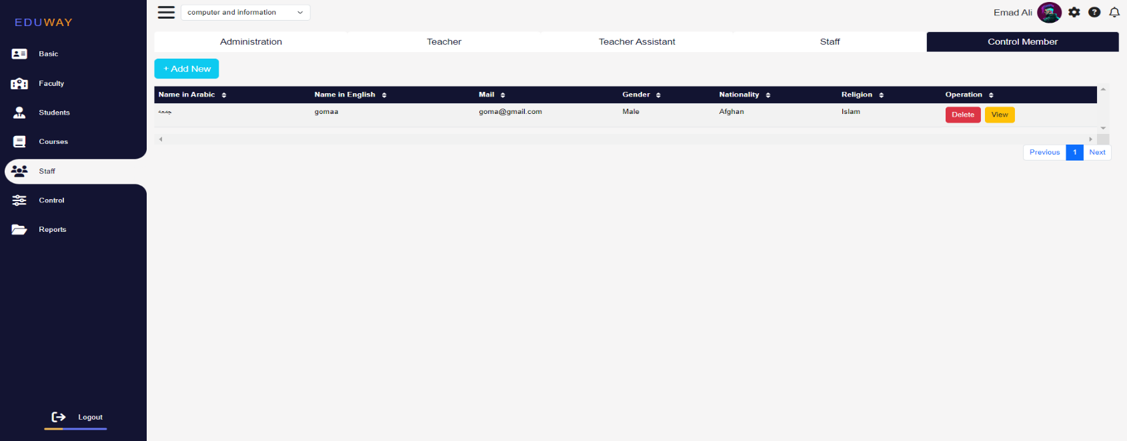

*Figure* 5*.2.39 Staff*

* **Control Page:**
  + Oversee and manage control-related tasks.
    - 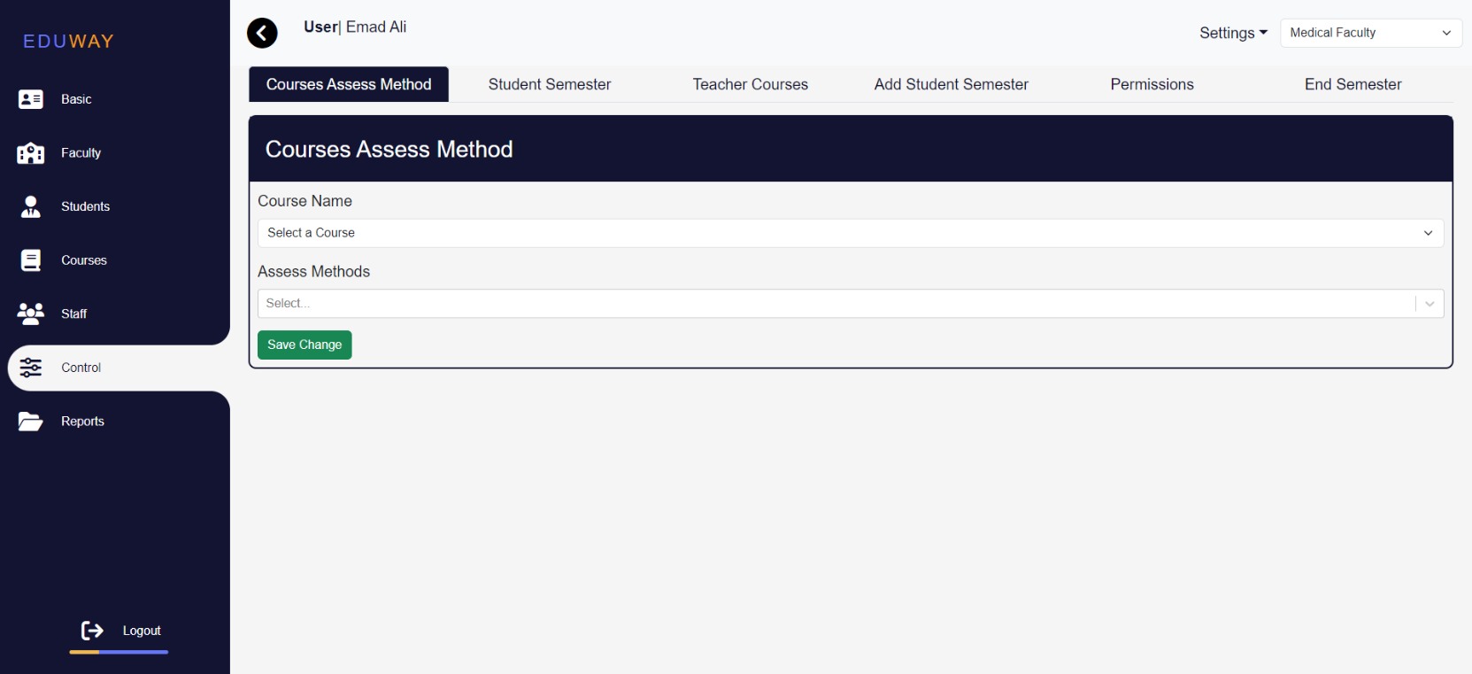 Through this page, you can add or change the Assess methods for a course

*Figure* 5*.2.40 Control*

July 1, 2024

* + - Through this page, you can display students in semester and delete student from this semester

67

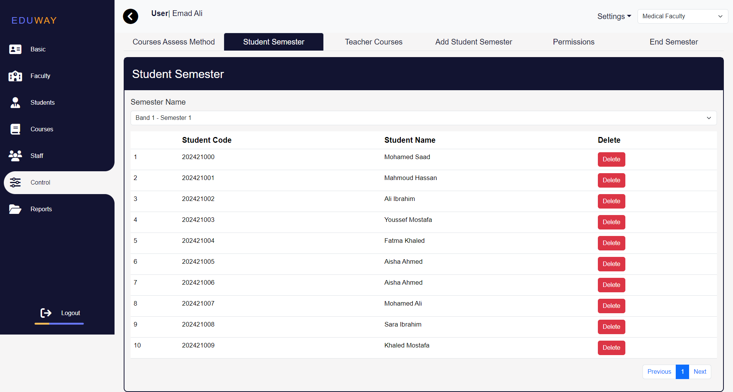

*Figure* 5*.2.41 Control*

* + - Through this page you can give the teacher or teacher assistant the courses he will teach

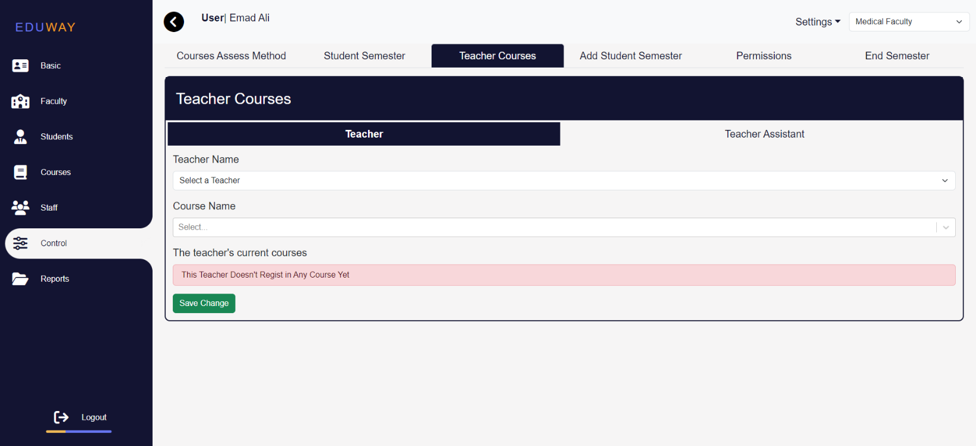

*Figure* 5*.2.42 Control*

July 1, 2024

* + - Through this page, you can add every student in semester and department

68

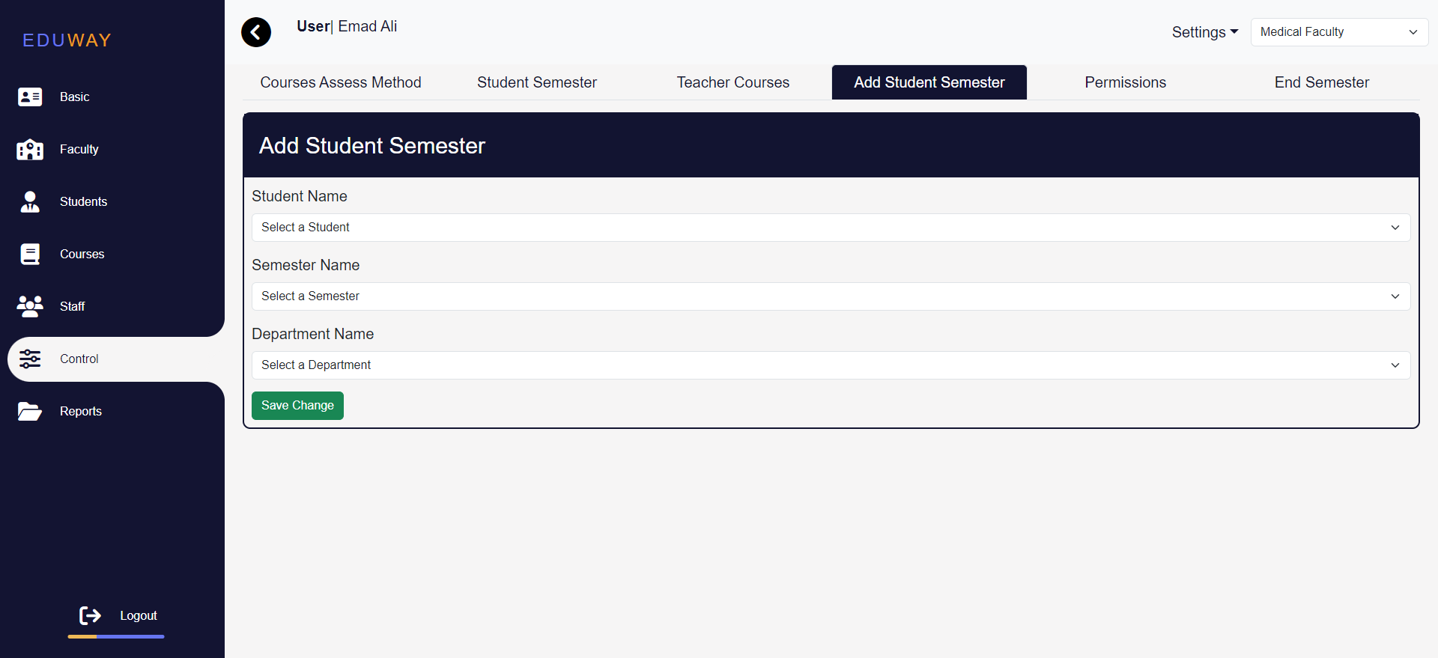

*Figure* 5*.2.43 Control*

* + - Through this page, you can give permission for teacher

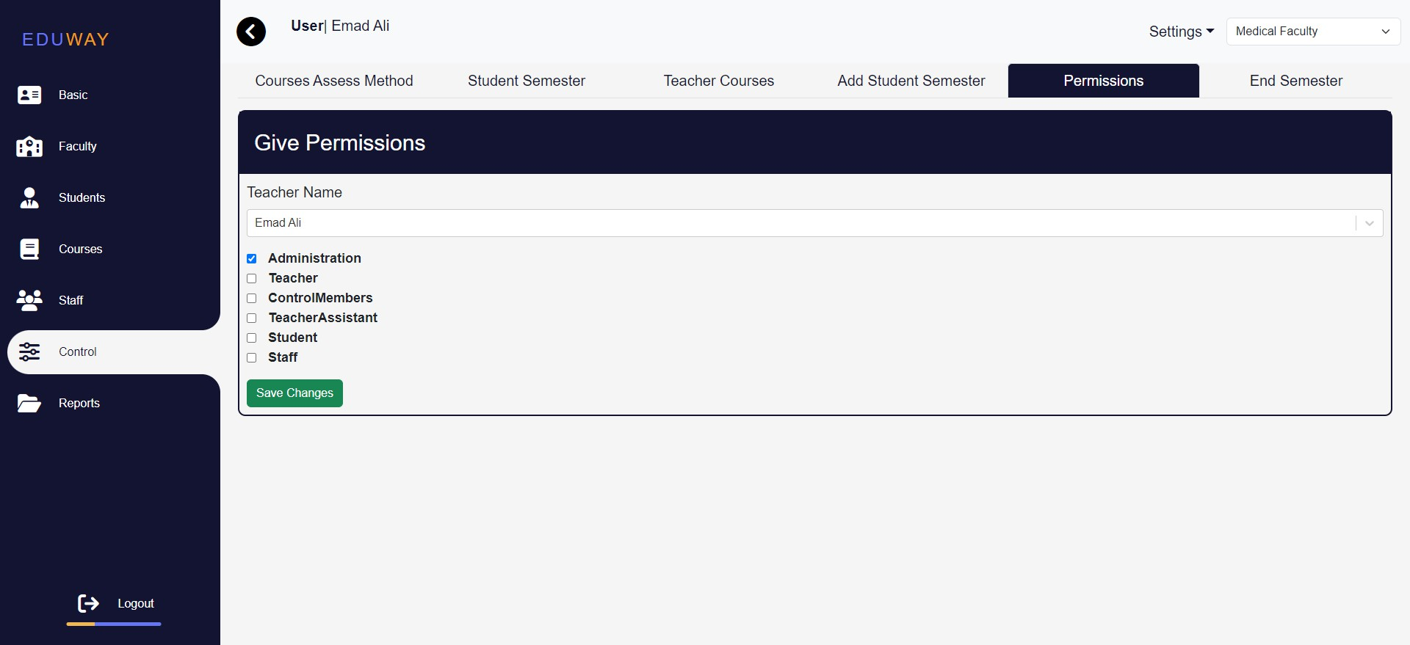

*Figure*5*.2.44 Control*

July 1, 2024

* + - Through this page, you can end semester

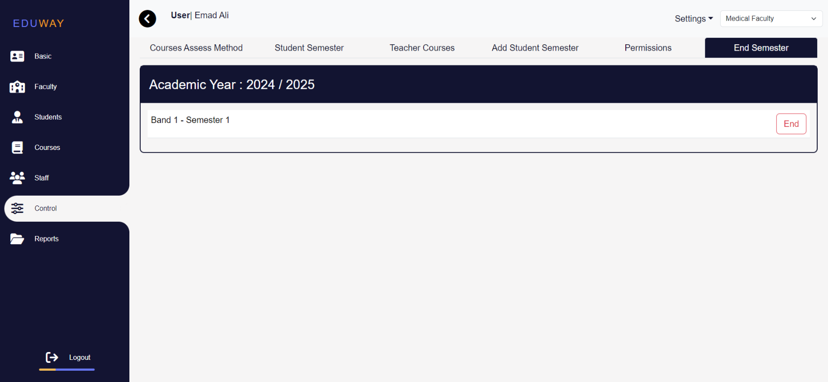

*Figure* 5*.2.38 Control*

* **Timetable page:**

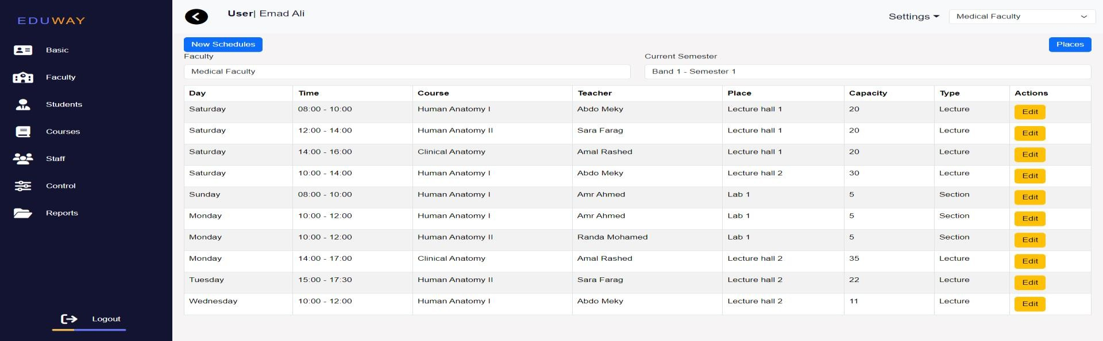

*Figure* 5*.2.38 Timetable*

* **Reports Page:**

69

July 1, 2024

* + Generate various reports as needed.

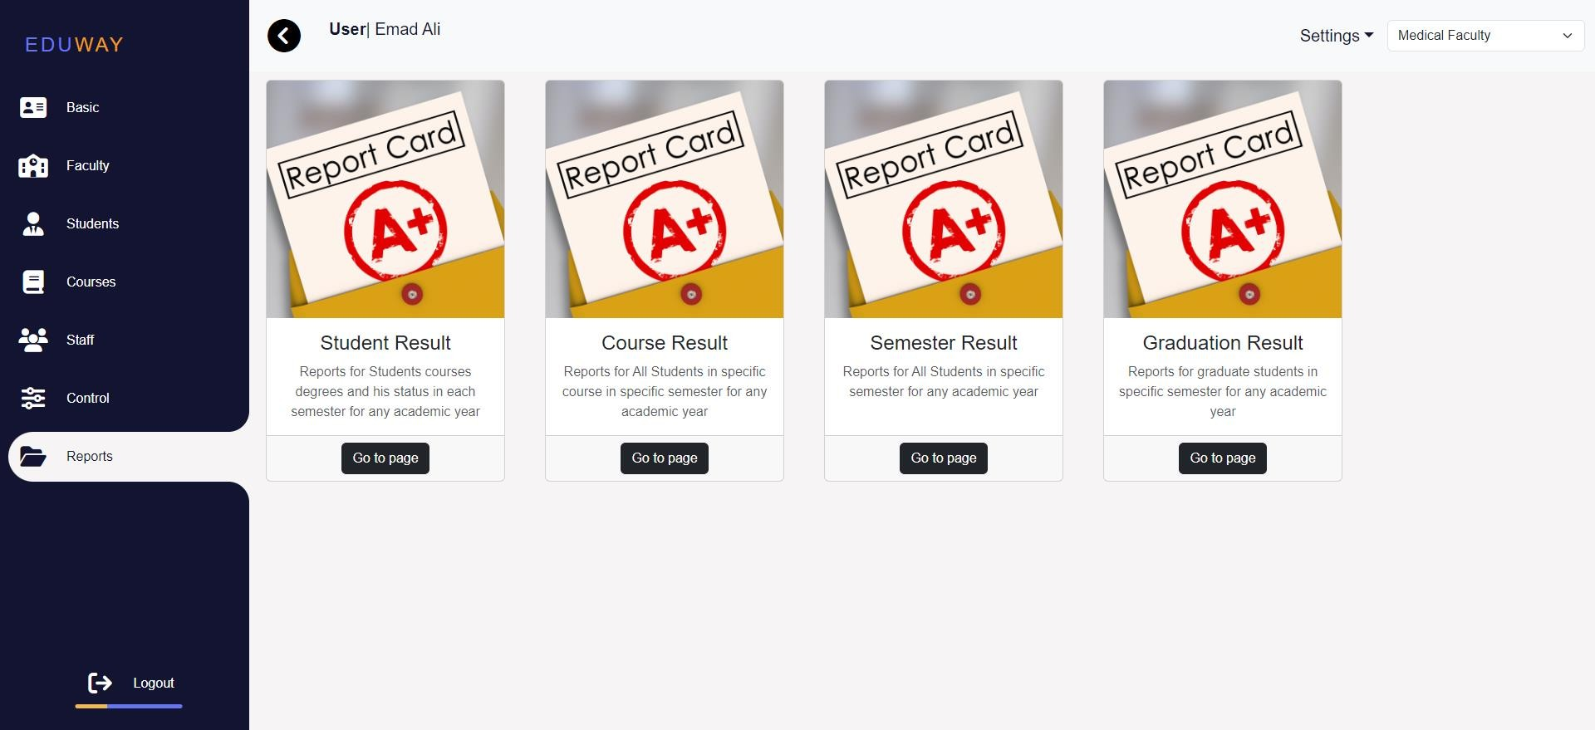

* + Student Result

*Figure* 5*.2.39 Report*

* + - 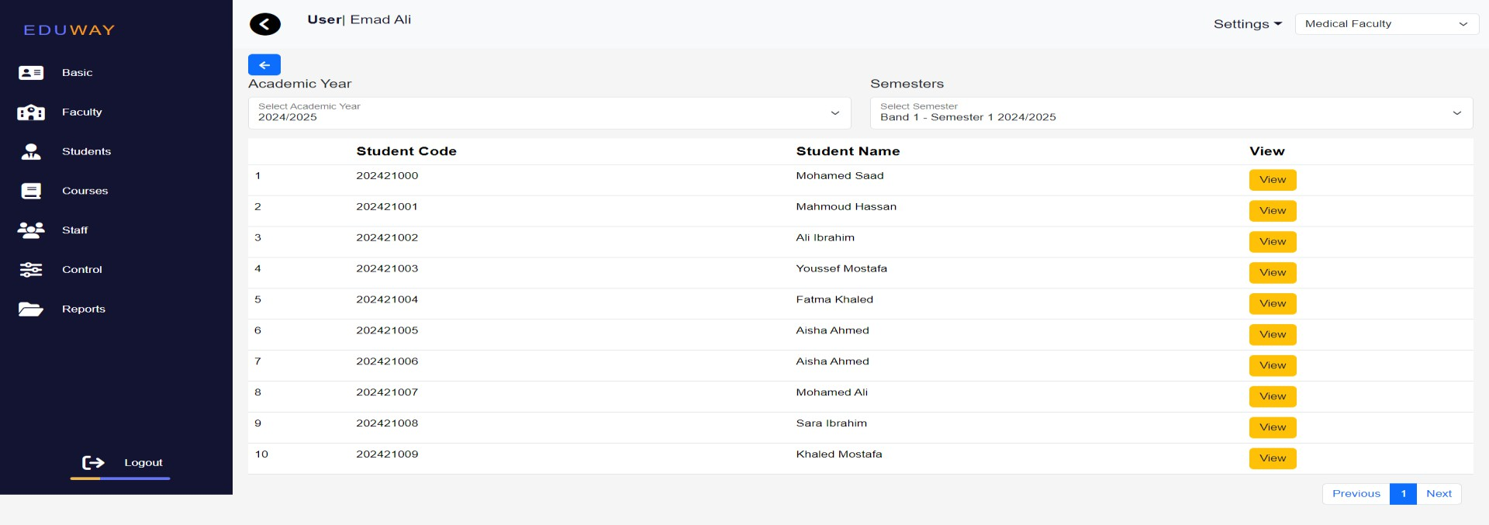Through this page, you can view the students by specifying the academic year and semester, then click on view to display the results.

70

*Figure* 5*.2.40 Report*

July 1, 2024

* + - This page view student result

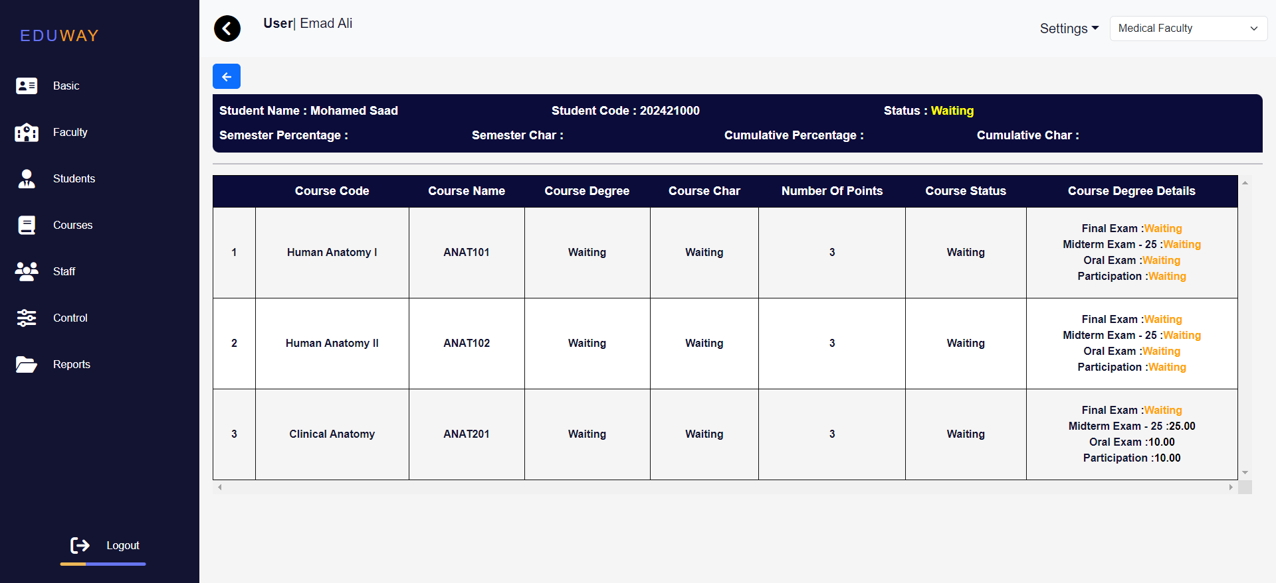

* + Course Result

*Figure* 5*.2.41 Report*

* + - 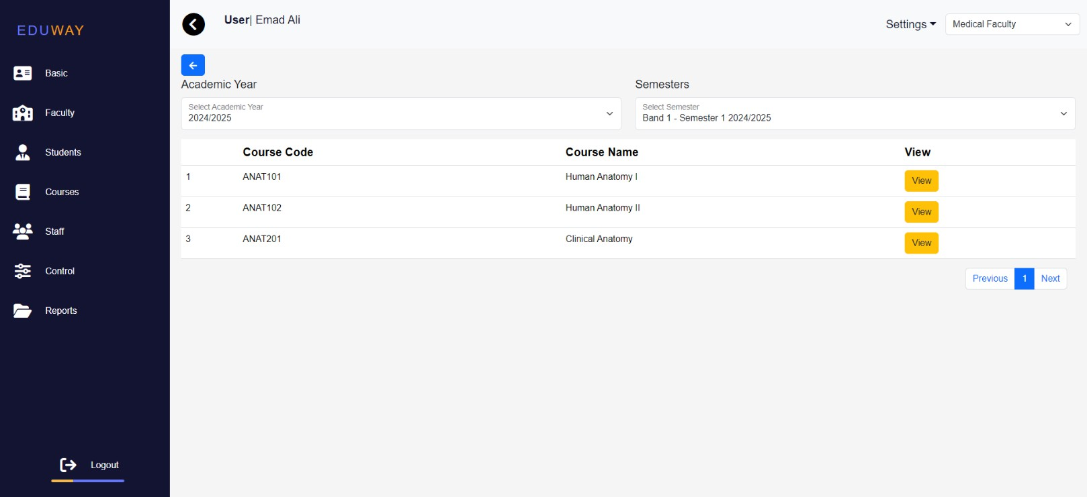Through this page, you can view the courses by specifying the academic year and semester, then click on view to display the results.

71

*Figure* 5*.2.42 Report*

July 1, 2024

* This page view students results in a specific course

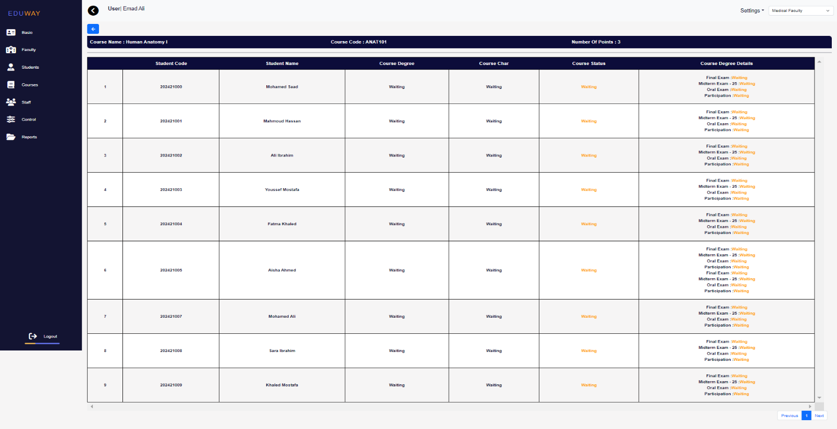

* + Semester Result

*Figure* 5*.2.43 Report*

* Through this page, you can view the students results in semester by specifying the academic year and semester

72

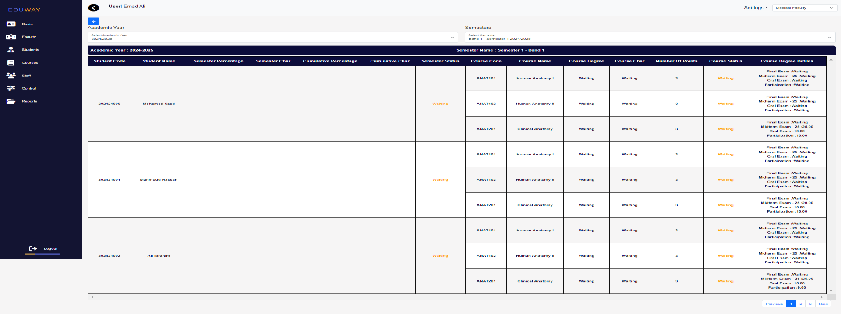

*Figure* 5*.2.44 Report*

July 1, 2024

* + Graduation Result

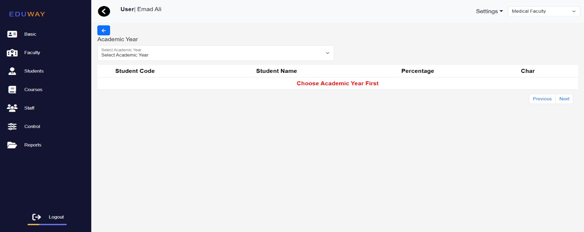

*Figure* 5*.2.45 Report*

* **Reports Page:**

o

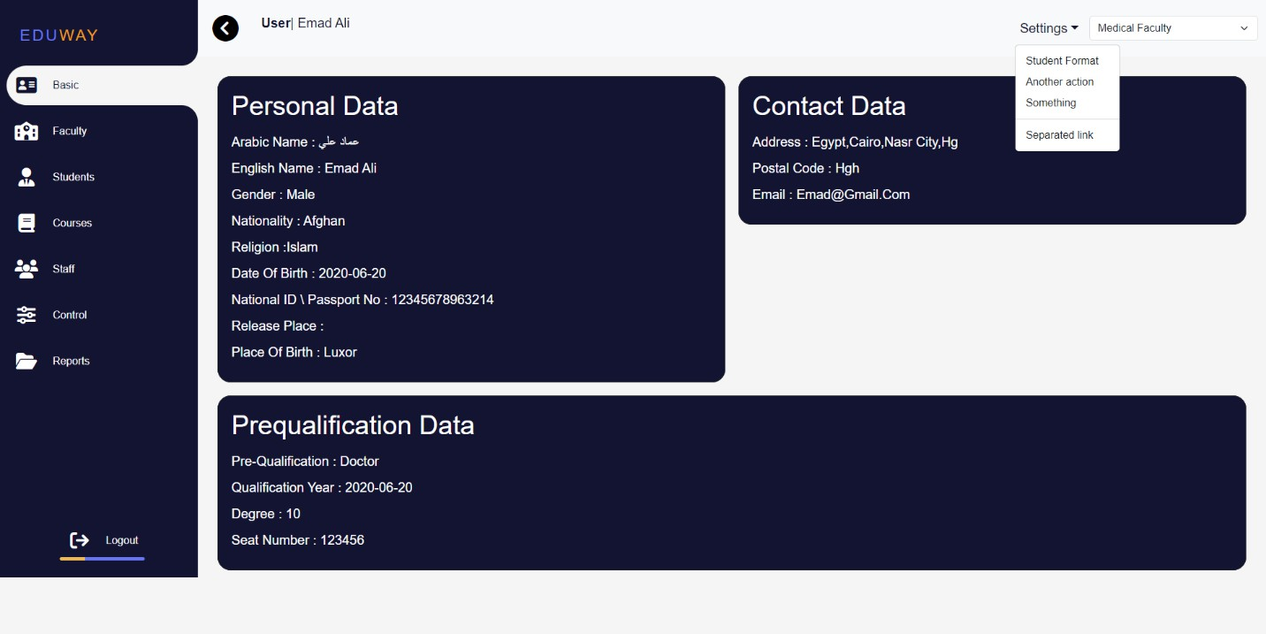



**1.17 Teacher**

* Basic information Page:
  + **Personal Data**

73

July 1, 2024

Arabic Name, English Name, Gender, Nationality, Religion, Date of Birth, National ID \ Passport No, Release Place, Place of Birth

74

* + **Contact Data**

Address, Postal Code, Email

* + **Prequalification Data**

Pre-Qualification, Qualification Year, Degree, Seat Number

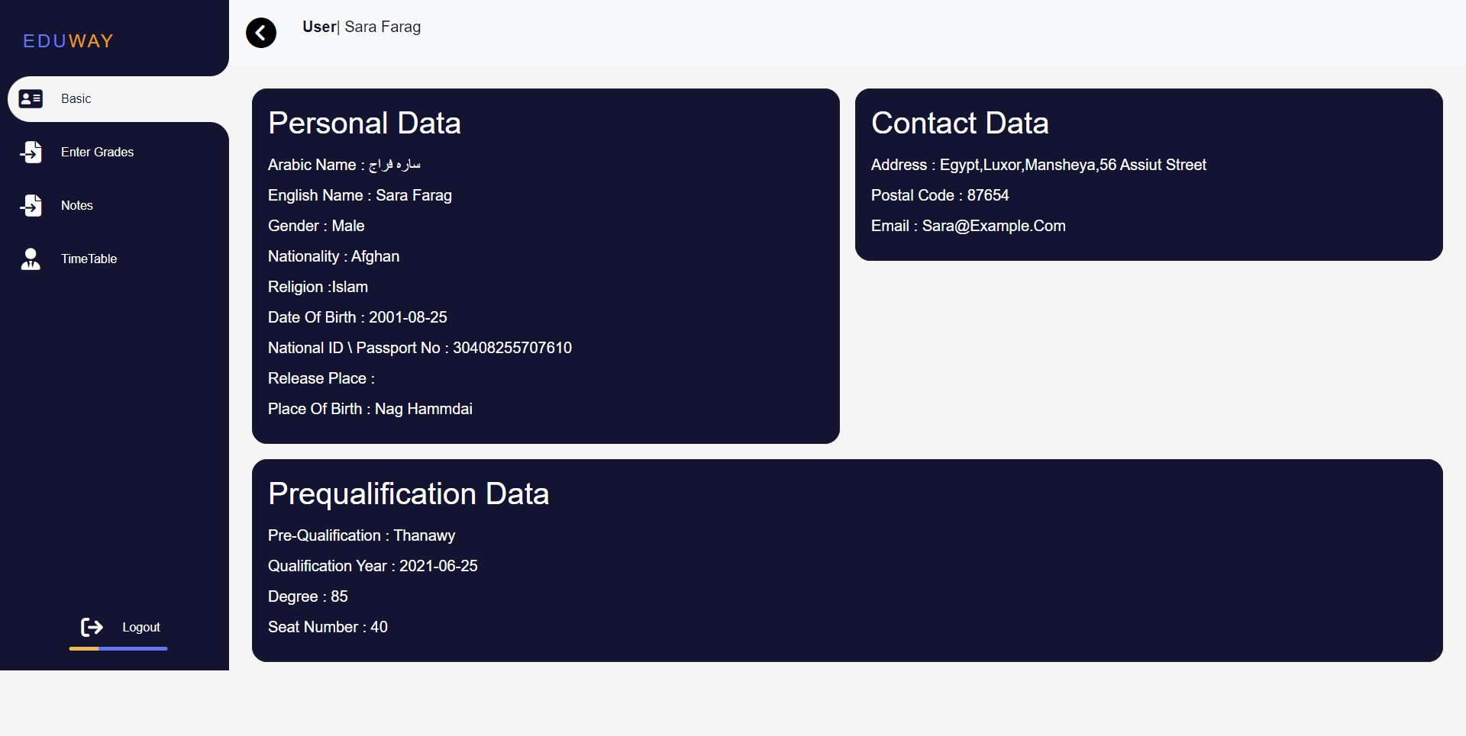

*Figure* 5*.3.1 Basic Information*

* Enter Grades Page:

July 1, 2024

* + Through this page, the teacher can enter course grades by selecting the course from the select sources button

75

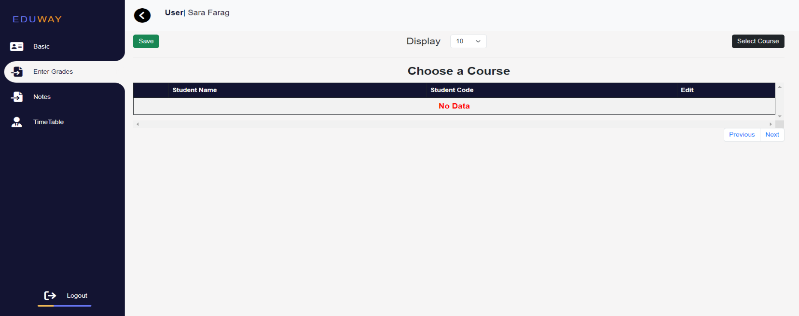

*Figure* 5*.3.2 Enter Grades*

* + select course

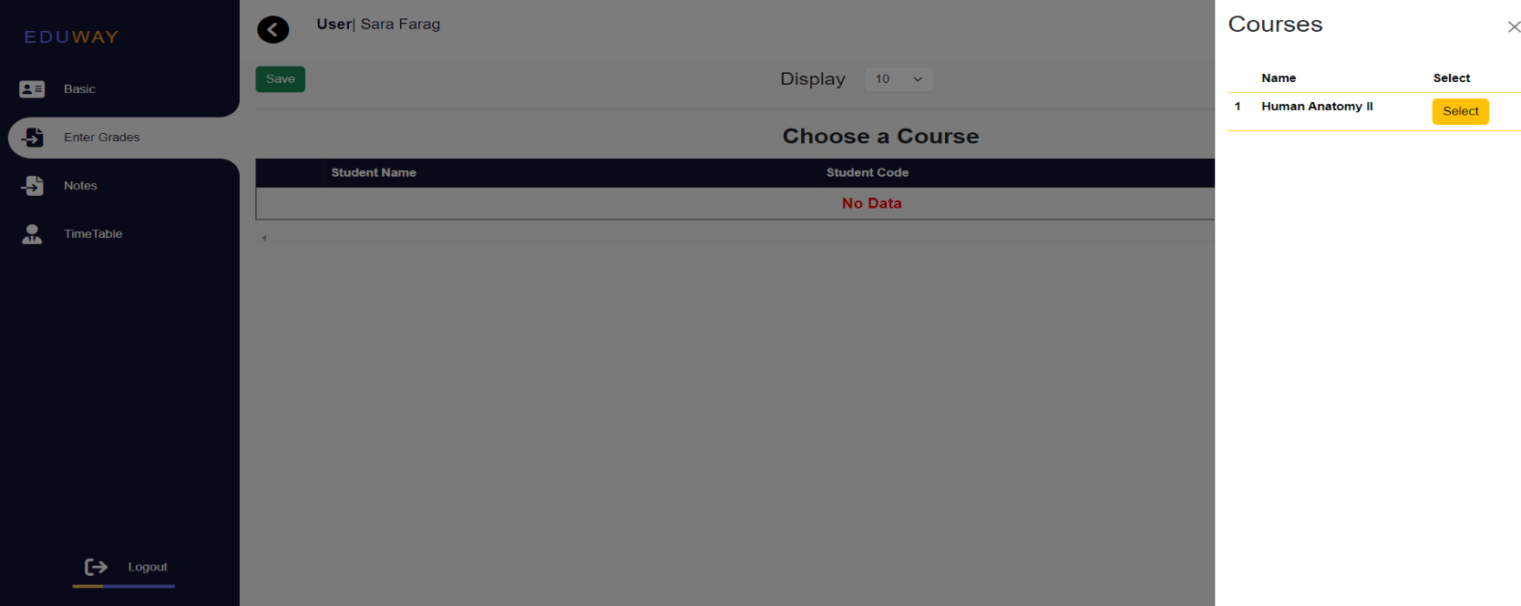

*Figure* 5*.3.3 Enter Grades*

July 1, 2024

* + After selecting the course, a table will appear with all the details of the course (mid, oral, ….), click on Edit button, enter the grades and save.

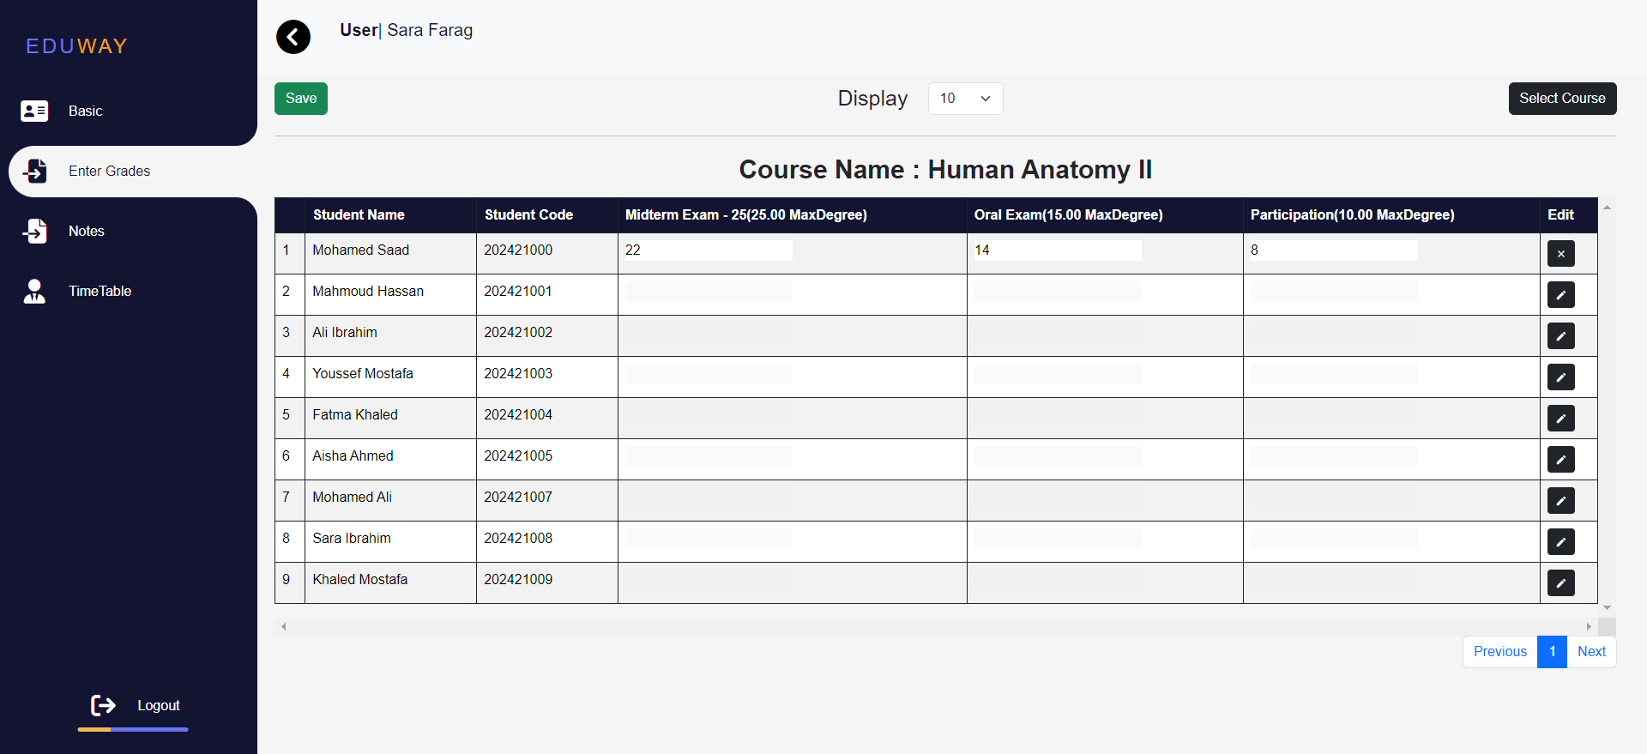

* Note page:

*Figure* 5*.3.4 Enter Grades*

* + through this page, the teacher can write some notes about the student

76

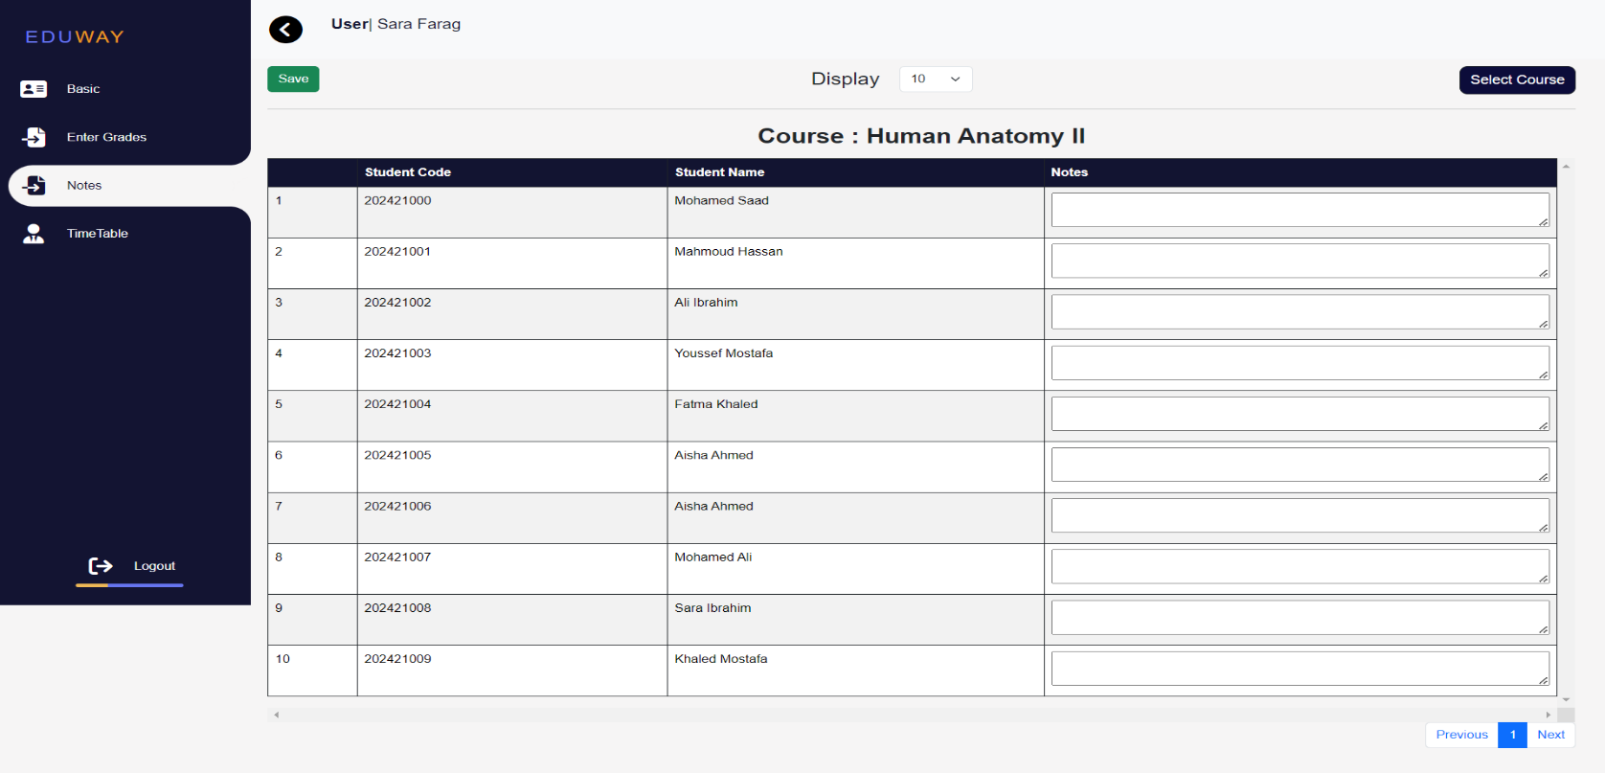

*Figure* 5*.3.5 Enter Grades*

July 1, 2024

77

* Time Table page:

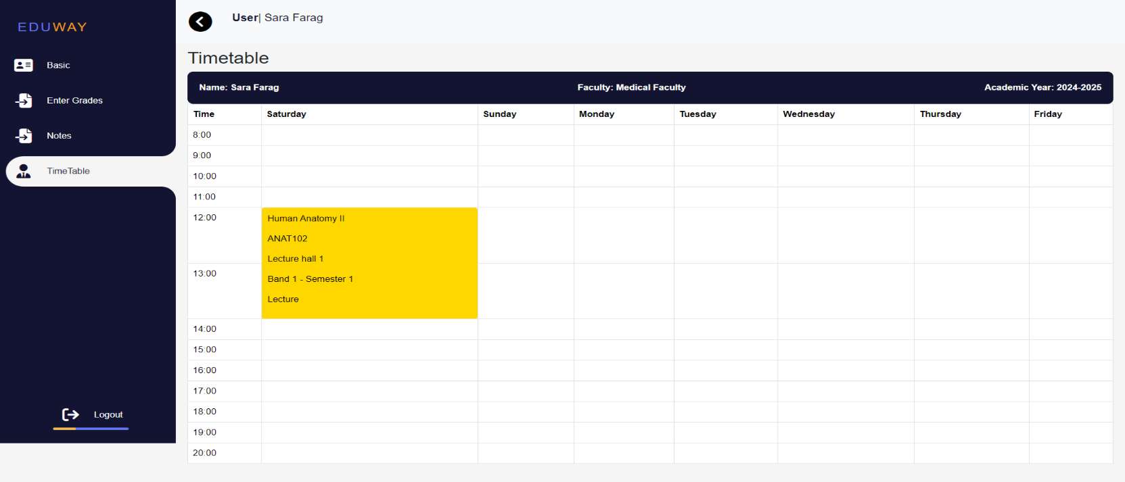

*Figure* 5*.3.6 Enter Grades*



**1.18 Teacher Assistant**

* Basic information Page:
  + **Personal Data**

Arabic Name, English Name, Gender, Nationality, Religion, Date of Birth, National ID \ Passport No, Release Place, Place of Birth

* + **Contact Data**

Address, Postal Code, Email

* + **Prequalification Data**

Pre-Qualification, Qualification Year, Degree, Seat Number

July 1, 2024

78

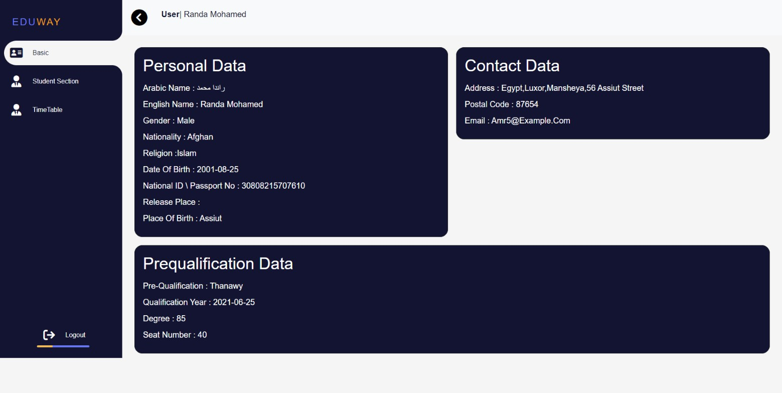

*Figure* 5*.4.1 Basic Information*

* Enter Grades Page:
  + Through this page, the teacher can enter course grades by selecting the course from the select sources button

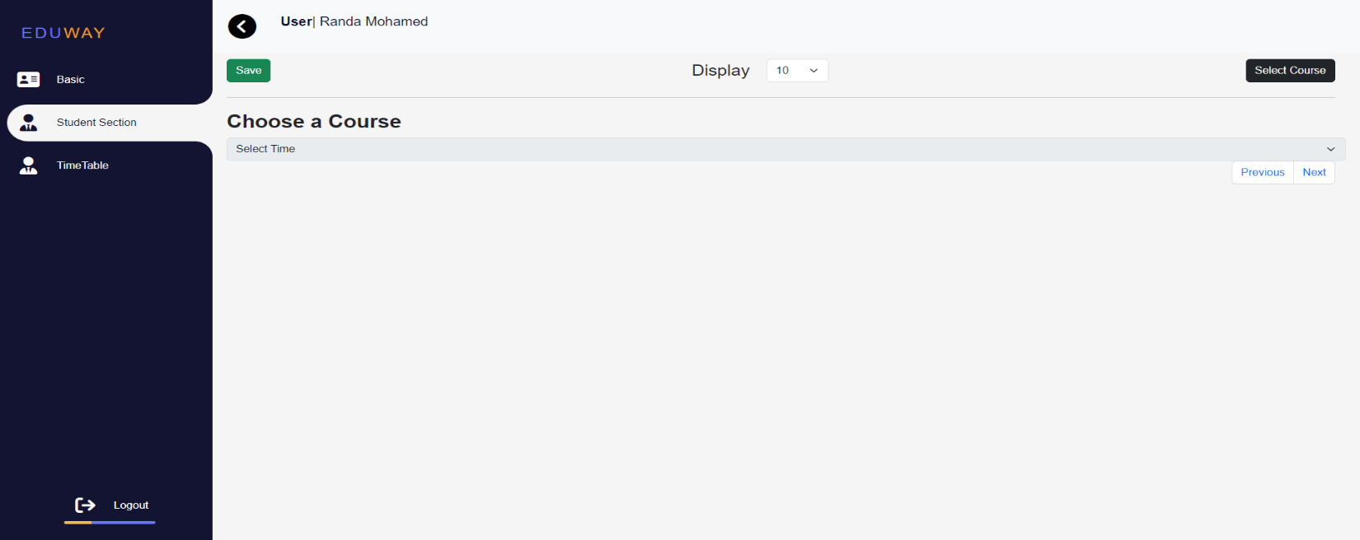

*Figure* 5*.4.2 Enter Grades*

July 1, 2024

* + select course

79

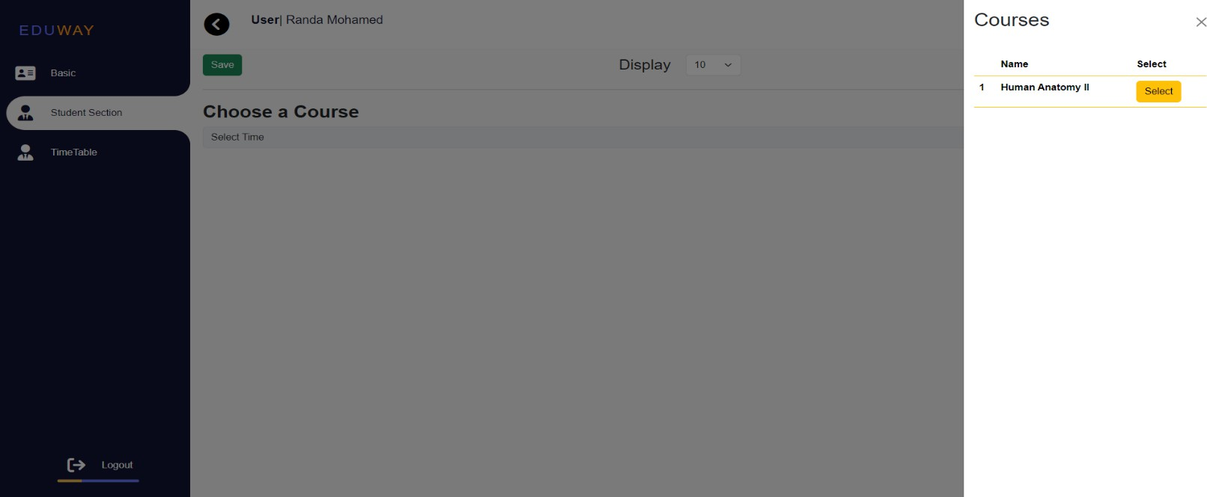

*Figure* 5*.4.3 Enter Grades*

* + After selecting the course, a table will appear with all the details of the course (mid, oral, ….), click on Edit button, enter the grades and save.

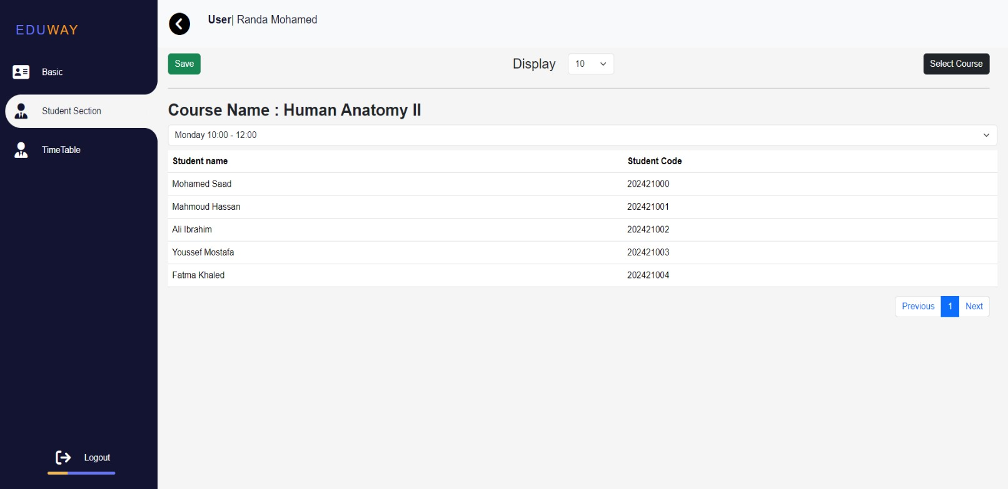

*Figure* 5*.4.4 Enter Grades*

July 1, 2024

80

* Time Table page:

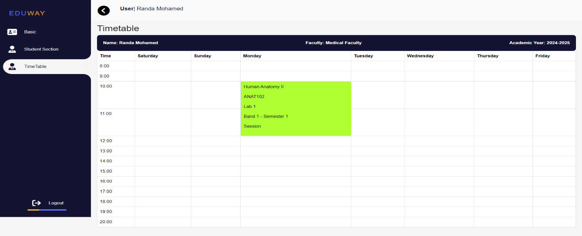

*Figure* 5*.4.5 Enter Grades*



**1.19 Control Members**

* Basic information Page:
  + **Personal Data**

Arabic Name, English Name, Gender, Nationality, Religion, Date of Birth, National ID \ Passport No, Release Place, Place of Birth

* + **Contact Data**

Address, Postal Code, Email

* + **Prequalification Data**

Pre-Qualification, Qualification Year, Degree, Seat Number

July 1, 2024

81

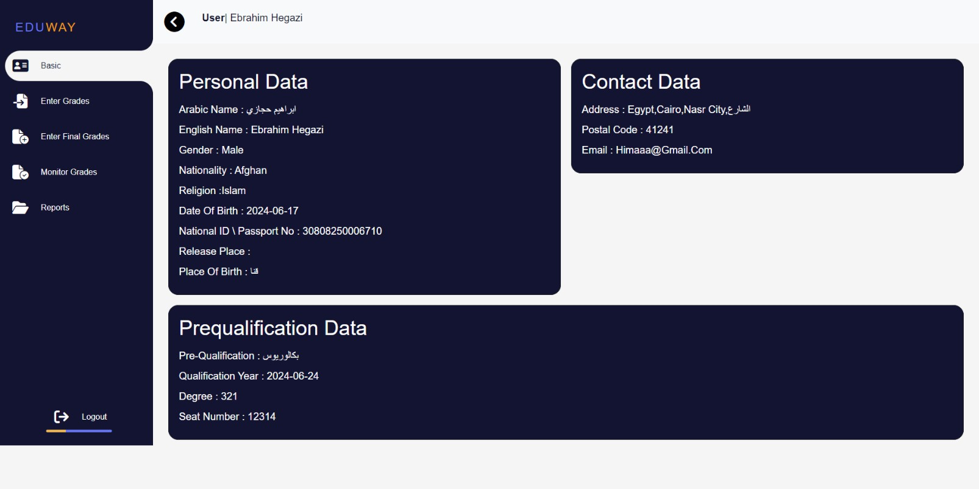

*Figure* 5*.5.1 Basic Information*

* Enter final Grades
  + Through this page, the Control Member can enter course grades by selecting the course from the select sources button and upload an Excel file containing grades

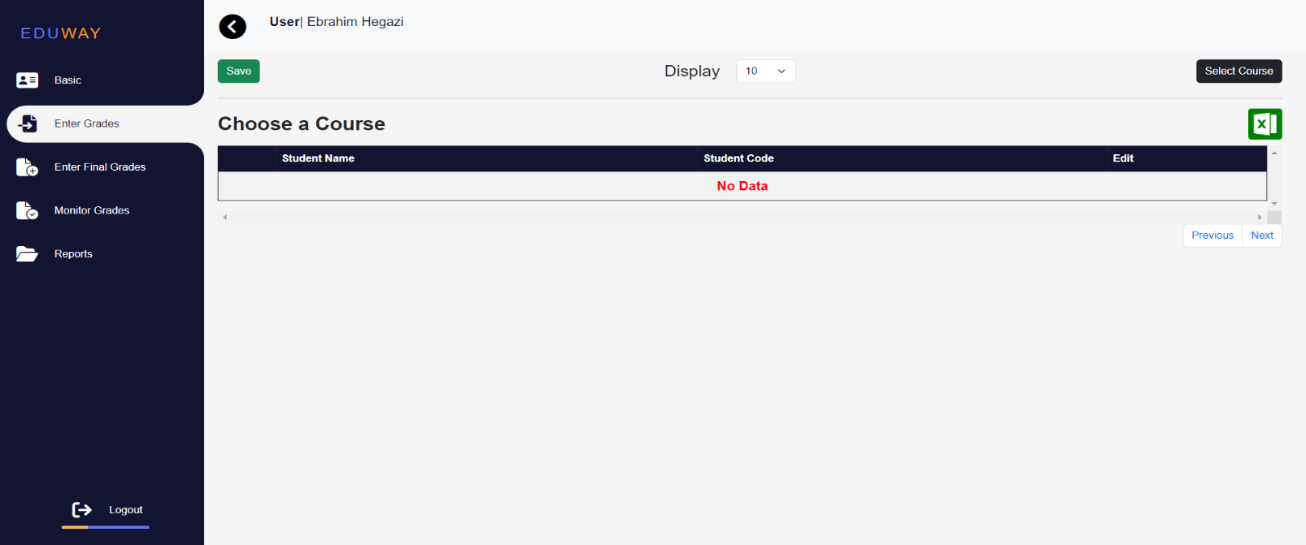

*Figure* 5*.*5*.2 Enter Grades*

July 1, 2024

* + Upload or download an Excel file containing grades

82

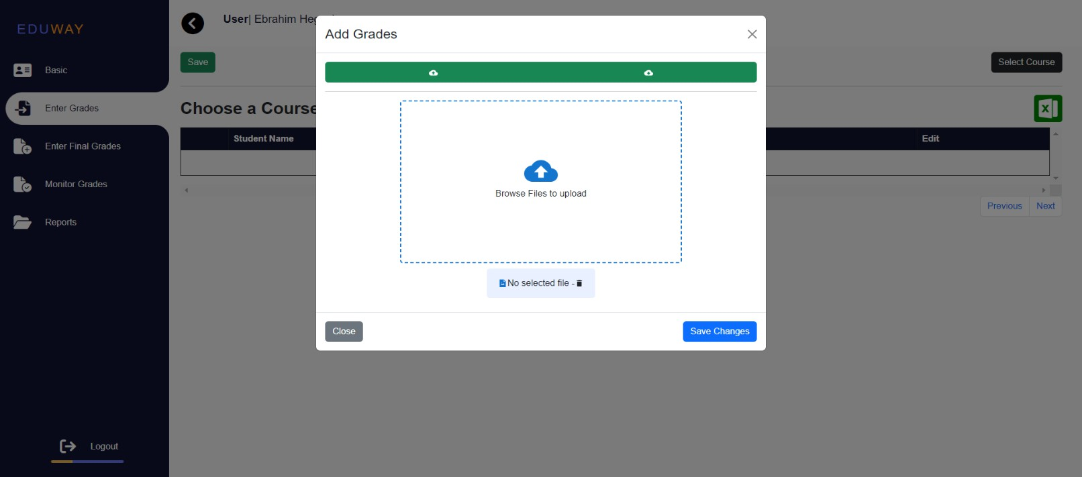

*Figure* 5*.*5*.*3 *Enter Grades*

* + select semester then click on select course

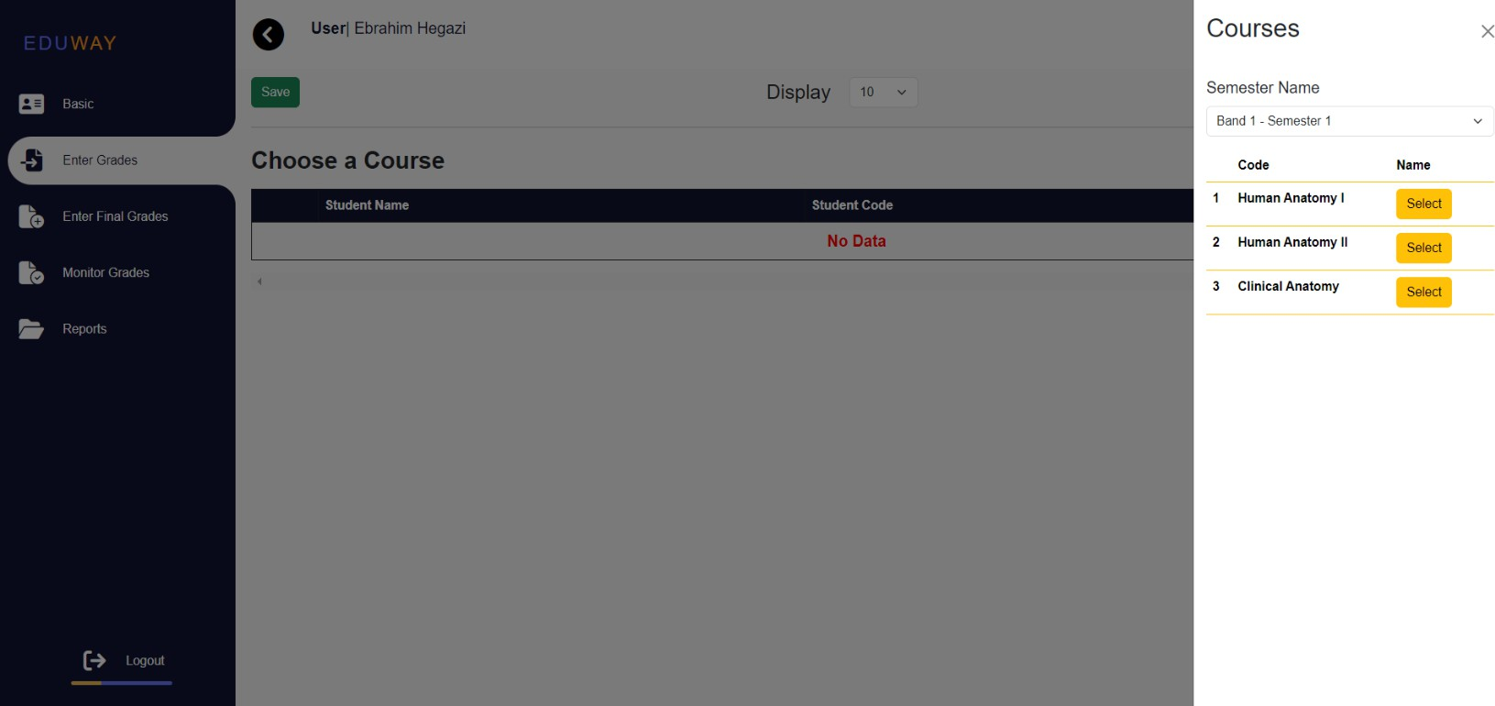

*Figure* 5*.*5*.4 Enter Grades*

July 1, 2024

* + After selecting the course, a table will appear with all the details of the course (mid, oral, final ….), click on Edit button, enter the grades and save.

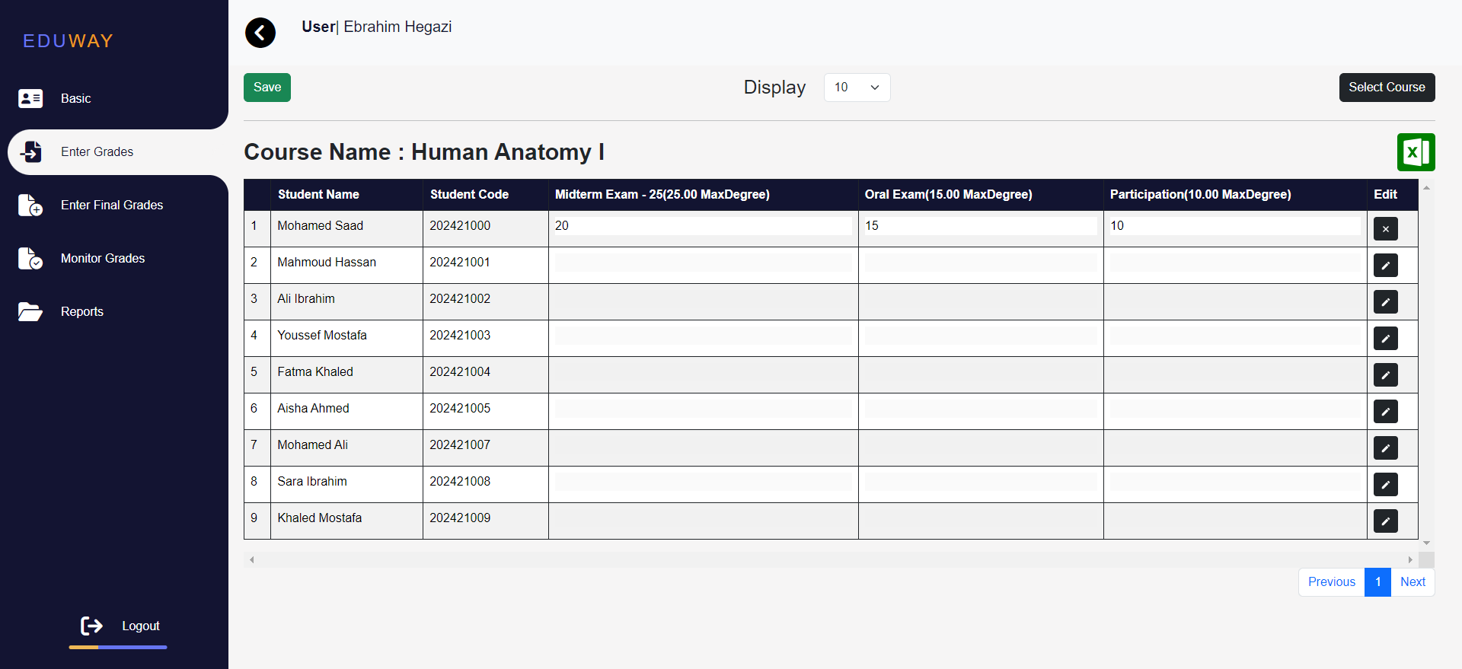

* Monitor Grade page:

*Figure* 5*.5.5 Enter Grades*

* + Through this page, the Control Member can monitor all courses in semester (click on monitor semester) or monitor one course (click on monitor)

83

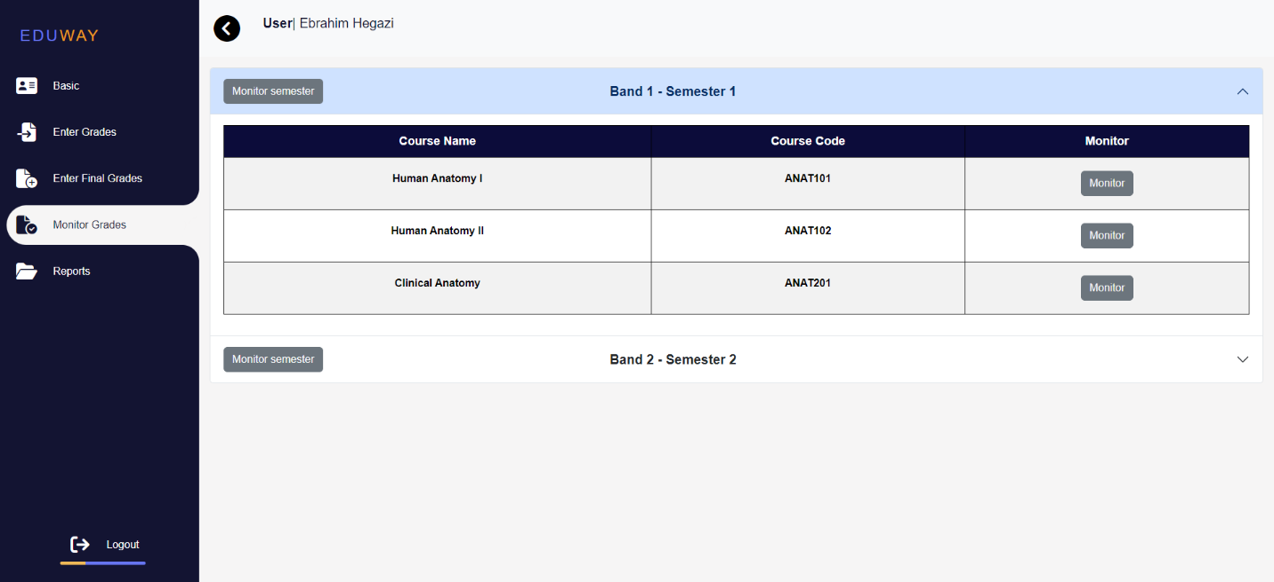

*Figure* 5*.5.5 Enter Grades*

July 1, 2024

* Reports Page:
  + Generate various reports as needed

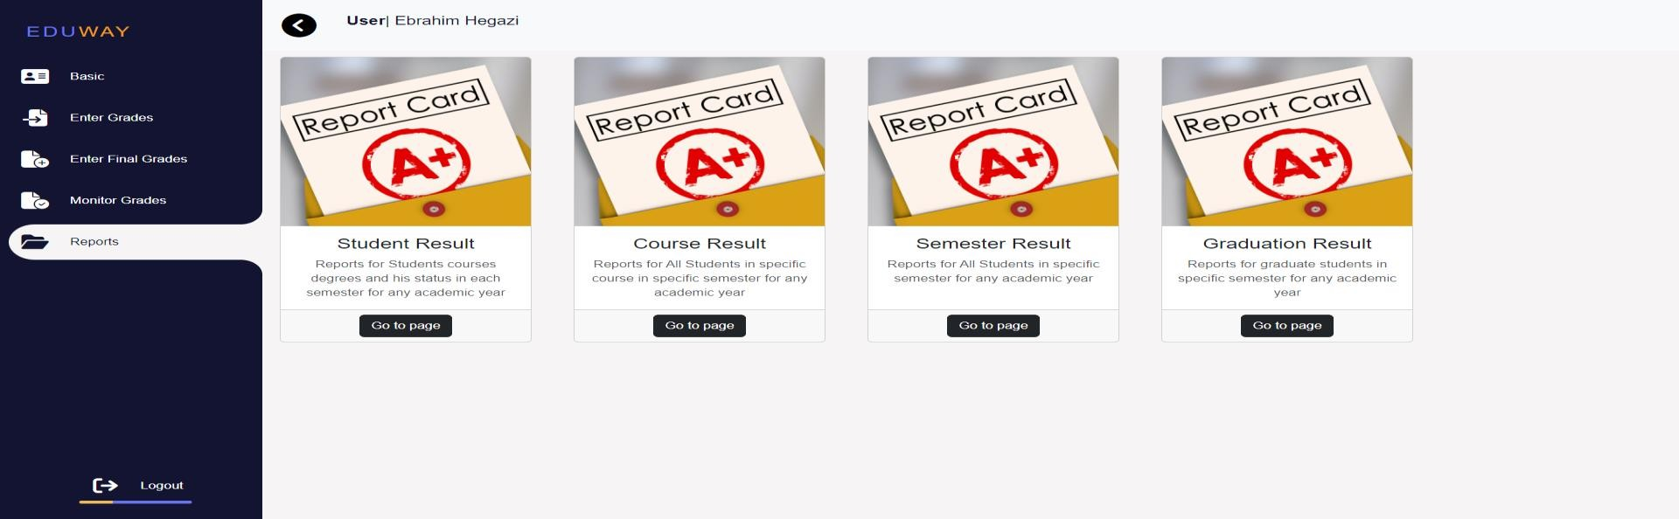

* + - Student Result

*Figure* 5*.5.6 Reports*

* + - * Through this page, you can view the students by specifying the academic year and semester, then click on view to display the results.

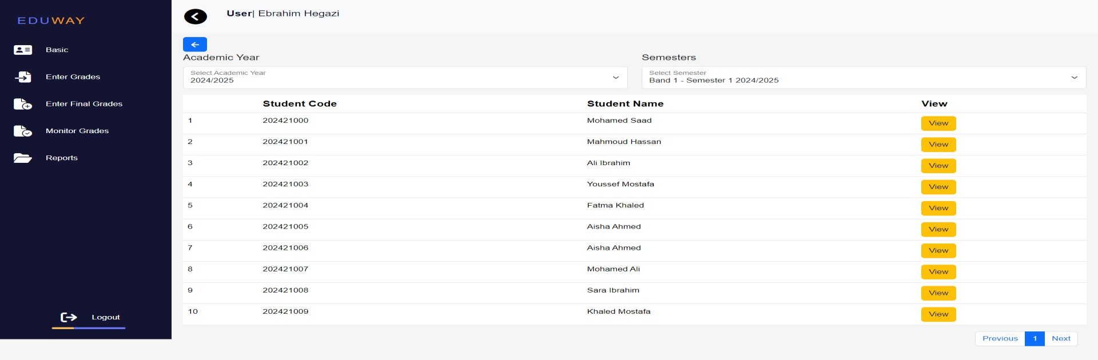

*Figure* 5*.5.7 Report*

84

July 1, 2024

* + - * This page view student result

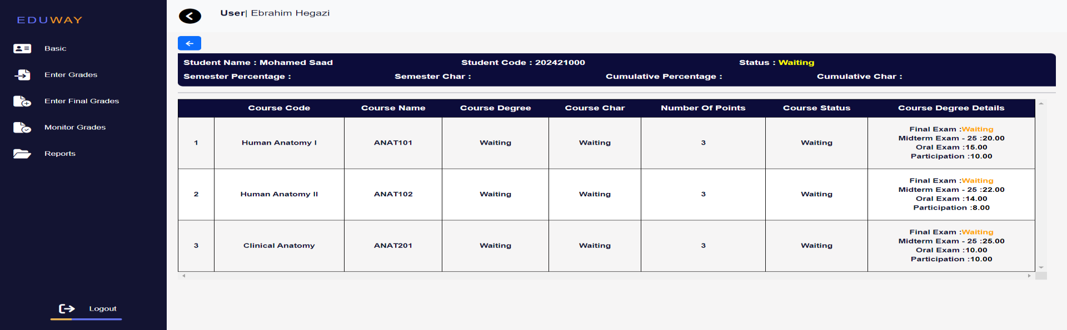

* + - Course Result

*Figure* 5*.5.7 Report*

* + - * Through this page, you can view the courses by specifying the academic year and semester, then click on view to display the results.

85

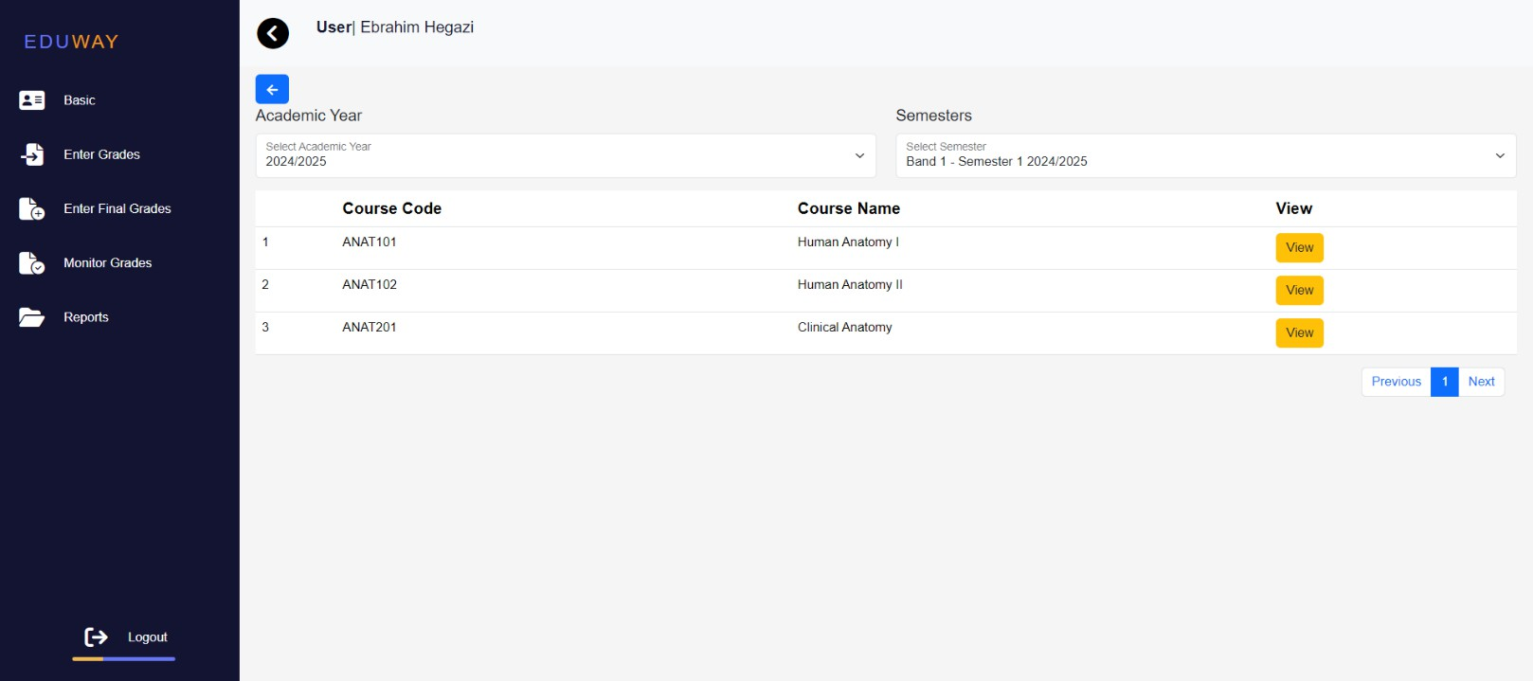

*Figure* 5*.5.8 Report*

July 1, 2024

* This page view students results in a specific course

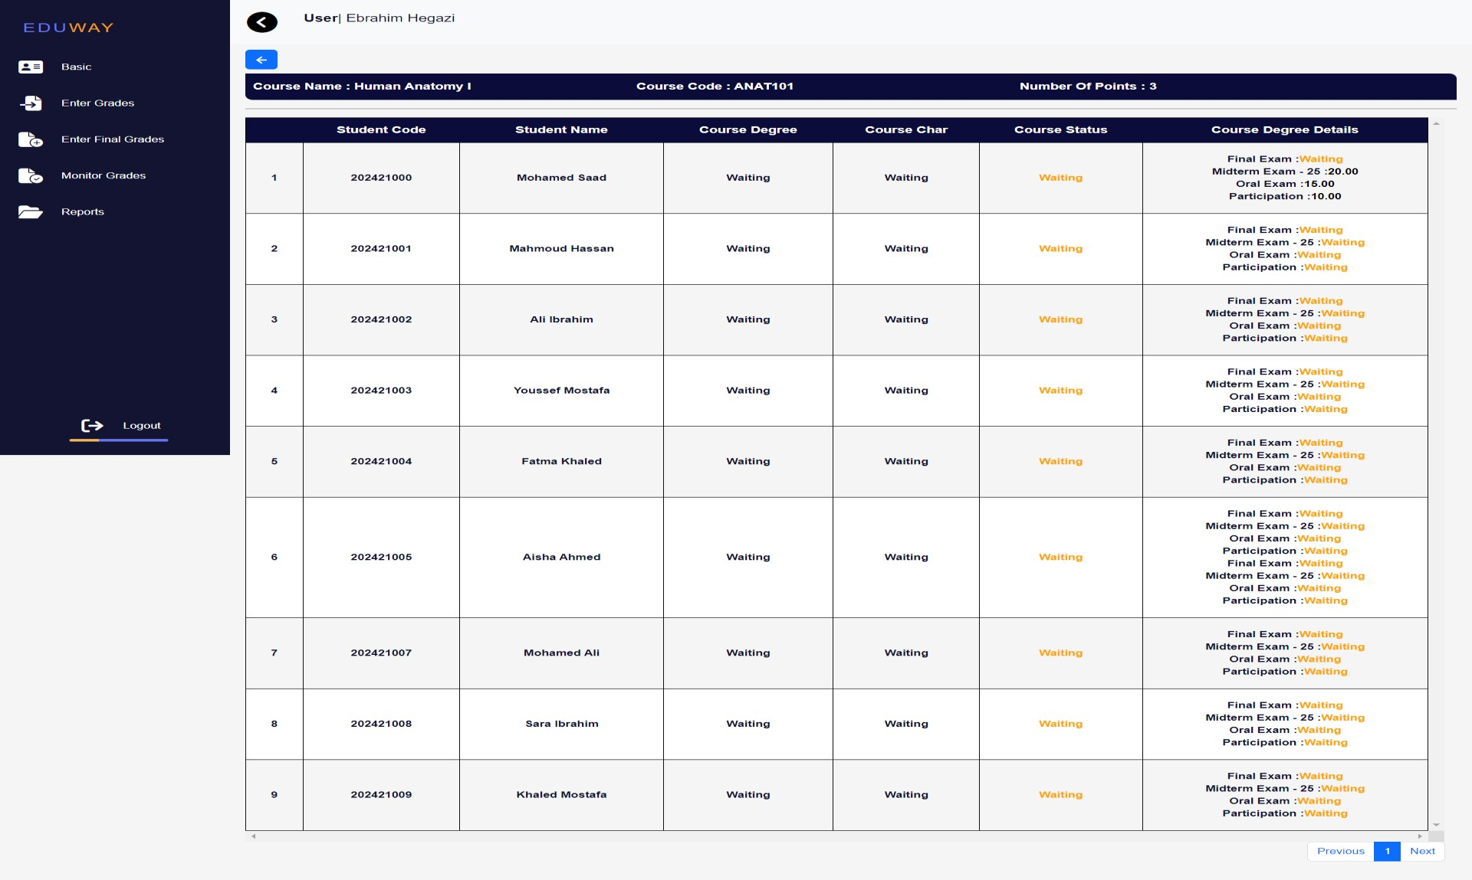

*Figure* 5*.5.8 Report*

* + Semester Result
* Through this page, you can view the students results in semester by specifying the academic year and semester

86

July 1, 2024

87

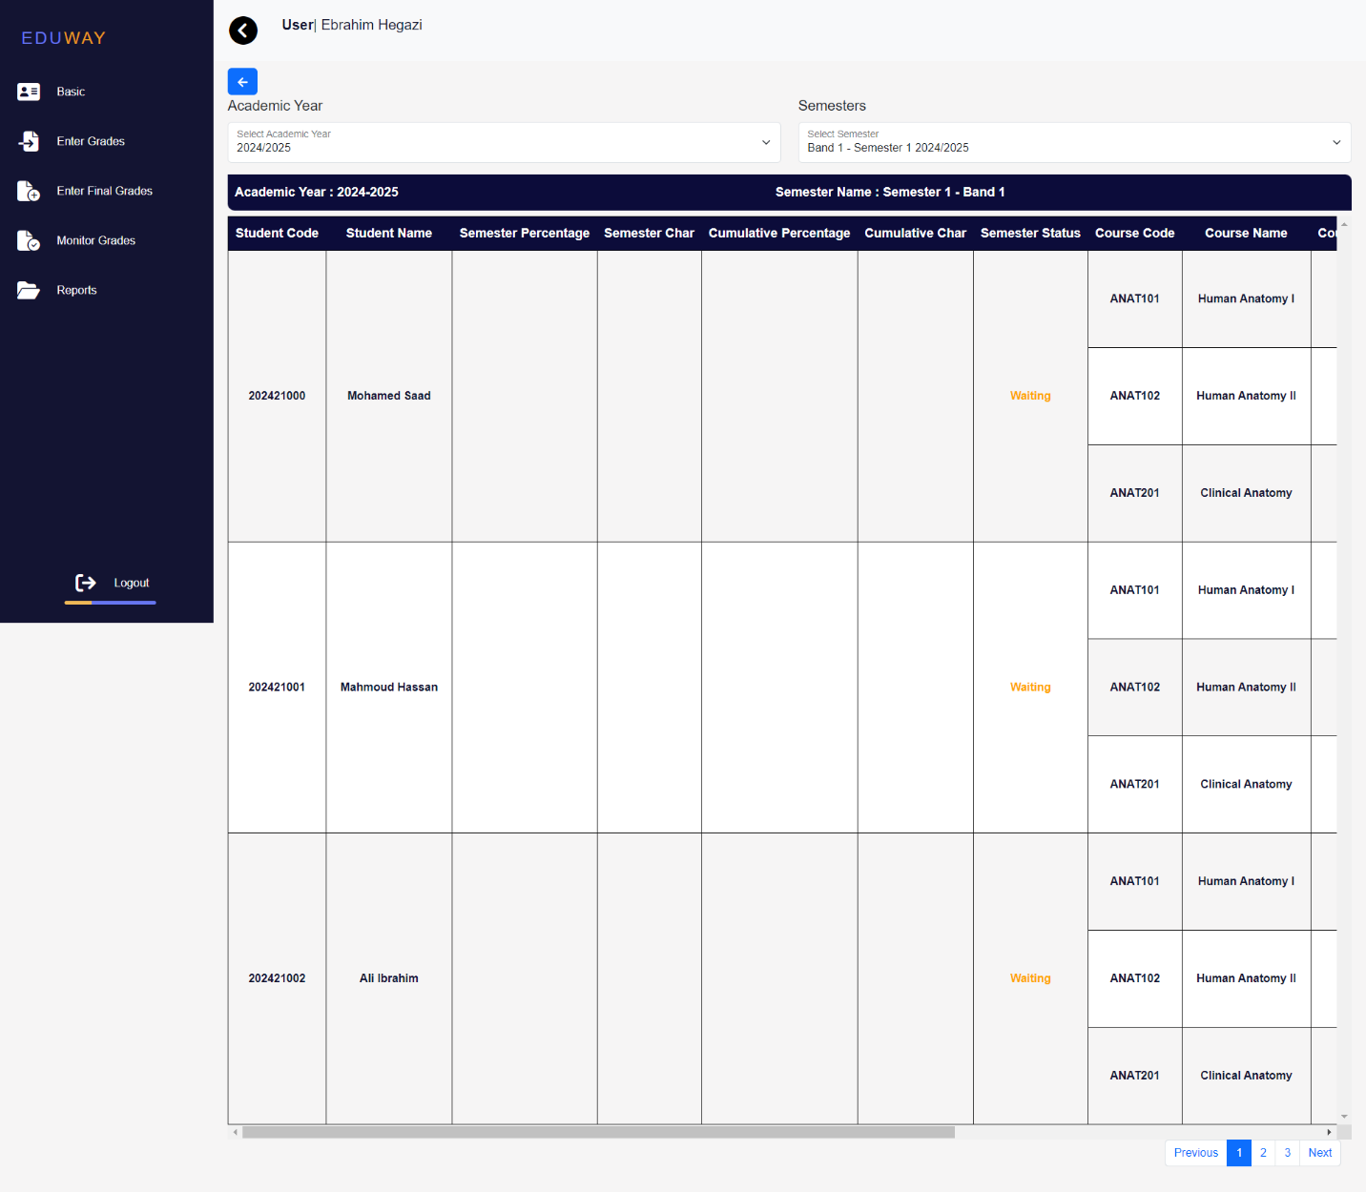

*Figure* 5*.5.9 Report*

* + Graduation Result

July 1, 2024

88

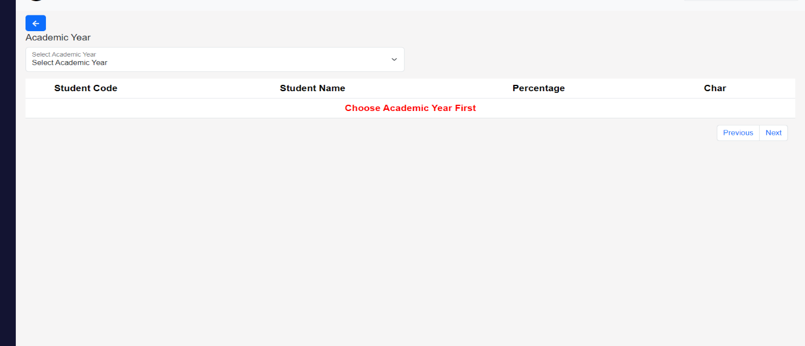

*Figure* 5*.5.10 Report*

#### 1.20 Staff



* Basic information Page:
  + **Personal Data**

Arabic Name, English Name, Gender, Nationality, Religion, Date of Birth, National ID \ Passport No, Release Place, Place of Birth

* + **Contact Data**

Address, Postal Code, Email

* + **Prequalification Data**

July 1, 2024

Pre-Qualification, Qualification Year, Degree, Seat Number

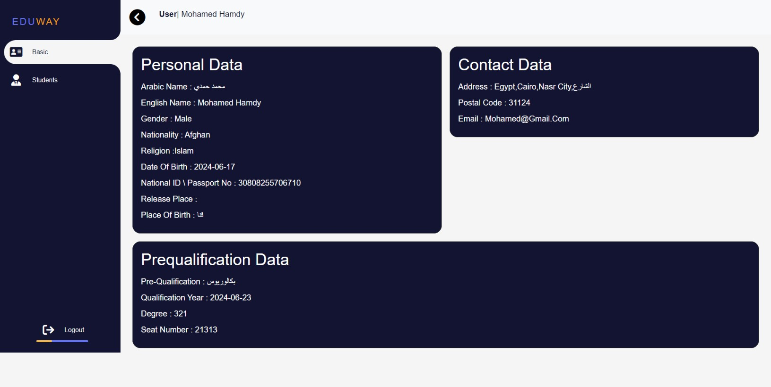

* Student Page:

*Figure* 5*.6.1 Basic Information*

* + Show, add, delete, and edit student information

89

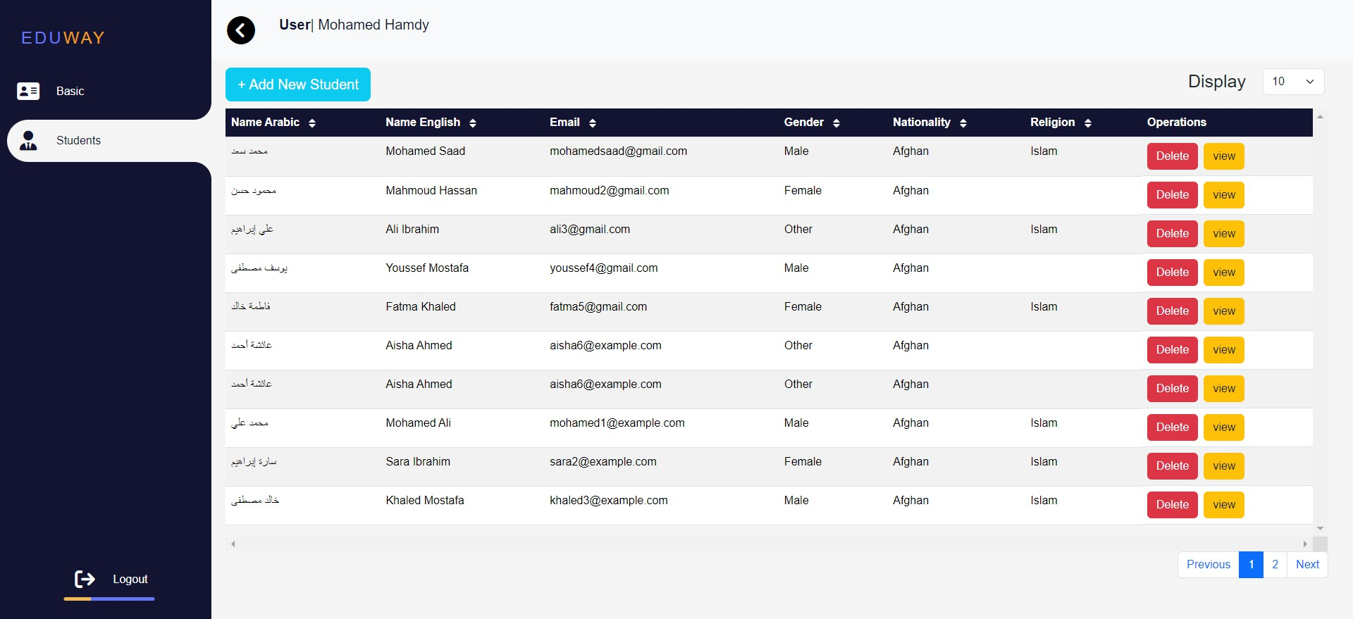

*Figure 5.6.2 Student*

July 1, 2024

* + Add New Student

90

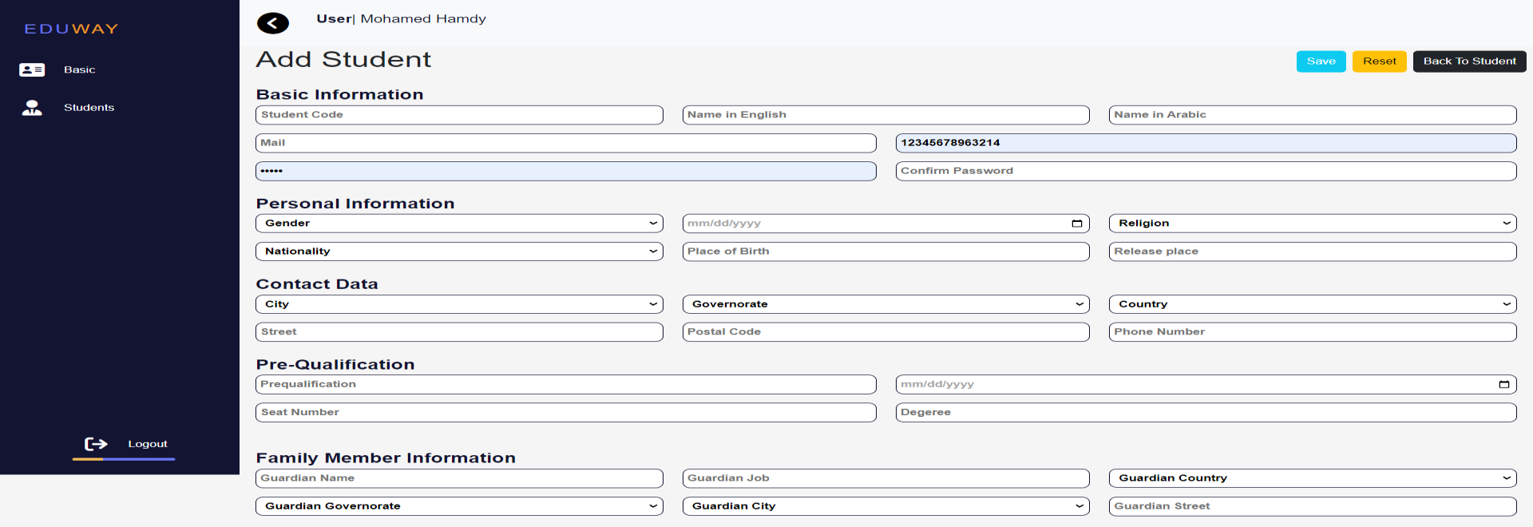

*Figure* 5*.6.3 Student*

* + View student information

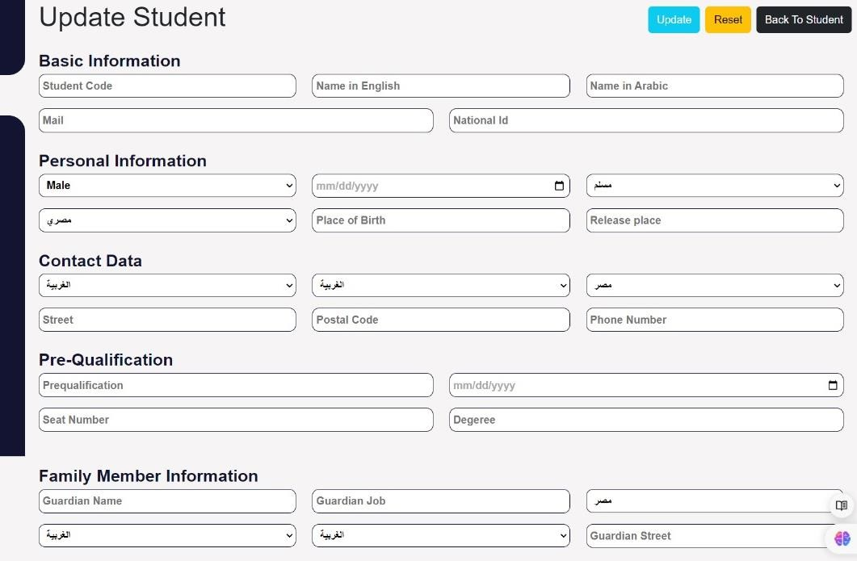

*Figure* 5*.6.4 Student*

July 1, 2024

* + Delete student

91

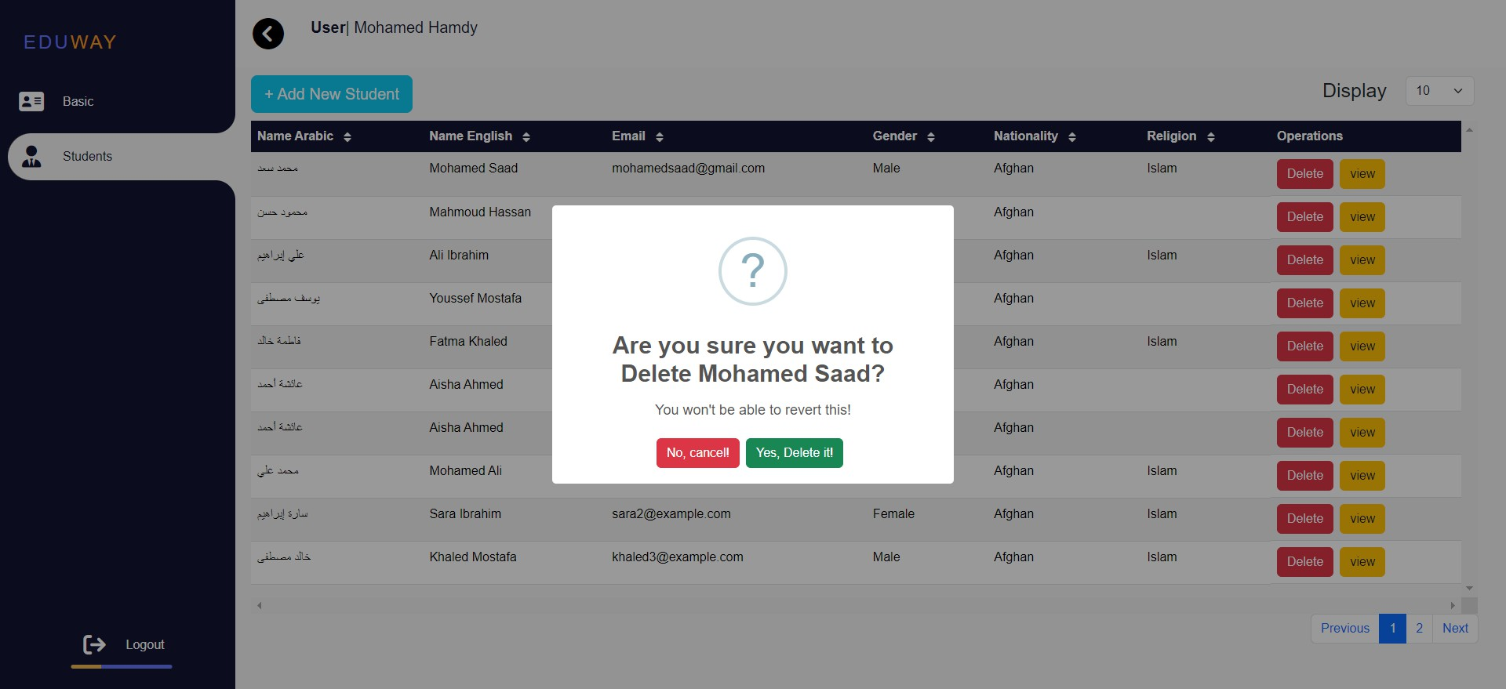

*Figure* 5*.6.5 Student*

July 1, 2024

92



**Student**

* Basic information Page:
  + **Personal Data**

Arabic Name, English Name, Gender, Nationality, Religion, Date of Birth, National ID \ Passport No, Release Place, Place of Birth

* + **Contact Data**

Address, Postal Code, Email

* + **Prequalification Data**

Pre-Qualification, Qualification Year, Degree, Seat Number

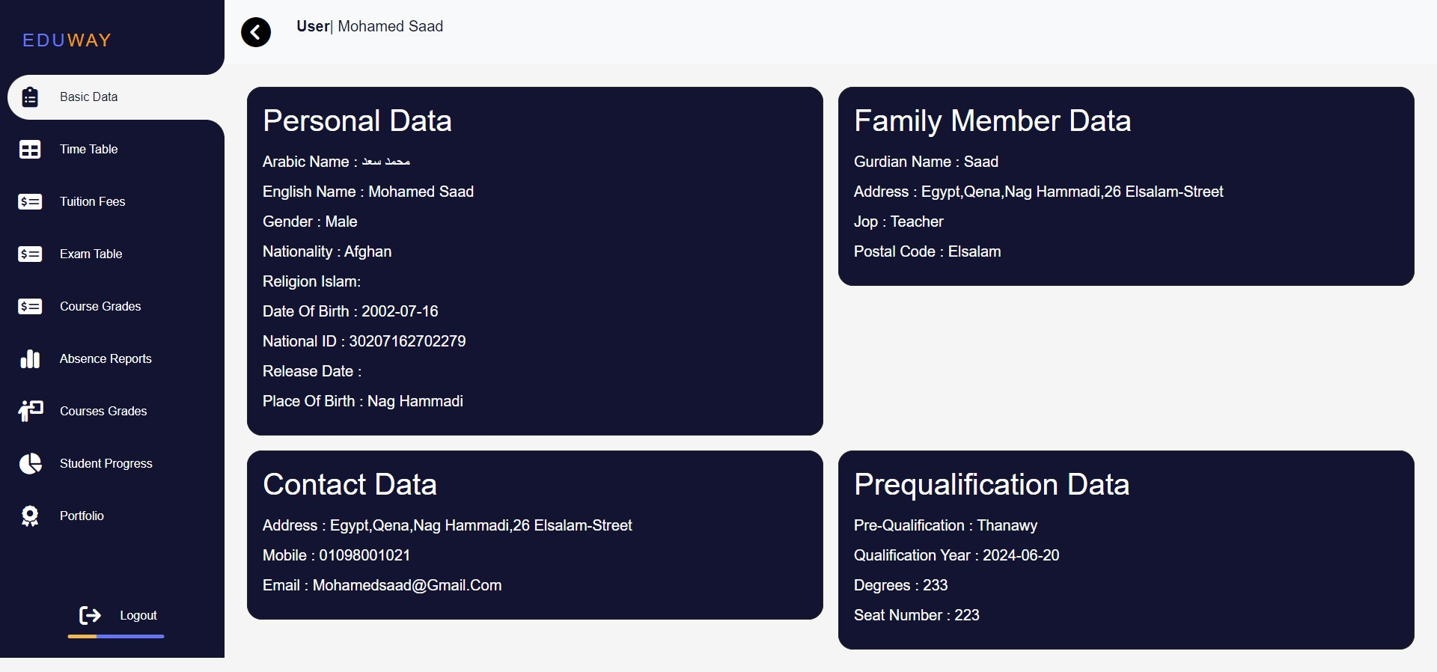

*Figure* 5*.7.1 Basic Information*

July 1, 2024

* Timetable Page:

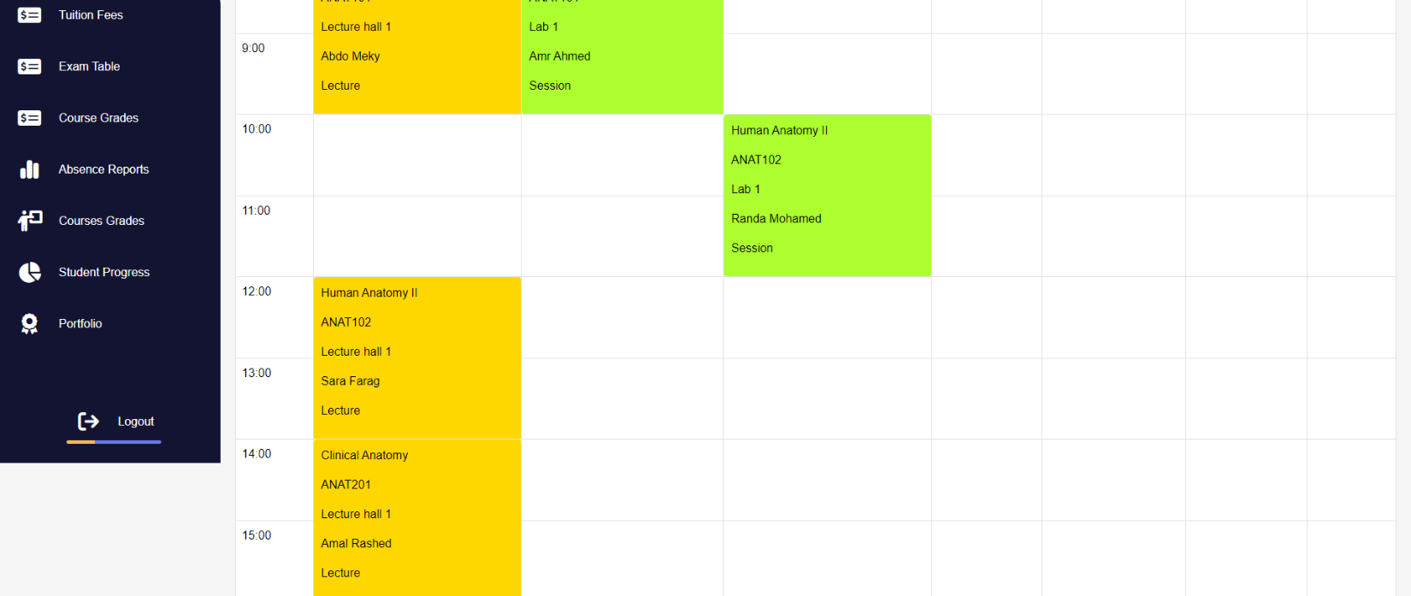

*Figure 5.7.2 Student*

* Coures grades Page:

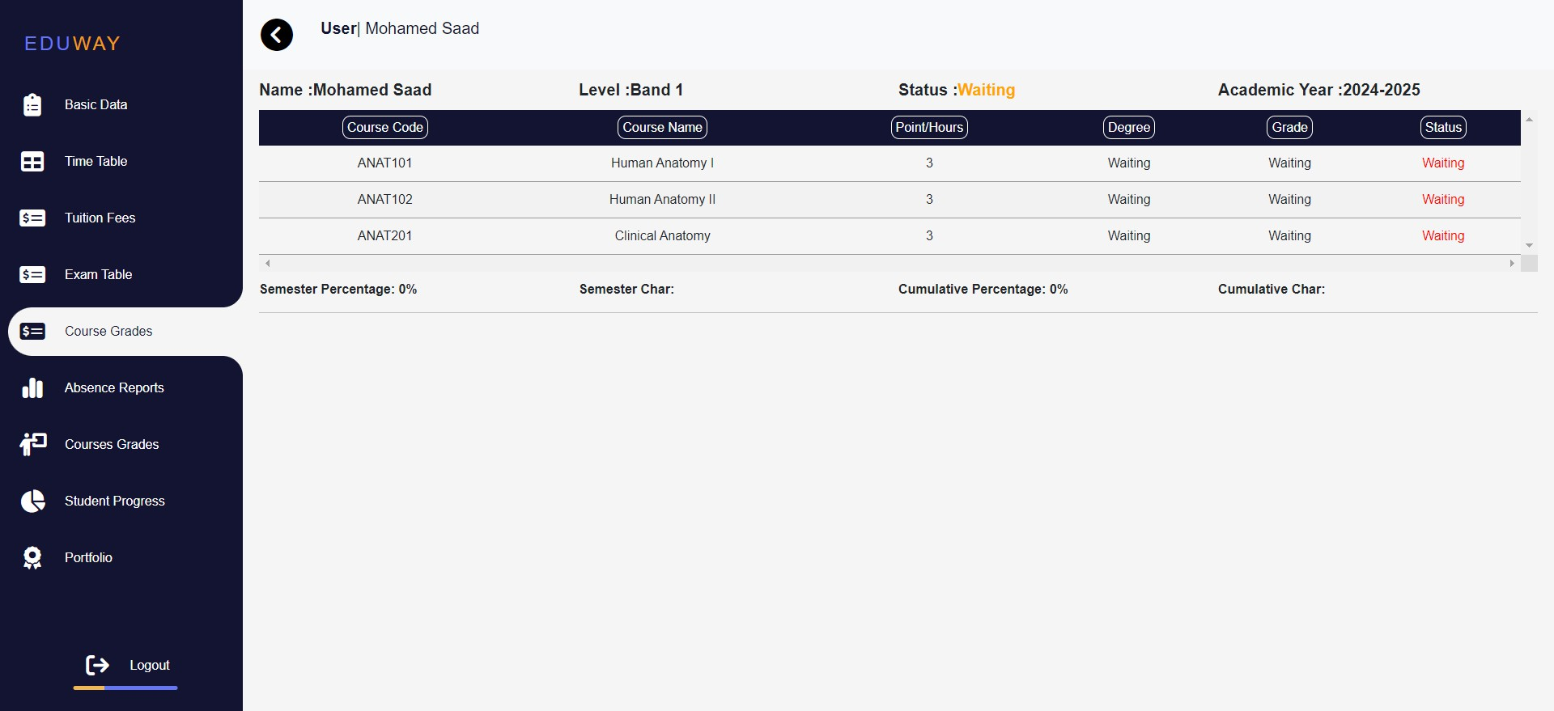

*Figure* 5*.7.3 Student*

93

July 1, 2024

94



**CONCLUSION**

The EduWay Student Management System (SMS) for SVU South Valley University advancement in the management of educational data and administrative processes. Designed with a focus on efficiency, security, and user-friendliness, EduWay addresses the diverse needs of administrators, faculty, staff, and students. Through comprehensive functionalities and a robust architecture, the system offers a seamless experience that enhances the overall efficiency and effectiveness of the university’s operations.

Key benefits of EduWay include:

Streamlined Administration: Facilitates efficient management of faculties, courses, students, and staff, reducing the administrative burden and allowing for more focus on educational quality.

Enhanced Student Experience: Provides students with easy access to personal data, academic schedules, tuition fee information, grades, and progress tracking, fostering a more engaged and informed student body.

Empowered Faculty and Staff: Equips teachers, teacher assistants, and control members with the tools necessary to manage courses, submit grades, and maintain academic records, thereby supporting the educational mission of the university.

Robust Reporting: Enables the extraction of detailed reports, aiding in decision- making and ensuring compliance with academic standards.

July 1, 2024